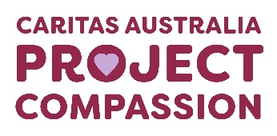

Project Compassion 2026

Parish Bulletin Notices

Throughout Lent, we kindly encourage parishes to promote Caritas Australia’s Project Compassion by sharing weekly bulletin notices with your parishioners and sharing content on your social media platforms to amplify the message of our Lenten appeal.
Need additional resources such as logos, high-resolution photos, or more details?
Please email us at - projectcompassion@caritas.org.au

Important Note:
The QR codes in the bulletin notices link to the Caritas Australia website for direct donations to Project Compassion.
If you’d like to track donations from your parish, you can create an online fundraising page. This will give you a unique QR code for your parish (to replace the ones provided) and allow you to monitor contributions from your community.
To learn more and register your parish page, visit:
https://www.projectcompassion.org.au/parish

*Please note: Photos provided are strictly for use in connection with Caritas Australia’s Project Compassion 2026 campaign.
Photo credits:
- Sisilia’s Story - Tanzania – Caritas Australia
- Monoranjon’s Story – Bangladesh - Caritas Australia
- Manaini’s Story – Fiji - Caritas Australia
- Ahmad’s Story – Gaza - Caritas Jerusalem

Video Links:
- 2nd Weekend of Lent (28 Feb -1 March) - Sisilia’s Story: https://vimeo.com/1128088709
- 3rd Weekend of Lent (7-8 March)- Monoranjon’s Story: https://vimeo.com/1128089124
- 4th Weekend of Lent (14-15 March) - Manaini’s Story: https://vimeo.com/1128089408
- 5th Weekend of Lent (21-22 March) - Ahmad’s Story: https://vimeo.com/1127713885

Bulletin for Weeks Prior to Project Compassion starting:


Project Compassion Donation Envelopes:
How do I use them?

This Lent, like we did in 2025, there is a single Project Compassion donation envelope – rather than the six weekly envelopes used in previous years. This change was made to reduce waste and support our shared commitment to caring for our common home.
You can still give weekly by taking several envelopes at once or simply make your offering when you're ready. Thank you for Uniting Against Poverty with us this Lent.



Project Compassion Sunday

Project Compassion Sunday
14–15 of February 2026

This Lent, we are called to Unite Against Poverty through Caritas Australia’s Project Compassion.
Your generosity this Lenten Season will enable Caritas Australia to provide life-changing support to vulnerable communities in need.
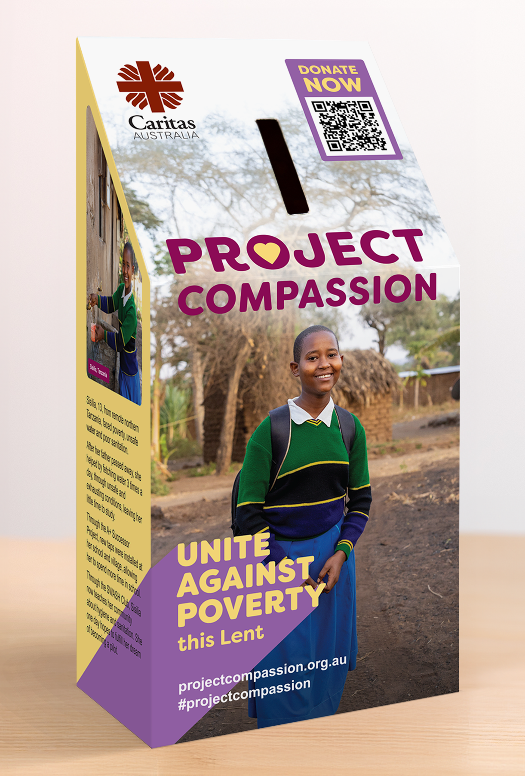
Please donate today.
You can support Project Compassion 2026 through the donation boxes, envelopes or by scanning the QR code.
Or online at: www.projectcompassion.org.au/donate
Or by calling: 1800 024 413
Thank you for standing with us, as we Unite Against Poverty this Lent.

First Week of Lent

First Sunday of Lent
21–22 February 2026

Project Compassion 2026 shares four stories from around the world. We’ll meet Sisilia from Tanzania, Monoranjon from Bangladesh, Manaini from Fiji and Ahmad from Gaza.
Each of this year’s stories highlights unique challenges, yet they are united by the determination to rise above adversity and to build brighter, more hopeful futures for themselves, their families and their communities.

Please donate today.
You can support Project Compassion 2026 through the donation boxes, envelopes or by scanning the QR code.
Or online at: www.projectcompassion.org.au/donate
Or by calling: 1800 024 413
Thank you for standing with us, as we Unite Against Poverty this Lent.

Second Week of Lent

Second Sunday of Lent
28 February – 1 March 2026

Sisilia is a 13-year-old girl living in remote Tanzania, who had to walk long distances to collect water every day. Thanks to Project Compassion, Sisilia’s school and village now have safe clean water close by and she can spend more time studying so she can fulfil her dream of one day becoming a pilot.
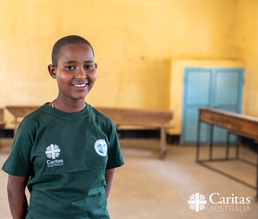
Please donate today.
You can support Project Compassion 2026 through the donation boxes, envelopes or by scanning the QR code.
Or online at: www.projectcompassion.org.au/donate
Or by calling: 1800 024 413
Thank you for standing with us, as we Unite Against Poverty this Lent.

Third Week of Lent

Third Sunday of Lent
7–8 March 2026

Monoranjon lives in a village in Bangladesh close to the sea, where floods and storms often damage his crops and his home. With support from Project Compassion, he learnt climate-resilient farming techniques and new ways to diversify his income, helping his family survive and build a safer, more sustainable future.

Please donate today.
You can support Project Compassion 2026 through the donation boxes, envelopes or by scanning the QR code.
Or online at: www.projectcompassion.org.au/donate
Or by calling: 1800 024 413
Thank you for standing with us, as we Unite Against Poverty this Lent.

Fourth Week of Lent

Fourth Sunday of Lent
14–15 March 2026

Life was hard for Manaini and her children living in rural Fiji. With the support from Caritas Australia’s partner, FRIEND, she learnt food processing and gardening skills, improving nutrition and creating new income opportunities to support her children’s education.
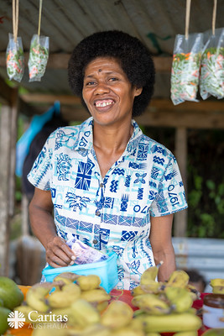
Please donate today.
You can support Project Compassion 2026 through the donation boxes, envelopes or by scanning the QR code.
Or online at: www.projectcompassion.org.au/donate
Or by calling: 1800 024 413
Thank you for standing with us, as we Unite Against Poverty this Lent.

Fifth Week of Lent

Fifth Sunday of Lent
21–22 March 2026

Since October 2023, Caritas Jerusalem staff in Gaza have endured displacement, personal loss, and danger alongside the communities they serve. Despite unimaginable challenges, they remain committed to providing lifesaving support, standing in solidarity with families enduring this conflict.
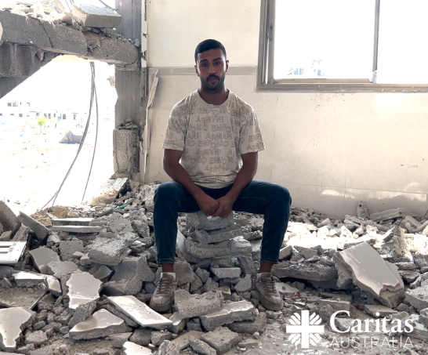
Please donate today.
You can support Project Compassion 2026 through the donation boxes, envelopes or by scanning the QR code.
Or online at: www.projectcompassion.org.au/donate
Or by calling: 1800 024 413
Thank you for standing with us, as we Unite Against Poverty this Lent.

Palm Sunday

Palm Sunday
28–29 March 2026

As Project Compassion 2026 comes to a close, we thank you for your generous support throughout Lent. This year, we shared the stories of four inspiring people whose lives are being uplifted through your compassion.
Your support is helping them overcome challenges and build stronger futures. There is still time to donate! Together, we can continue nurturing hope and empowering communities facing poverty and injustice.
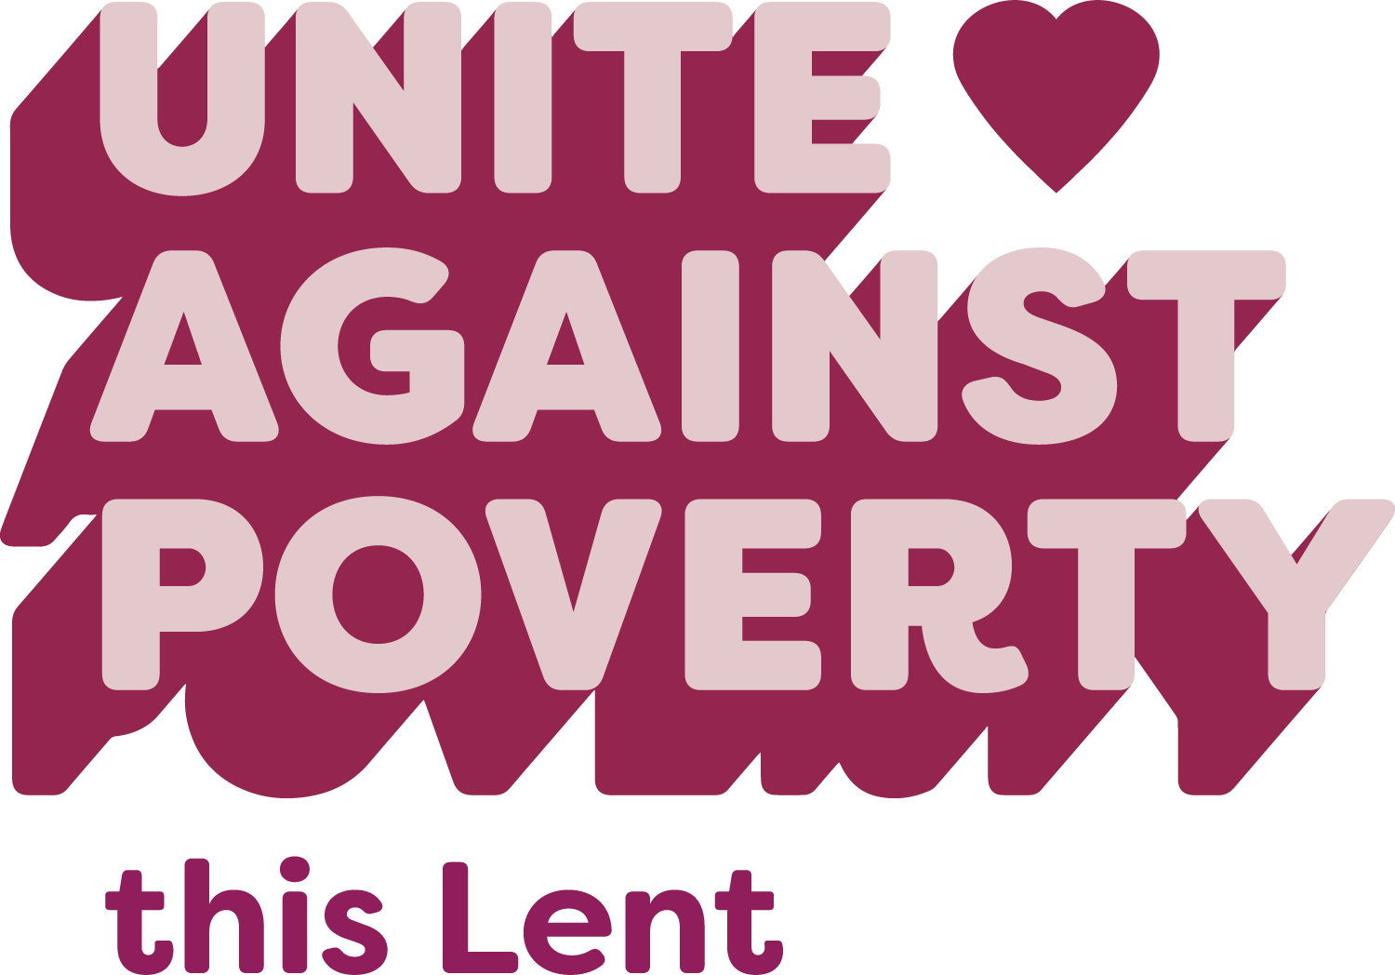
Please donate today.
You can support Project Compassion 2026 through the donation boxes, envelopes or by scanning the QR code.
Or online at: www.projectcompassion.org.au/donate
Or by calling: 1800 024 413
Thank you for standing with us, as we Unite Against Poverty this Lent.

Easter Sunday

Easter Sunday
4 – 5 April 2026

Happy Easter from all of us here at Caritas Australia!
Thank you for your continued support through Project Compassion. Your generosity is helping to empower the world’s most vulnerable communities, enabling them to overcome challenges and lift themselves out of poverty. There is still time to donate!

Please donate today.
You can support Project Compassion 2026 through the donation boxes, envelopes or by scanning the QR code.
Or online at: www.projectcompassion.org.au/donate
Or by calling: 1800 024 413
Thank you for standing with us, as we Unite Against Poverty this Lent.

Thank You Message (General)

THANK YOU!
Caritas Australia sincerely thanks you for your generous support of Project Compassion this Lent.
If you still have your Project Compassion box or donation envelope at home, please return it next week at Mass. Every contribution, no matter the size, helps to bring hope and opportunity to people experiencing poverty and injustice.
Together, we are Uniting Against Poverty and walking alongside vulnerable communities as they build stronger, more sustainable futures.
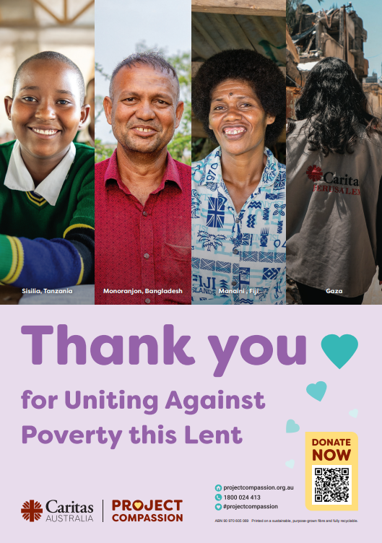
Please donate today.
You can support Project Compassion 2026 through the donation boxes, envelopes or by scanning the QR code.
Or online at: www.projectcompassion.org.au/donate
Or by calling: 1800 024 413
Thank you for standing with us, as we Unite Against Poverty this Lent.

Final Thank You Message (Parish Specific)

THANK YOU!
Caritas Australia would like to extend our heartfelt thanks to the parish community of [INSERT PARISH NAME] for your generous support of Project Compassion 2026.
Your support is helping to bring hope, uphold dignity and create lasting change to communities facing poverty and injustice around the world. Together, your community raised an incredible [$INSERT TOTAL RAISED], helping to bring clean water, education, nutritious food, healthcare and support for those living with disability - showing what’s possible when we come together as a Church to live out the Gospel message of love and justice.
Thank you for uniting with us this Lent to build a more just and compassionate world.

