Project Compassion 2026
School Newsletter Notices

Thank you so much for your support of Caritas Australia’s Project Compassion 2026. We are truly grateful to be working in partnership with you and your school once again to help bring hope and lasting change to vulnerable communities across the world.
Throughout Lent, we encourage schools to promote Project Compassion in their weekly newsletters to inspire parents and the wider community to get involved and to keep them informed about the incredible impact that the school is making. This pack includes some suggested wording and images that you could add into your newsletters to help keep your school community updated and rally their support for your amazing fundraising efforts.
Feel free to use these notices as they are, or to personalise them by including the activities and initiatives your school is undertaking as part of Project Compassion.
If you need any additional resources, or more information, please get in touch with us at projectcompassion@caritas.org.au
Thank you again for standing with us as we Unite Against Poverty this Lent.
IMPORTANT:
The QR codes included in the notices below will take users to the Project Compassion online fundraising hub, where they will be able to donate to the general Project Compassion campaign. If you’d like to track donations from your school community, please:
- Register your school for an online fundraising page.
- Visit your online dashboard to download a unique QR code that’s specific to your school.
- Replace the QR code in the notices below with your own school code.
Scanners will be taken to your school fundraising page, making it easy for you to monitor donations that come from your community.
To learn more and register your school, visit: projectcompassion.org.au/schools
Photo credits:
Please note, photos provided are strictly for use in connection with Caritas Australia’s Project Compassion 2026 campaign.
- Sisilia’s Story - Tanzania – Caritas Australia
- Monoranjon’s Story – Bangladesh - Caritas Australia
- Manaini’s Story – Fiji - Caritas Australia
- Emergency Relief – Gaza – Caritas Jerusalem

Ash Wednesday
(Wednesday 18 Feb 2026)

This Lent, our school community is invited to be a part of something incredible. Once again, we are called to stand hand in hand with thousands of others across the country and Unite Against Poverty by supporting Caritas Australia’s Project Compassion.

Last year, our school was a part of a nationwide movement that raised over $10 million to bring opportunity and change to vulnerable communities across the world. This year, with your support, we hope to have an even greater impact.

By taking home a Project Compassion donation box this year, you’ll be answering the Gospels’ call to care for our global family and walk alongside the most vulnerable. Your generosity will enable Caritas Australia to provide life-changing support to communities facing poverty, food insecurity, lack of education and water shortages, while building resilience against future challenges.

Together, through faith and action, we can bring hope and opportunity to those most in need.

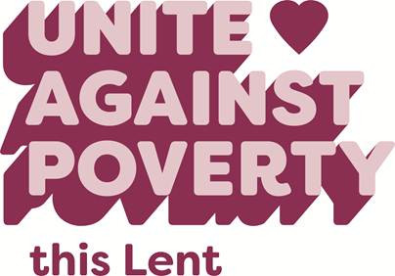
Please donate today.
You can support Project Compassion 2026 through the donation boxes or by scanning the QR code to donate online.
You can also donate:
Online at: projectcompassion.org.au
By phone at: 1800 024 413
Thank you for standing with us, as we Unite Against Poverty this Lent.

First Week of Lent
(Week beginning Monday 23 Feb)
This Lent, our school community is supporting Caritas Australia’s Project Compassion, uniting in faith and action to make a lasting impact for vulnerable communities around the world. In our classrooms, we’ll be sharing four inspiring stories of resilience and strength, showing the kind of transformative change that we can play a part in achieving.

We will first be introduced to Sisilia, a young student from Tanzania, who often missed classes at school because she had to walk long distances to collect water every day. Thanks to Project Compassion and the support of schools just like ours, her community now has safe, clean water nearby – giving Sisilia more time to learn and chase her dreams of one day becoming a pilot.

We’ll also get to know Monoranjon from Bangladesh, who is using climate-smart farming to feed his family and build a safer, more sustainable future for his children. We’ll meet Manaini, a mother of six and a grandmother of two from remote Fiji, who is learning food processing skills to create new income opportunities. And we’ll shine a light on Caritas Jerusalem staff in Gaza, who have endured displacement, personal loss and danger, yet remain committed to providing life-saving support to those in need.

Watch Caritas Australia’s Introduction to Project Compassion film HERE to be inspired by these stories and learn about the impact your support can have on vulnerable communities around the world.

Our school has the opportunity to be a part of a nationwide movement for change and to pave the way to a brighter future for people and families across the world. We can’t do it without you - will you stand with us?

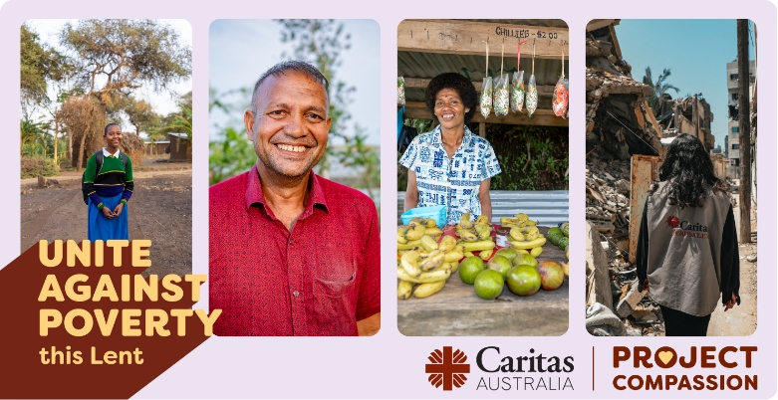
Please donate today.
You can support Project Compassion 2026 through the donation boxes or by scanning the QR code to donate online.
You can also donate:
Online at: projectcompassion.org.au
By phone at: 1800 024 413
Thank you for standing with us, as we Unite Against Poverty this Lent.

Second Week of Lent
(Week beginning Monday 2 March)

This Lent, we are proud to support Caritas Australia’s Project Compassion and to stand in solidarity with school communities across the world who have their education disrupted by the daily struggle for clean, safe water.

This week, we’re introduced to Sisilia, a 13-year-old girl from Tanzania. Sisilia supported her mother by walking long distances three times a day to fetch water. The water was unsafe, causing frequent illness, and the long walks left Sisilia exhausted and struggling to focus on her studies.

Thanks to Project Compassion and the support of schools like ours, Sisilia’s school and village now have safe clean water taps. This means it takes Sisilia just two minutes to collect water, giving her more time to learn so she can fulfil her dreams of one day becoming a pilot.

“I’d like to fly to different countries and pass through the sky.” – said Sisilia. “Also, I want to help my family live a better life. If I can study without spending so much time fetching water, I know I can achieve my dream.”

Watch Sisilia’s story HERE to learn more about how our school’s support of Project Compassion helps to create ripples of change that are felt by our fellow students, teachers and parents across the world.

Will you stand with students like Sisilia this Lent?
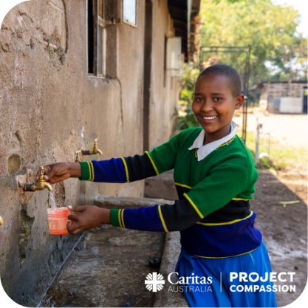
Please donate today.
You can support Project Compassion 2026 through the donation boxes or by scanning the QR code to donate online.
You can also donate:
Online at: projectcompassion.org.au
By phone at: 1800 024 413
Thank you for standing with us, as we Unite Against Poverty this Lent.
Third Week of Lent
(Week beginning Monday 9 March)

Every dollar raised by our school community in support of Caritas Australia’s Project Compassion this Lent will help empower people across the world to build stronger, more resilient futures for themselves and their families. People just like Monoranjon.

Monoranjon lives in a coastal village in southwest Bangladesh, one of the regions most affected by climate change. He and his family face extreme heat, cyclones and water scarcities, which often destroy his crops and threaten his livelihood.
Things began to change when Monoranjon joined the Community Managed Sustainable Livelihoods and Resilience Program run by Caritas Bangladesh, with the support of Caritas Australia. Through the program, he learnt climate-resilient farming techniques including organic vegetable cultivation and livestock vaccination, meaning he is now able to grow salt-tolerant vegetables and raise livestock.
Today, Monoranjon’s income has improved, allowing him to send his children to school and protect their futures from poverty. He also now teaches others in his village, inspiring further change and opportunity across the community.
Watch Monoranjon’s story HERE to learn more about how our school is changing lives around the world - ensuring that people have the tools they need to face poverty, climate change and disaster.
Will you join us and walk alongside people like Monoranjon this Lent?
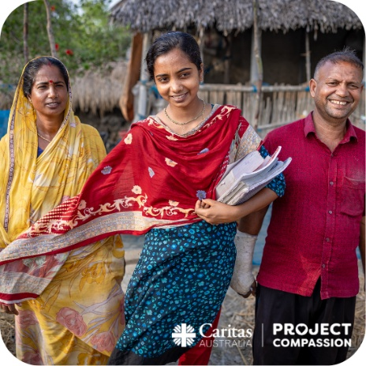
Please donate today.
You can support Project Compassion 2026 through the donation boxes or by scanning the QR code.
Or online at: projectcompassion.org.au
Or by calling: 1800 024 413
Thank you for standing with us as we Unite Against Poverty this Lent.

Fourth Week of Lent
(Week beginning Monday 16 March)

This Lent, our school community has answered the call to Unite Against Poverty as part of Caritas Australia’s Project Compassion. We are proud to join thousands of others across Australia to create real, lasting change for people like Manaini.

Manaini is a mother of six and a grandmother of two living in rural Fiji. Life has always been a struggle - holding back tears, she shared: “The thing I worry about the most is my children’s education. The requirements that need to be met are hard for me to try and achieve with my daily income”.

Thanks to the generosity of schools like ours, Manaini joined training offered by Caritas Australia’s local partner, FRIEND. Through the program, she learnt food processing skills to transform leftovers from crops into flour, improving her family’s nutrition and increasing her weekly income to support her children’s education. “The project totally changed the life of my family and even the community,” Manaini said.

Watch Manaini’s story HERE to see how the actions of our school community today can create a lasting legacy of impact and change that will be felt for generations to come.

There is still time for you to be a part of that legacy - will you join us and stand with people like Manaini this Lent?

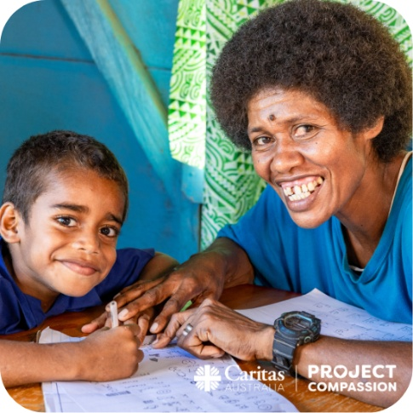
Please donate today.
You can support Project Compassion 2026 through the donation boxes or by scanning the QR code to donate online.
You can also donate:
Online at: projectcompassion.org.au
By phone at: 1800 024 413
Thank you for standing with us, as we Unite Against Poverty this Lent.

Fifth Week of Lent
(Week beginning Monday 23 March)

This Lent, our school community has been supporting Caritas Australia’s Project Compassion, walking alongside our global family to ensure that when people face disaster or emergency, they don’t do so alone.

Families in Gaza have endured catastrophic conditions. Frontline staff at Caritas Jerusalem – many of whom have been displaced themselves – have been standing alongside and serving families whose lives have been disrupted by this devastating war.

Despite these challenges, including displacement, destruction and danger, the dedicated team continues to deliver critical emergency support. They remain committed to serving families in need in the hope that Gaza can rebuild.

Watch the story of Ahmad, one Caritas Jerusalem staff member, HERE to learn more.

As we draw close to the end of Lent, our school community is called to stand in solidarity with communities across the world who are impacted by crisis. Will you stand with us?

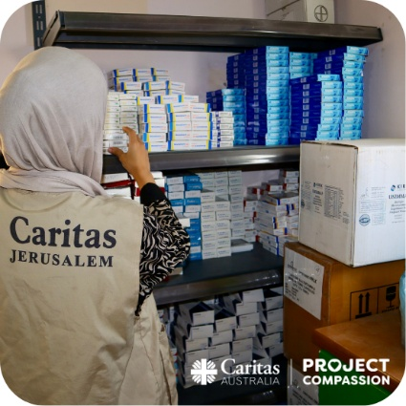
Please donate today.
You can support Project Compassion 2026 through the donation boxes or by scanning the QR code to donate online.
You can also donate:
Online at: projectcompassion.org.au
By phone at: 1800 024 413
Thank you for standing with us, as we Unite Against Poverty this Lent.

Holy Week
(Week beginning Monday 30 March)
As we mark Holy Week, we reflect on another year of turning our faith and love into action through Caritas Australia’s Project Compassion. Throughout Lent, we’ve witnessed the power that our school community can generate when we come together as one, and heard four incredible stories of resilience and strength which offer a window into the kind of transformative impact we can achieve.

In Tanzania, Sisilia’s life was changed with access to nearby clean water. She can now spend more time studying so she can fulfil her dreams of one day becoming a pilot.
Monoranjon, from Bangladesh, learnt climate-resilient farming techniques, helping his family survive and build a safer, more sustainable future.
In rural Fiji, Manaini learnt food processing and gardening skills through Caritas Australia’s partner, FRIEND, creating more income opportunities to support her children’s education.
And in Gaza, Caritas Jerusalem staff remain committed to providing lifesaving support, standing in solidarity with families enduring this conflict.
But the work isn’t done yet, and there is still time to donate! Will you help make this our school’s most meaningful Project Compassion yet?
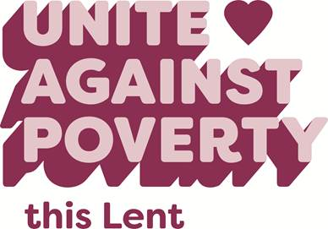

It’s not too late to donate. Keep collecting donations through your Project Compassion collection box, scan the QR code to donate online, or donate over the phone by calling 1800 024 413.
Thank you for standing with us as we Unite Against Poverty this Lent.

THANK YOU

This Lent, our school community was a part of something truly extraordinary.

As part of Caritas Australia’s Project Compassion, we united with schools and parishes across the country in solidarity with vulnerable communities all over the world, paving the way to a brighter, more just future for all.

Our whole school community stepped up and answered the call, and we are truly grateful to all of you for your incredible support. We harnessed the collective kindness and generosity of our students, parents, teachers and wider community and turned it into real, lasting change for those who need it most. Together, we became a powerful force for good, achieving so much more together than we ever could alone.

THANK YOU for standing with us and choosing to Unite Against Poverty this Lent!

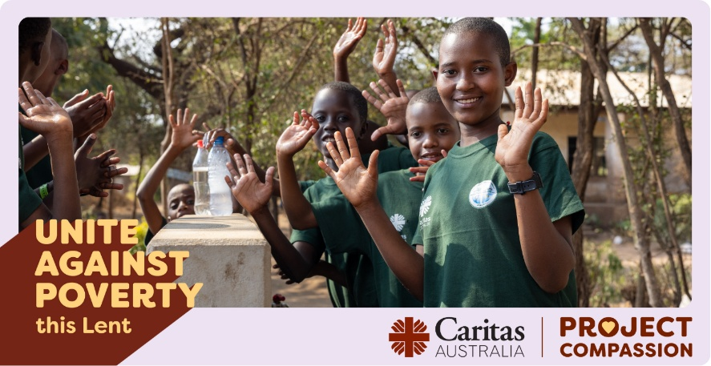

It’s not too late to donate! If you still have your Project Compassion donation boxes at home, please remember to bring them back in next week. Alternatively, scan the QR code to make a donation online or call 1800 02 413 to donate over the phone.

