
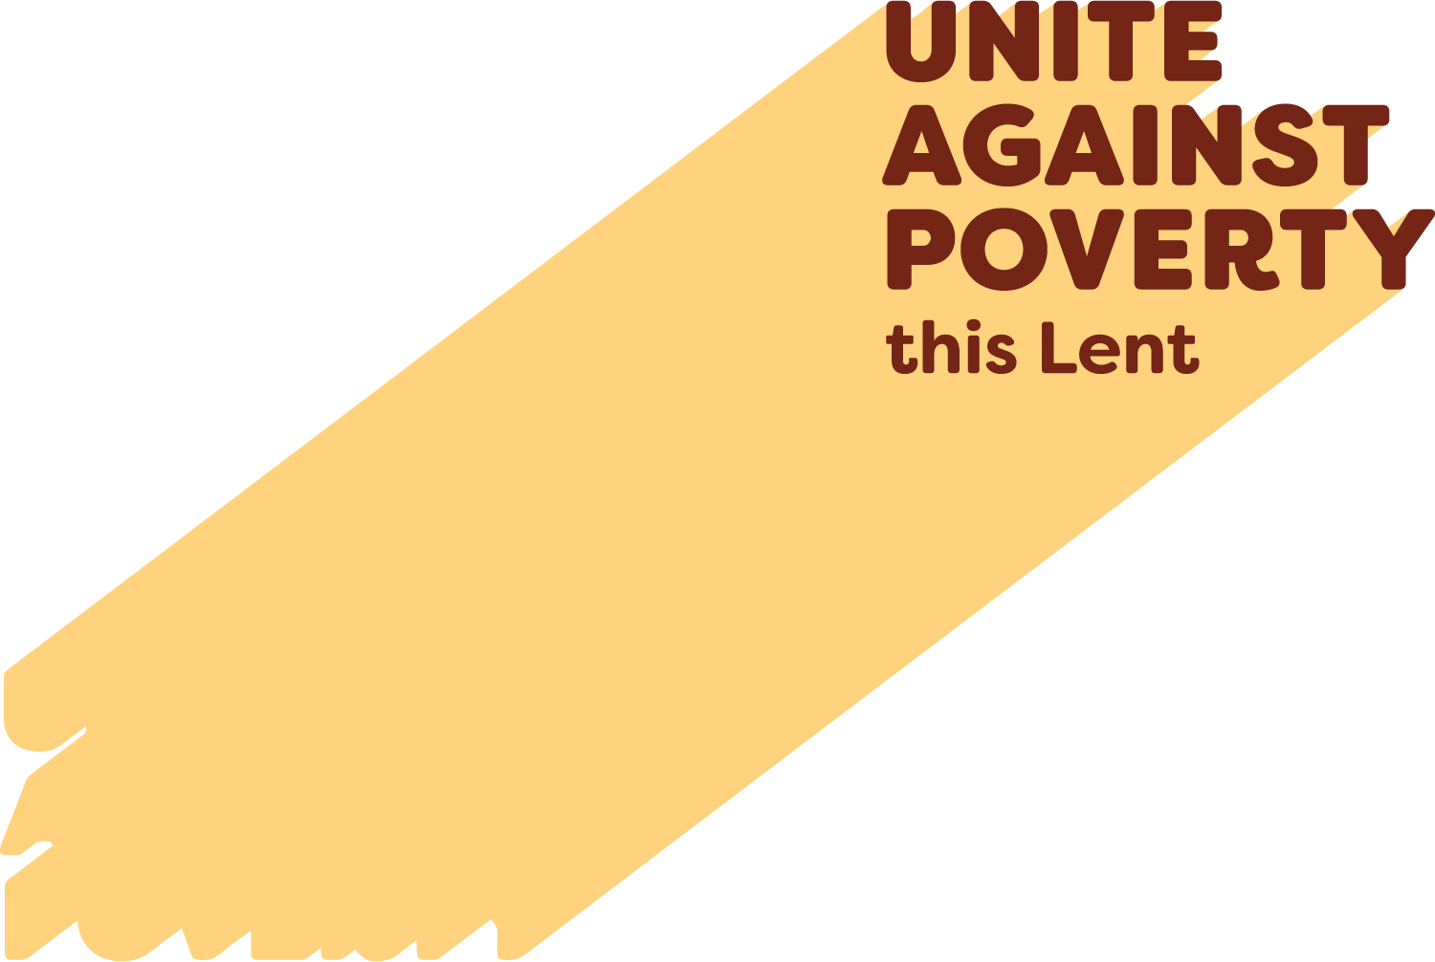

Prayers of the Faithful
projectcompassion.org.au

Ash Wednesday
We pray this Lent for a deeper trust in God’s plan. May our commitment to prayer, fasting and almsgiving, awaken within us a hunger for justice and compassion. May the Jubilee year remind us of our need for a fresh start. May our work for Project Compassion help us to Unite Against Poverty.
Lord hear us.
First Sunday of Lent
We pray for greater respect for the environment. May we care deeply for Earth, the place that God has entrusted to our care. May we celebrate the Year of Jubilee year as pilgrims of hope, ready to find the direction towards peace and justice that God wants for us. May we Unite Against Poverty as we grow in respect for all life.
Lord hear us.
Second Sunday of Lent
We pray for all those whose access to food and water is insecure. May the whole human family respond generously in creating lasting justice in the distribution of life’s necessities. May we respond to opportunities such as those presented by Project Compassion this Lent to Unite Against Poverty. May we all be one.
Lord hear us.
Third Sunday of Lent
We pray for anyone who lives with disability, especially people who are stigmatised in any way. May we do all we can to support their flourishing as truly equal participants in the human family. May our work this Lent with Project Compassion help to create greater justice.
Lord hear us.
Fourth Sunday of Lent
We pray for those driven away from their homes by violence, persecution or poverty, especially women. May our hearts be open to do all we can to rebuild the lives of others through supporting Caritas Australia and the work of Project Compassion. May we be instruments of God’s peace and pilgrims of hope.
Lord hear us.
Fifth Sunday of Lent
We pray that all women may be respected and encouraged to take their rightful place in society. We pray also that all people will have access to clean water and safe housing. May we Unite Against Poverty as we act for justice in concrete ways, such as through Project Compassion.
Lord hear us.
Palm Sunday
We pray for a renewal of our faith during Holy Week. May we learn more deeply what it means to be pilgrims of hope in this Year of Jubilee. Through works such as Project Compassion, may we Unite Against Poverty and walk alongside our sisters and brothers towards the new life of Easter.
Lord hear us.

