Project Compassion 2024
School and Community Bulletin Notices

We encourage schools to include information about Project Compassion in their weekly newsletter, daily bulletins and social media as a way of informing parents and the wider community about our Lenten appeal. If you would like any other information, logos or photos, please email us: education@caritas.org.au
Please note that the photos can only be used in relation to Caritas Australia’s Project Compassion campaign.
Ash Wednesday
14 February
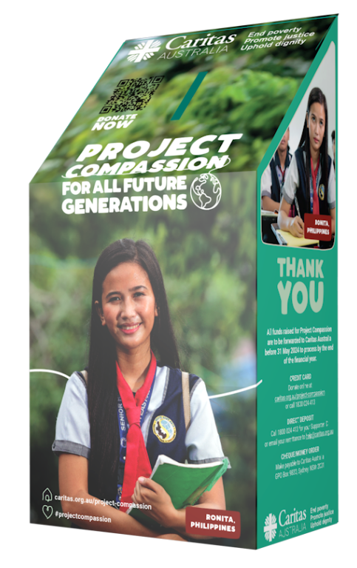
This week, the season of Lent begins with Ash Wednesday, which also marks the beginning of the annual Caritas Australia Project Compassion Appeal. Donations to Project Compassion allow Caritas Australia, the Catholic Agency for International Aid and Development, to work with local communities around the world to end poverty, promote justice and uphold dignity.
Please give generously to Caritas Australia this Lenten season and help vulnerable people around the world, now and for all future generations.
With your support, Caritas Australia has been able to assist communities around the world through income generation, water and sanitation, food security, education and disaster risk reduction programs.
Project Compassion 2024 reminds us that the good we do today will extend and impact the lives of generations to come. Together, we can help vulnerable communities face their challenges today and build a better tomorrow.
You can donate through Project Compassion donation boxes and online by visiting caritas.org.au/project-compassion or by calling 1800 024 413.

First Week of Lent
(Week beginning Monday 19 February)

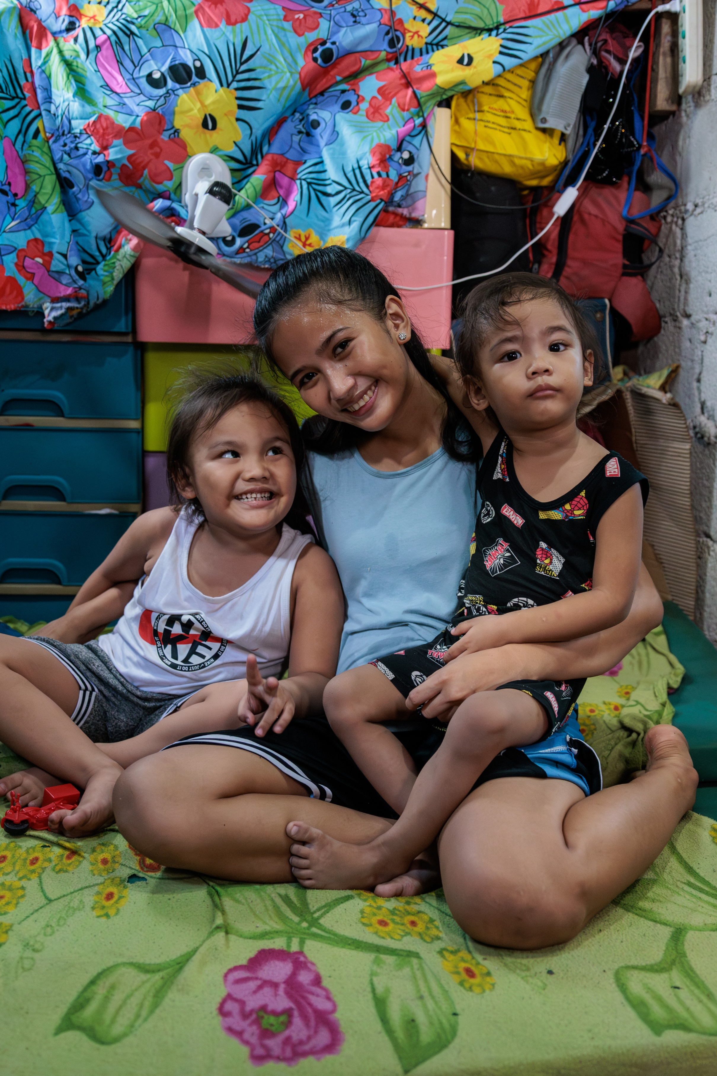
This year, Project Compassion brings you the stories of three resilient women from three different corners of the world. They are facing vastly different challenges, but are all united by one dream: to create a better tomorrow for all future generations. ​
Meet Ronita from the Philippines. Ronita lives with her husband and two children in a barangay (local district) in Quezon City, which is situated in Metro Manila in the Philippines. She went back to school to finish her education so that she could earn income to support her children.
Meet Leaia from Samoa. Not having access to a reliable source of clean water was very difficult for Leaia and her family. But, with the support of Caritas Australia, a water tank was installed at their home, improving their health and living conditions.
Meet Memory from Malawi. Memory, the eldest daughter from a rural Malawian family, trained to become a carpenter and is now a trailblazer for future generations of women in her village.
Throughout Project Compassion, you will get to know the stories of Ronita, Leaia and Memory. Journey with them as they forge a path to a brighter future for all generations.
Watch a short film: Introduction to Project Compassion (Primary school version) or Introduction to Project Compassion (General)
Please donate to Project Compassion.
You can donate through Project Compassion donation boxes, online by visiting caritas.org.au/project-compassion or by calling 1800 024 413.
Photo: Richard Wainwright/Caritas Australia

Second Week of Lent
(Week beginning Monday 26 February)

Ronita is 22. She lives with her husband and two children in a barangay (local district) in Quezon City, which is situated in Metro Manila in the Philippines.
Ronita left school when she became pregnant as a teenager. This could have had a life-long impact on her ability to find work and provide for her family but, thankfully, she heard about the Alternative Learning System (ALS) program run by the Faithful Companions of Jesus (FCJ), Caritas Australia’s local partner in the Philippines.
Through the FCJ, Ronita was able to re-enrol in her studies and continue learning in a safe and flexible environment – even with the arrival of her second child.
After completing her ALS classes, Ronita went on to earn her Grade 12 Senior High School Diploma. With her new diploma, Ronita has now secured a job at a call centre and is looking to a brighter future for her whole family.
“I have now graduated senior school and I am so proud of myself,” she said. “I feel hopeful for the future… Now it’s not impossible for me to achieve my dream… Thank you.”
Watch Ronita’s Story
Please donate to Project Compassion.
Together, we can help vulnerable communities face their challenges today and build a better tomorrow for all future generations.
You can donate through Project Compassion donation boxes, online by visiting caritas.org.au/project-compassion or by calling 1800 024 413.
Photo: Richard Wainwright/Caritas Australia

Third Week of Lent
(Week beginning Monday 4 March)
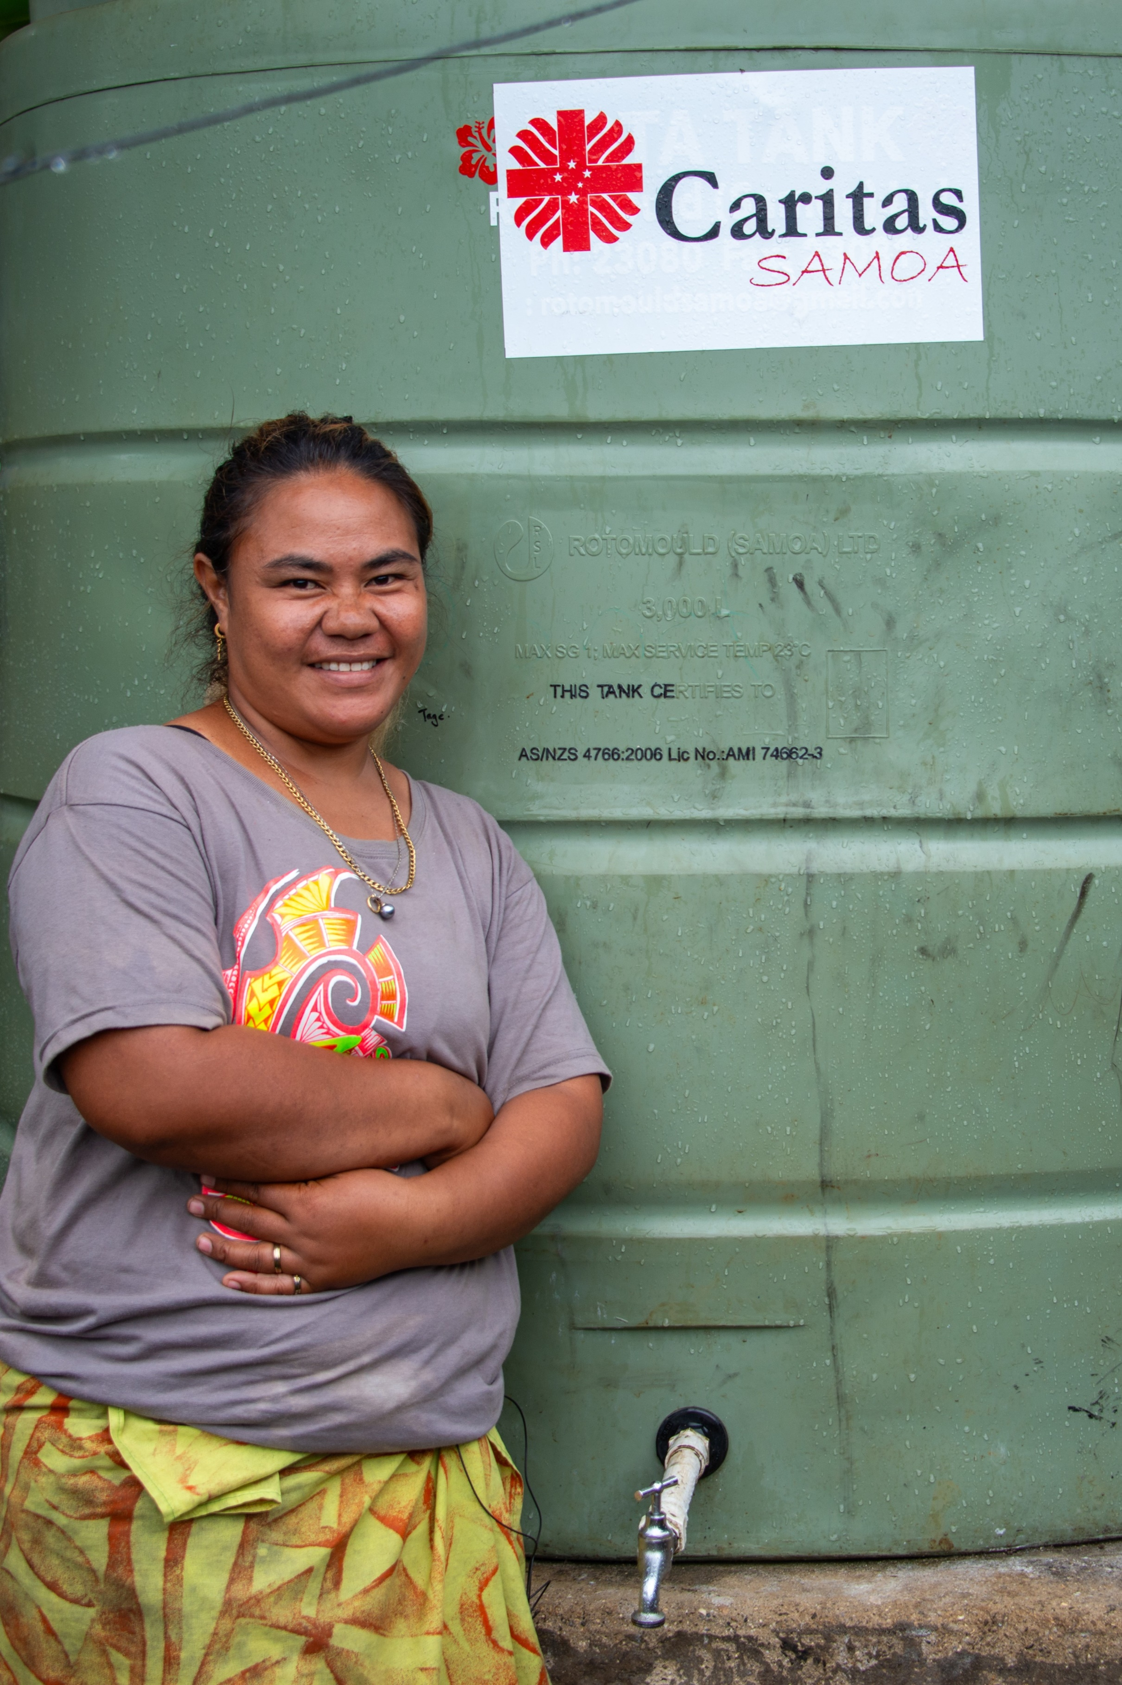
Samoa may be a country surrounded by water, but access to clean drinking water is scarce in some areas, with many families facing extreme hardship as a result.
Leaia lives with her five children, husband, brother and sister-in-law on the island of Upolu in Samoa. Not having access to a reliable source of clean water caused Leaia a lot of worry.
Their home is not connected to a piped water system, so they had to rely solely on rainwater collected in old fridges. When their water ran out, Leaia had to walk with her young children to collect water in buckets and containers from a neighbour down the street.
With the support of Caritas Australia's local partner, Caritas Samoa, a water tank was installed at Leaia's home. She and her family now have a steady supply of clean drinking water at home. Next year, they will also have a toilet built, with the support of Caritas Samoa, which will further improve their health and living conditions.
“We are very thankful and grateful for the water tank. It has helped us so much and made our daily life easier,” Leaia said.
Watch Leaia’s Story
Please donate to Project Compassion.
Together, we can help vulnerable communities face their challenges today and build a better tomorrow for all future generations.
You can donate through Project Compassion donation boxes, online by visiting caritas.org.au/project-compassion or by calling 1800 024 413.
Photo: Laura Womersley/Caritas Australia

Fourth Week of Lent
(Week beginning Monday 11 March)

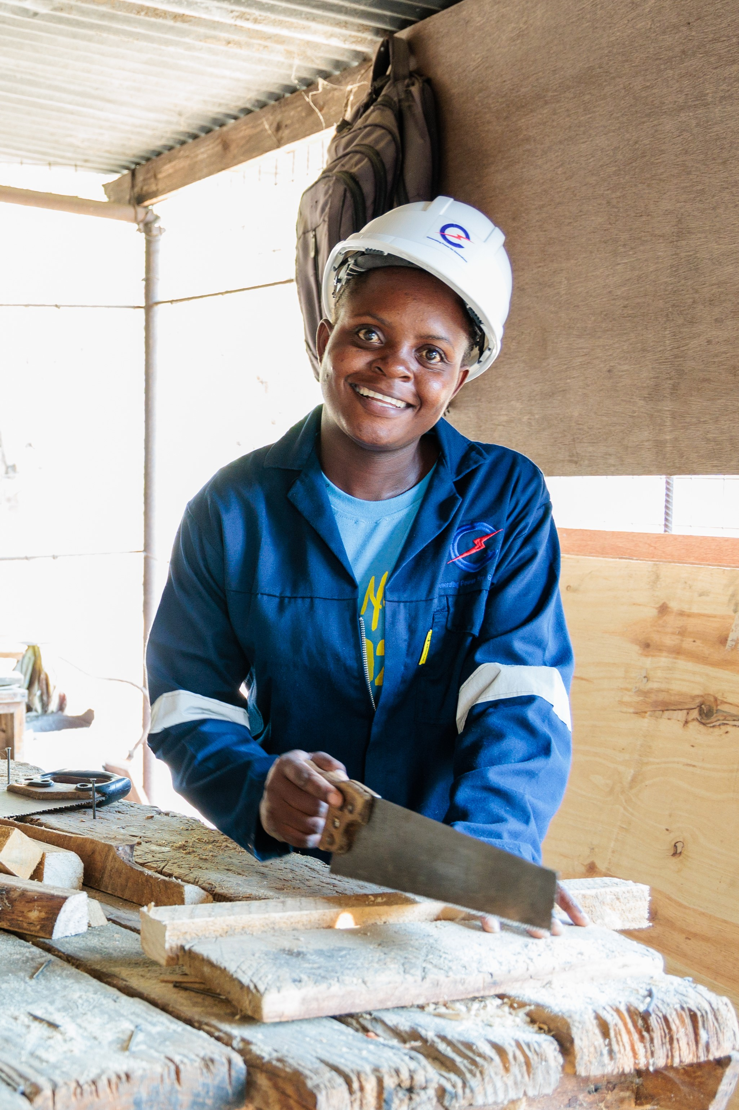
Memory is 26 years old and lives in rural Malawi. As the eldest child in a low-income farming family, Memory had to take on many household chores and farming activities to support her parents. They struggled to pay for Memory’s school fees and school supplies, and Memory often had to walk to school barefooted.
With the support of Caritas Australia and its partner the Catholic Development Commission in Malawi (CADECOM), Memory was able to enrol at a technical college where she learnt technical skills in carpentry. She undertook a three-year carpentry course, with CADECOM supporting part of her tuition and boarding fees.
Memory became the first female carpenter from her village. Today, she works as a carpenter at one of Malawi’s largest hydroelectric power stations. With the income from her job, she can provide financial support to her family and inspire other young women in her community so that they may have the opportunity to succeed in a male-dominated industry.
Watch Memory’s Story
Please donate to Project Compassion.
Together, we can help vulnerable communities face their challenges today and build a better tomorrow, for all future generations.
You can donate through Project Compassion donation boxes, online by visiting caritas.org.au/project-compassion or by calling 1800 024 413.
Photo: Tim Lam/Caritas Australia

Fifth Week of Lent
(Week beginning Monday 18 March)

Partnership in action
The work of Caritas Australia is only possible with the dedication, passion and tenacity of our local partners who implement the programs. They are the heroes on the ground, working tirelessly behind-the-scenes every day to create a better future for their communities.
Caritas Australia partners with the Faithful Companions of Jesus (FCJ) to support communities living in urban slums in the Philippines. FCJ runs a number of programs that include house renovating, food processing, basic literacy skills, urban gardening, upcycling and income generating activities. They also have a clinic visited weekly by a doctor and community nurse.
Caritas Australia partners with Caritas Samoa to assist communities to have increased access to clean water, sanitation and hygiene to ensure human health and well-being by providing water tanks and sanitation facilities.
Caritas Australia partners with the Catholic Development Commission in Malawi through the A+ program. Since 2016, the A+ program has helped 7,397 families across Malawi improve their food security, access to basic water and sanitation, boost women’s income generation and strengthen child protection.
Please donate to Project Compassion.
Together, we can help vulnerable communities face their challenges today and build a better tomorrow for all future generations.
You can donate through Project Compassion donation boxes, online by visiting caritas.org.au/project-compassion or by calling 1800 024 413.
Photo: Richard Wainwright / Caritas Australia

Holy Week
(Week beginning Monday 25 March)
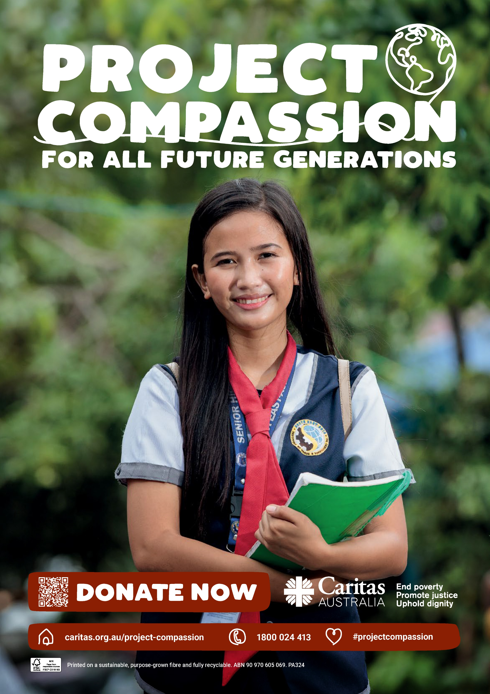
This year, we shared with you the story of three inspiring women from across the globe, who overcame challenges to complete their education, access water and find secure employment. With the support of compassionate people like you, they are now forging a path to a better future for their families and their communities.
Ronita from the Philippines has now graduated high school and secured a job at a call centre. This job was only possible because of a certificate she gained from completing her studies.
Leaia and her family now have a water tank at their home in Samoa. She and her family now have a steady supply of clean drinking water. Next year, they will also have a toilet built, with the support of Caritas Samoa, which will further improve their health and living conditions.
Memory completed her vocational training course in carpentry and joinery. After completing a work contract at one of the largest electrical companies in Malawi, Memory now plans to return to her village and provide carpentry services to people in her community.
It’s through the generosity of people like you that we can continue to support people like Ronita, Leaia and Memory.
There is still time to donate! Together, we can help vulnerable communities face their challenges today and build a better tomorrow, for all future generations.
You can donate through Project Compassion donation boxes, online by visiting caritas.org.au/project-compassion or by calling 1800 024 413.

Thank you – after easter
Thank You!
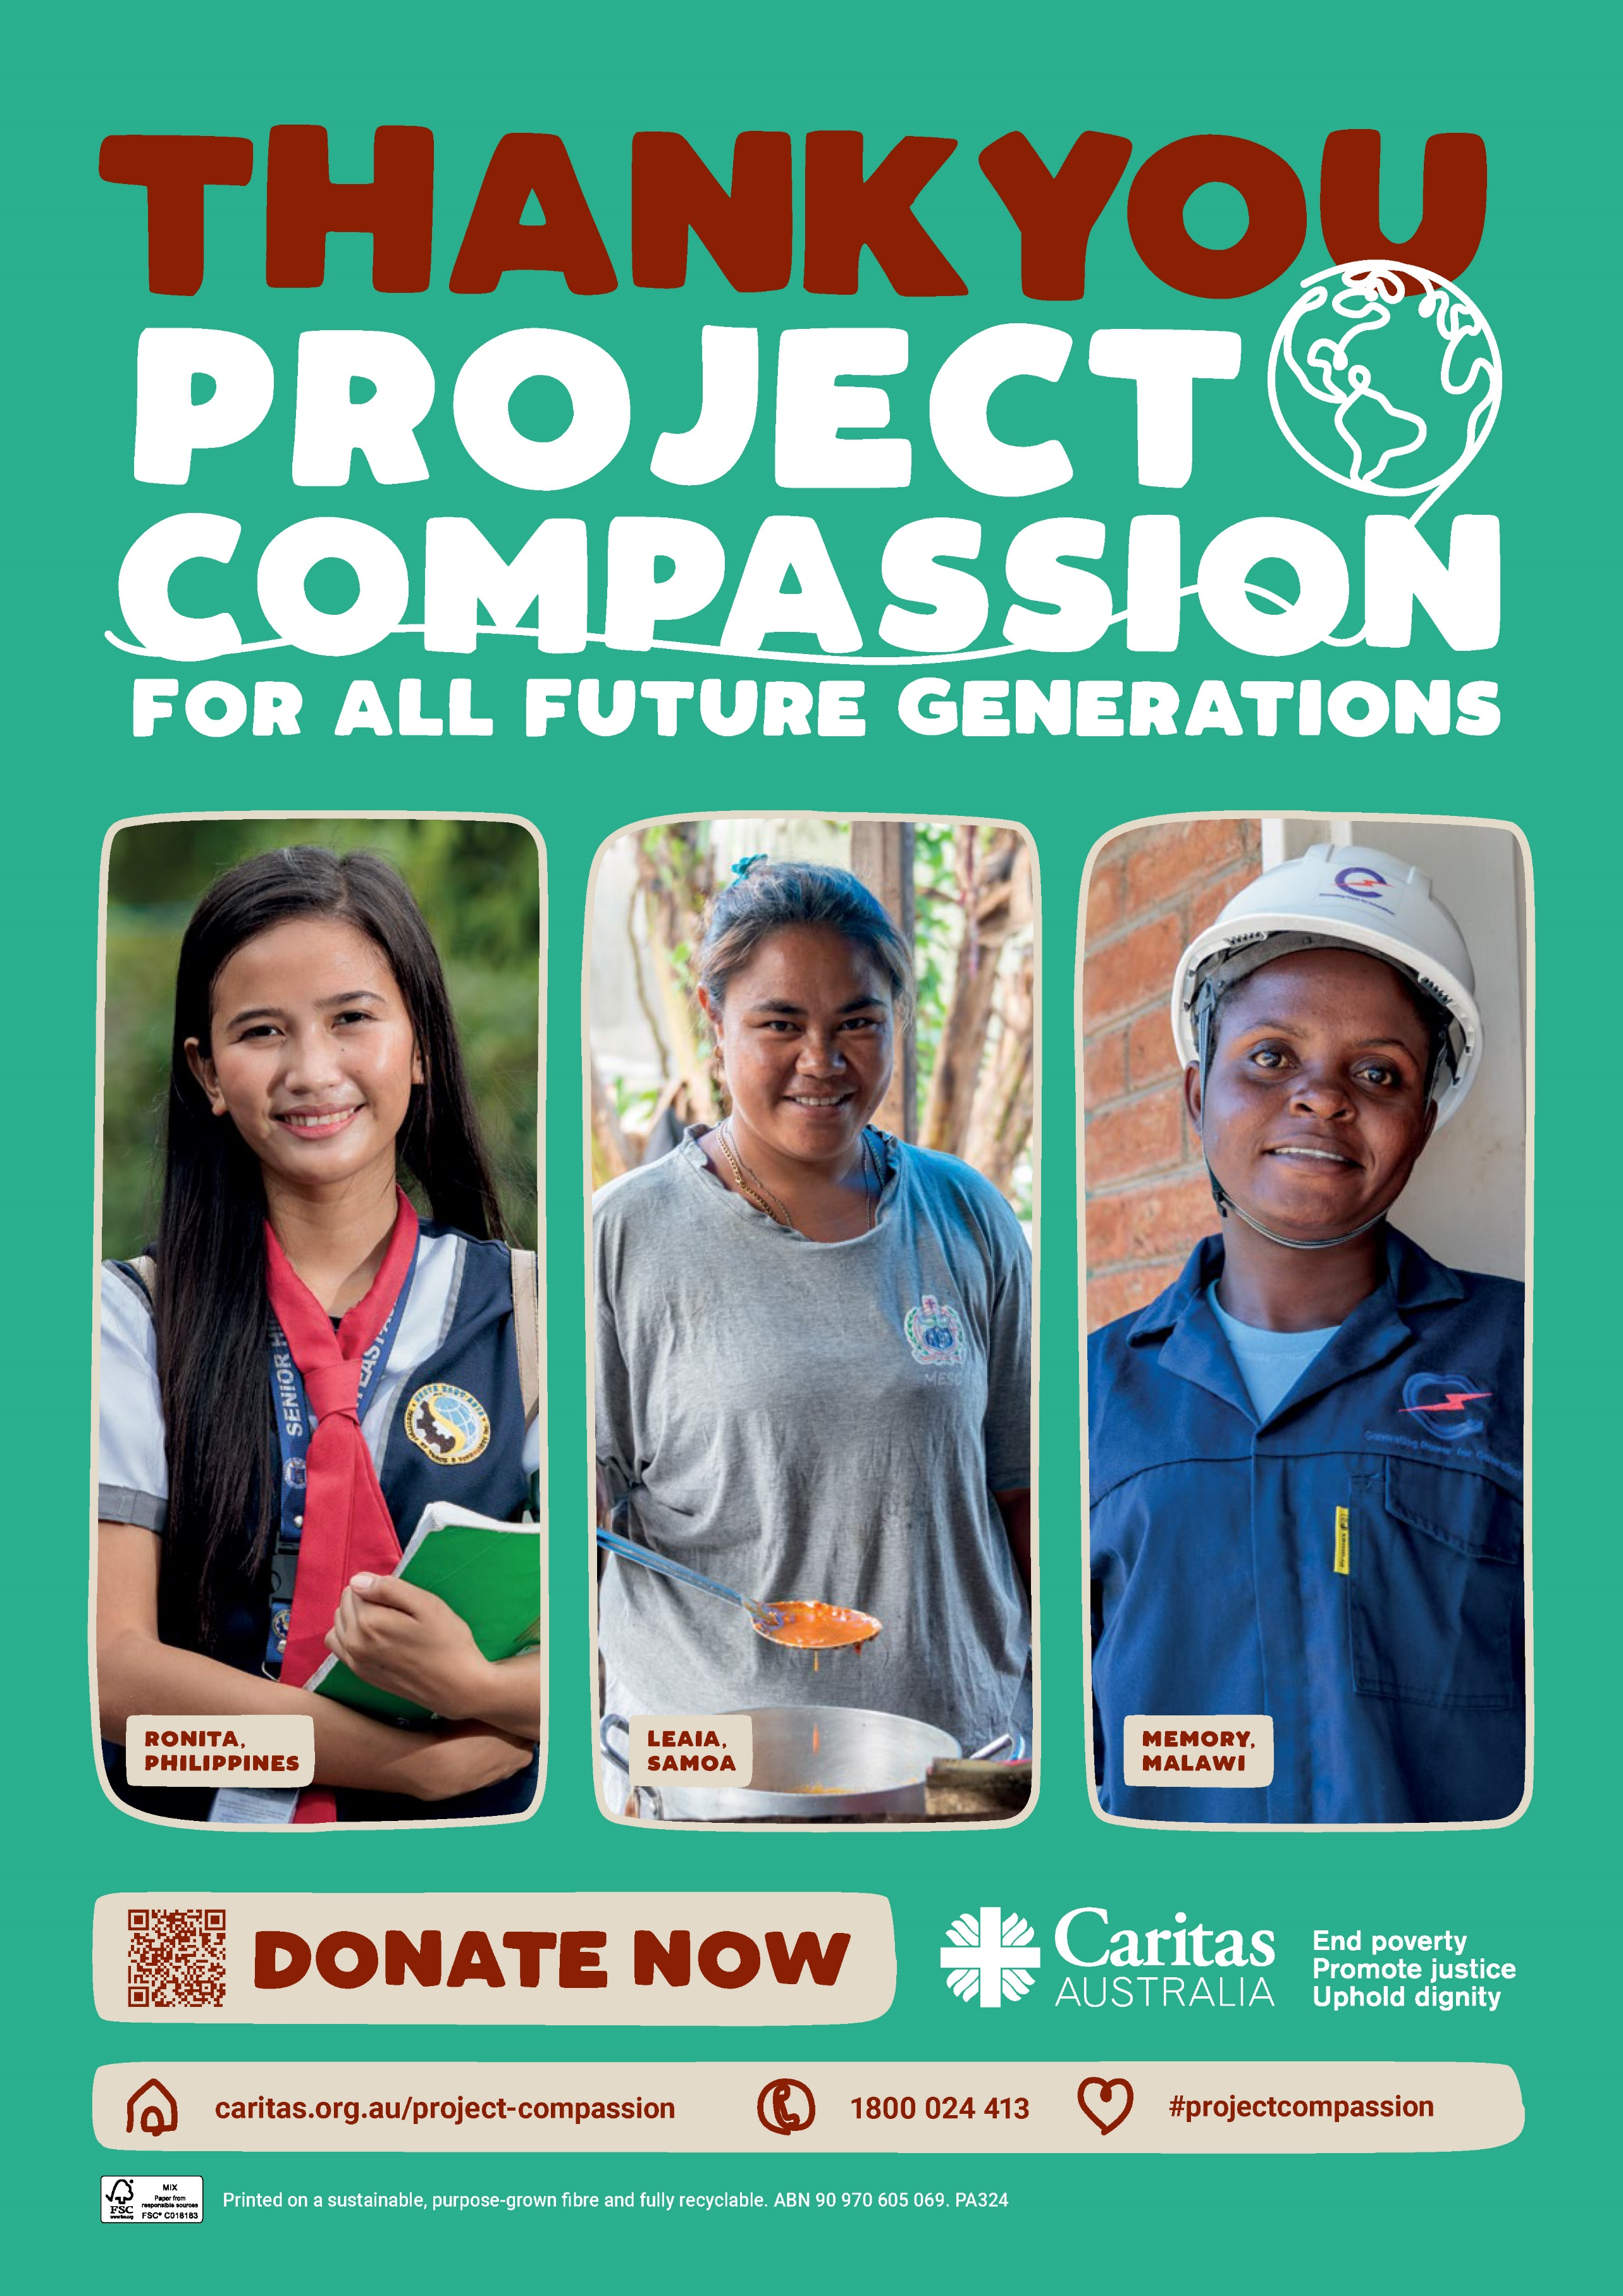
Caritas Australia would like to THANK YOU for supporting Project Compassion 2024. If you still have your Project Compassion box at home, please bring it back to school next week or visit caritas.org.au/project-compassion and donate online.
Your generosity will empower the world’s most vulnerable communities to grow stronger and lift themselves out of poverty.
Together, we can help vulnerable communities face their challenges today and build a better tomorrow, for all future generations.
Watch the Project Compassion Thank You film.
You can donate through Project Compassion donation boxes, online by visiting caritas.org.au/project-compassion or by calling 1800 024 413.

