
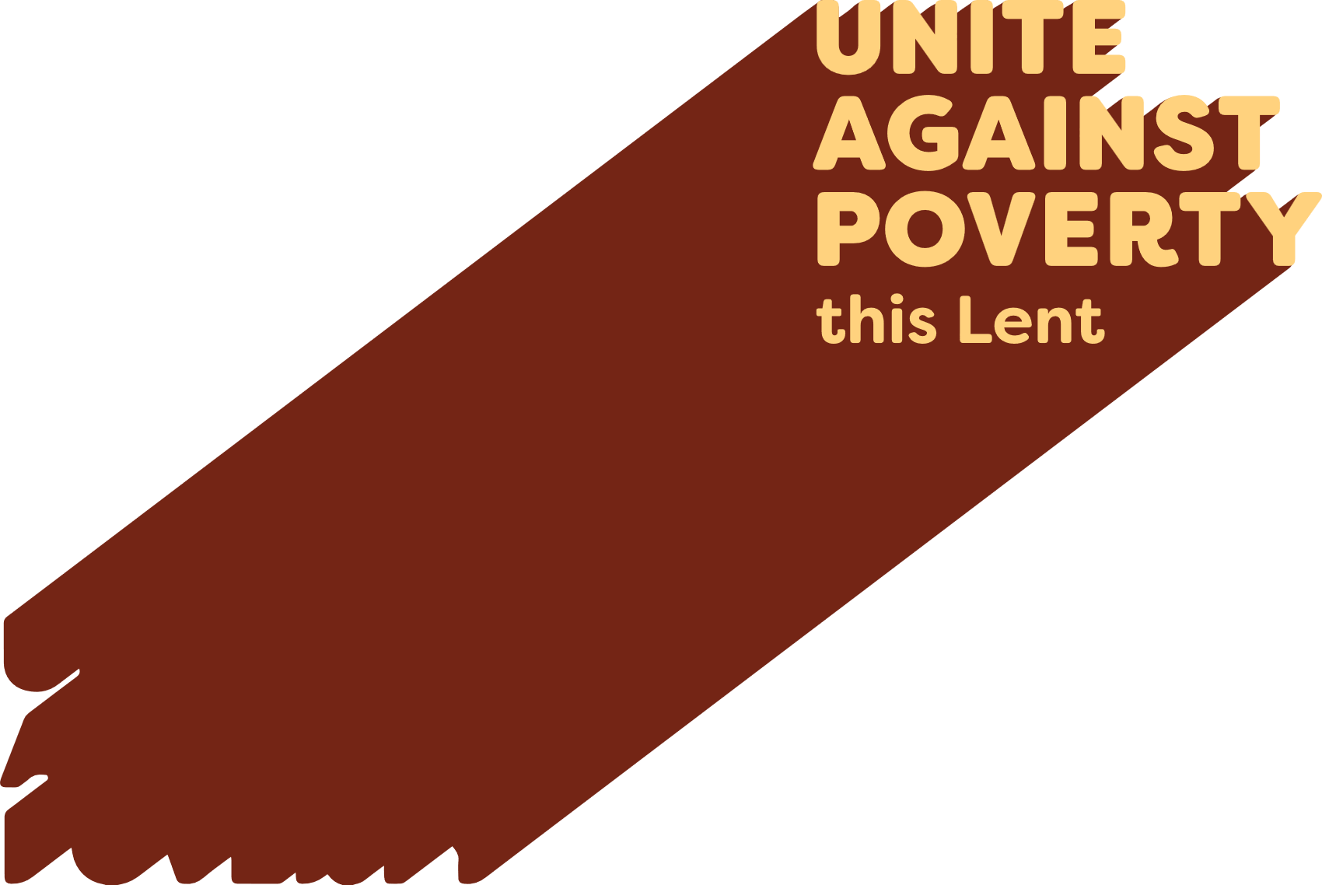

Lenten Weekly Reflection
Written by Michael McGirr
projectcompassion.org.au
First Sunday of Lent
Genesis 2:7-9; 3:1-7 | Ps 51:3-4, 5-6, 12-13, 17. R. v.3 | Romans 5:12-19 | Matthew 4:1-11
Nelson Mandela said that education was the most powerful weapon we can use to change the world. There are plenty of people who would agree with him. One of them is Oprah Winfrey who said that education was the way to move mountains, build bridges and, yes, to change the world.
Today’s readings certainly suggest the value of learning. The story from the Book of Genesis comes from pre-history. It has often been misunderstood to suggest that sin entered the world through one woman. This is not true. On the contrary, the readings tell us that the world is good. When humans try to overstretch their boundaries, trouble follows, and the experience of beauty and harmony is threatened. We need to choose our teachers. Are we going to listen to God or the serpent? In our modern world, the serpent takes many forms. There are countless threats to the harmony of the human race and the beauty of our natural environment.
Likewise, today’s story of the temptations in the wilderness from Matthew’s Gospel shows us that some lessons are difficult. Jesus teaches the devil. He tells the evil one that God is in charge. Jesus must decide which voices he will follow. He must learn that some ideas may not be as good as they sound. All the kingdoms of the world, Jesus learns, are no substitute for an honest and life-giving relationship with God.
Each week during Lent, Caritas Australia asks us to think about the world and learn more about our role in building God’s kingdom. Today we start with an introduction to Project Compassion, which allows us to appreciate how much the Catholic community, has been able to achieve across the decades for the most marginalised people of the world. We are all still learning. Pope Leo XIV has reminded us that the vulnerable are great teachers.
In Dilexi Te he writes:
Christians must not abandon almsgiving… It is always better at least to do something rather than nothing. Whatever form it may take, almsgiving will touch and soften our hardened hearts… for our part, we need to give alms as a way of reaching out and touching the suffering flesh of the poor.
The evil spirit will always focus on the negative and convince us that change is too difficult. The spirit of grace and truth will show us what is truly possible and help us sort our priorities.
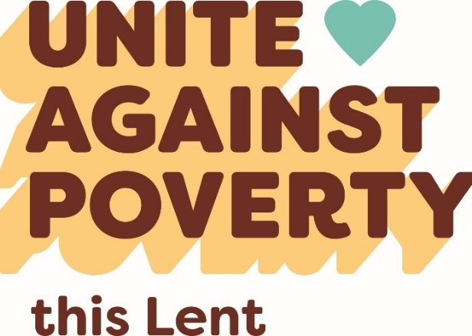
Prayer of Intercession

For those experiencing poverty and marginalisation, that our support for Project Compassion during Lent will be a sign to them of the love of God for all people.

