
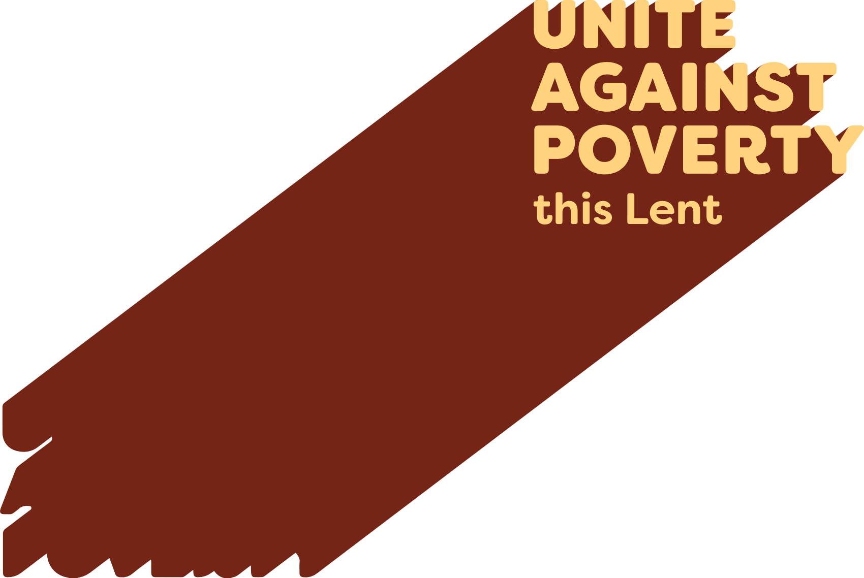

Lenten Weekly Reflection
Written by Michael McGirr
projectcompassion.org.au
Palm Sunday
Isaiah 50: 4–7 | Ps 22: 8–9, 17–18, 19–20, 23–24 | Philippians 2: 6-11 | Matthew 26:14-27:66
It is only once in every three years that we publicly share together Matthew’s full account of the arrest, trial and death of Jesus. Today is that day. Matthew’s passion is rich in every sense of the word. It is the longest account of what Jesus endured, and it also has the most diverse cast of characters. Only Matthew devotes attention, not only to the tragic fate of Judas who was filled with remorse, but also to the thirty pieces of silver which were used to buy a cemetery for foreigners called the Field of Blood. Only Matthew tells us about the dream of Pilate’s wife which leads her to send a message to her husband that he should have nothing to do with Jesus. Matthew’s Gospel features several dreams. Joseph is told in a dream to take Mary as his wife, to flee with his family to Egypt and later to return from Egypt. Dreams are one of the many links between Matthew’s Gospel and the Hebrew scriptures.
This is by no means to say that Matthew’s Gospel is merely an interesting piece of literature. It is only to suggest that, in Holy Week, Matthew’s Passion is a wonderful encounter to enter slowly as we spend time with the Lord, allowing the mystery of the cross to deepen within us. One commitment we might make is to take a section each day this week and stay with it for ten minutes:
Monday Mt 26: 14-35
Tuesday Mt 26: 36-56
Wed Mt 26: 57-75
Thursday Mt 27: 1-26
Friday Mt 27: 27-56
Saturday: Mt 27: 57-66
The trial and death of Jesus reminds us of the tragedy of injustice that continues to this day in so many places around the world. Throughout Lent, Caritas Australia, through Project Compassion, has attempted to draw our attention to many important issues in our world. We have been invited to take up the cross and follow Jesus in our own time as we Unite Against Poverty. We can pray, with Jesus, ‘Let it be as you, not I, would have it.’ God’s desire is for peace, healing and unity in the face of all the challenges facing humanity. Let us help Jesus carry the cross in our time.
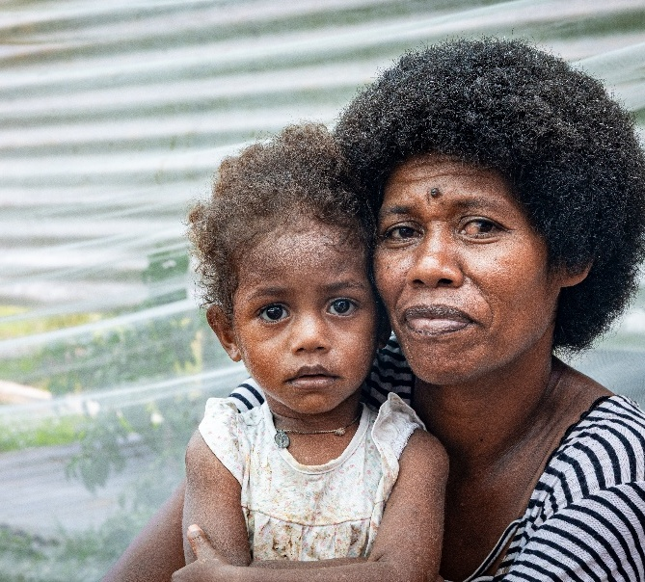
Prayer of Intercession

For all who suffer injustice as Jesus did and for those who take up the cross to follow Jesus. May our work to end injustice bring peace, healing and unity in the face of all the challenges facing humanity.

Photo: Manaini with her granddaughter in their garden in a small village in Fiji. Credit: Caritas Australia.

