
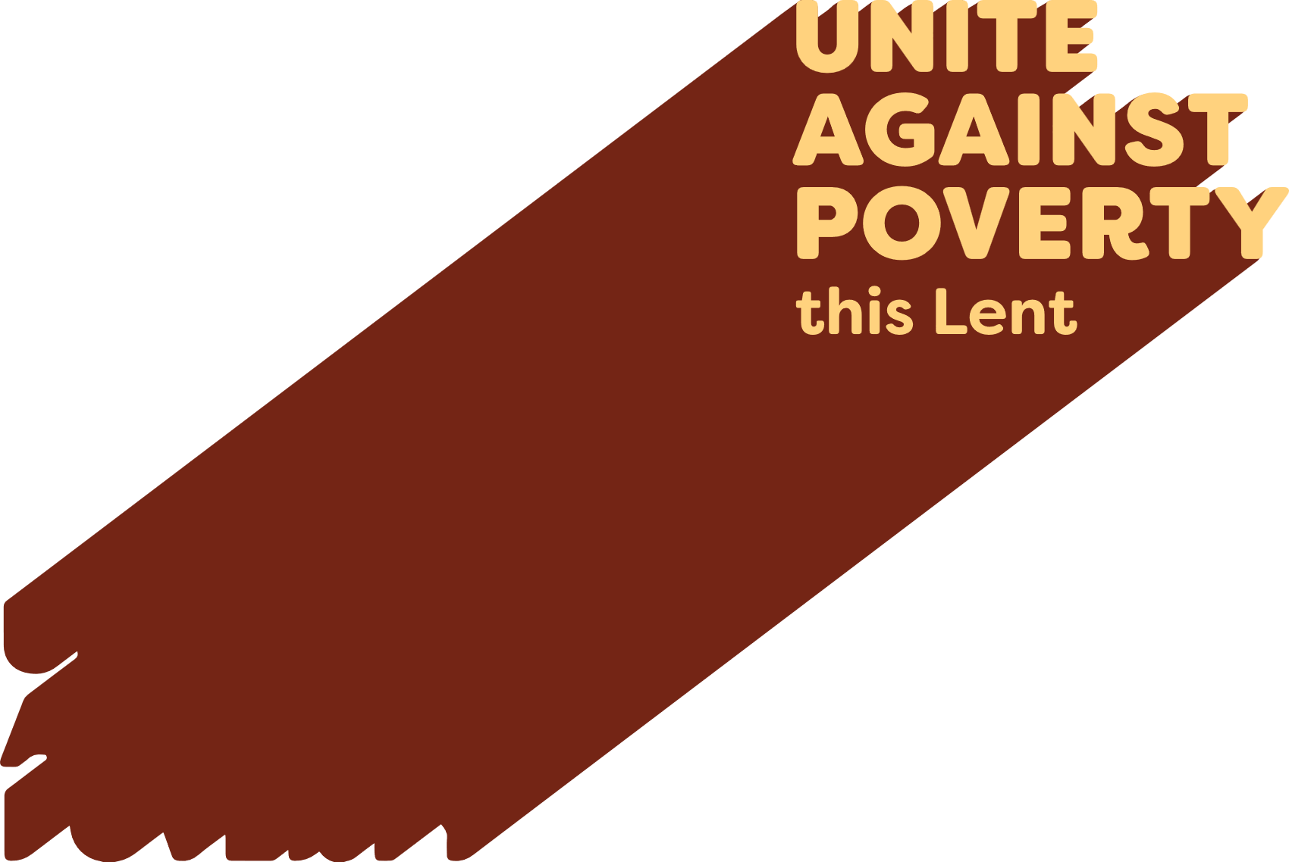

Lenten Weekly Reflection
Written by Michael McGirr
projectcompassion.org.au
Second Sunday of Lent
Genesis 12:1-4 | Ps 33:4-5, 18-19, 20, 22. R. v.22 | 2Timothy 1:8-10 | Matthew 17:1-9
We all need a vision. Long ago, the Book of Proverbs told us that ‘where there is no vision, the people perish.’ When we look at the world around us, with so many wars, so much violence, such widespread hardship and numerous groups of people putting up walls against each other, we might wonder where the real leaders are to be found. On the world stage, Pope Leo XIV often seems like a lone voice for peace, justice and sanity. He points a direction based on his deep encounter with God.
Perhaps we find vision in the less well-known stories of ordinary people, some of whom we may know. This week, Project Compassion shares with us the story of young Sisilia who lives in a remote part of northern Tanzania. Her father died when she was young, and her family has faced enormous difficulty. ‘Life is hard,’ she says as an understatement. Your help has enabled her village to gain access to a reliable supply of safe water. What has this got to do with education? The time that Sisilia spent walking three times a day for water was having a major impact on her schooling. She now has a vision for life, one she shares with her community.
In today’s readings, we hear about vision. In the book of Genesis, Abram leaves his country, his family and his father’s house. He may not know quite what will happen, but he puts his faith in a call that will lead to life and abundance. He does not have a map, but he does have a vision.
We hear in the Gospel that Jesus took his closest friends to the top of a high mountain. His face shone like the sun and became ‘as white as the light.’ A voice from heaven said, ‘this is my beloved son; listen to him.’ Peter said how wonderful it was to be there, and he wanted to build a tent so they could stay. But vision is always on the move and Jesus knew that he and his friends had a hard road ahead. The transfiguration may have only lasted a few minutes, but it was clear that Jesus’ friends never forgot it. Every year, we hear this story near the start of Lent because we, too, need to be inspired.
During Lent, we are also called to transfigure the world, to make a difference by uniting against poverty.
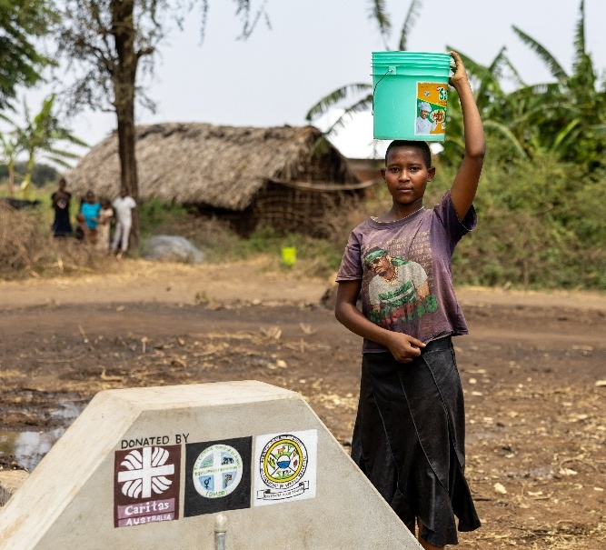

Prayer of Intercession

For all people who lack access to safe and reliable water, that they will be able to receive this basic necessity of life as a result of generous support for the Project Compassion campaign.

Photo: Sisilia collecting water from a new water tap that has been constructed in her village. Credit: Caritas Australia.

