

Project Compassion 2026

Parish Bulletin Notices

Throughout Lent, we kindly encourage parishes to promote Caritas Australia’s Project Compassion by sharing weekly bulletin notices with your parishioners and sharing content on your social media platforms to amplify the message of our Lenten appeal.
Need additional resources such as logos, high-resolution photos, or more details?
Please email us at - projectcompassion@caritas.org.au

Important Note:
The QR codes in the bulletin notices link to the Caritas Australia website for direct donations to Project Compassion.
If you’d like to track donations from your parish, you can create an online fundraising page. This will give you a unique QR code for your parish (to replace the ones provided) and allow you to monitor contributions from your community.
To learn more and register your parish page, visit:
https://www.projectcompassion.org.au/parish

*Please note: Photos provided are strictly for use in connection with Caritas Australia’s Project Compassion 2026 campaign.
Photo credits:
- Sisilia’s Story - Tanzania – Caritas Australia
- Monoranjon’s Story – Bangladesh - Caritas Australia
- Manaini’s Story – Fiji - Caritas Australia
- Ahmad’s Story – Gaza - Caritas Jerusalem

Video Links:
- 2nd Weekend of Lent (28 Feb -1 March) - Sisilia’s Story: https://vimeo.com/1128088709
- 3rd Weekend of Lent (7-8 March)- Monoranjon’s Story: https://vimeo.com/1128089124
- 4th Weekend of Lent (14-15 March) - Manaini’s Story: https://vimeo.com/1128089408
- 5th Weekend of Lent (21-22 March) - Ahmad’s Story: https://vimeo.com/1127713885

Bulletin for Weeks Prior to Project Compassion starting:


Project Compassion Donation Envelopes:
How do I use them?

This Lent, like we did in 2025, there is a single Project Compassion donation envelope – rather than the six weekly envelopes used in previous years. This change was made to reduce waste and support our shared commitment to caring for our common home.
You can still give weekly by taking several envelopes at once or simply make your offering when you're ready. Thank you for Uniting Against Poverty with us this Lent.



Project Compassion Sunday

Project Compassion Sunday
14–15 of February 2026

This Lent, we are called to Unite Against Poverty through Caritas Australia’s Project Compassion.
Your generosity this Lenten Season will enable Caritas Australia to provide life-changing support to vulnerable communities in need.
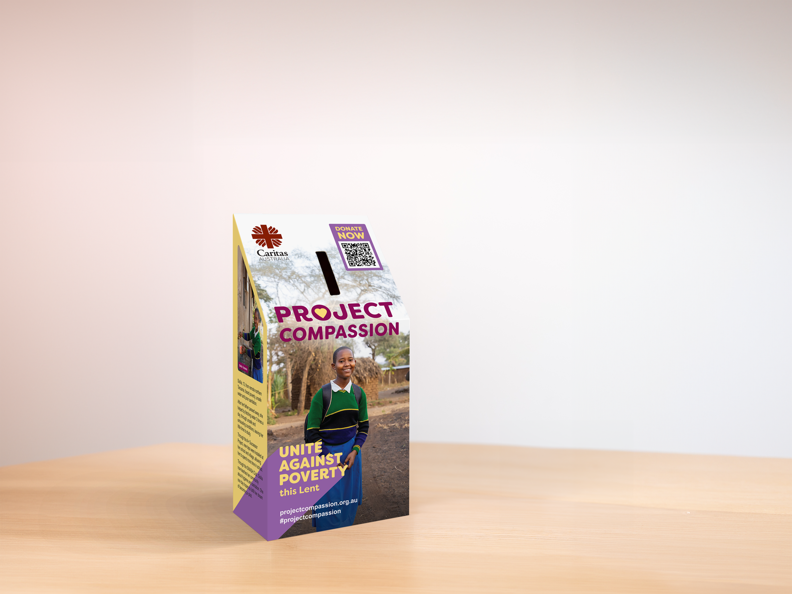
Please donate today.
You can support Project Compassion 2026 through the donation boxes, envelopes or by scanning the QR code.
Or online at: www.projectcompassion.org.au/donate
Or by calling: 1800 024 413
Thank you for standing with us, as we Unite Against Poverty this Lent.

