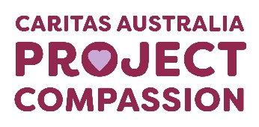
Project Compassion 2026

Parish Bulletin Notices

Throughout Lent, we kindly encourage parishes to promote Caritas Australia’s Project Compassion by sharing weekly bulletin notices with your parishioners and sharing content on your social media platforms to amplify the message of our Lenten appeal.
Need additional resources such as logos, high-resolution photos, or more details?
Please email us at - projectcompassion@caritas.org.au

Important Note:
The QR codes in the bulletin notices link to the Caritas Australia website for direct donations to Project Compassion.
If you’d like to track donations from your parish, you can create an online fundraising page. This will give you a unique QR code for your parish (to replace the ones provided) and allow you to monitor contributions from your community.
To learn more and register your parish page, visit:
https://www.projectcompassion.org.au/parish

*Please note: Photos provided are strictly for use in connection with Caritas Australia’s Project Compassion 2026 campaign.
Photo credits:
- Sisilia’s Story - Tanzania – Caritas Australia
- Monoranjon’s Story – Bangladesh - Caritas Australia
- Manaini’s Story – Fiji - Caritas Australia
- Ahmad’s Story – Gaza - Caritas Jerusalem

Video Links:
- 2nd Weekend of Lent (28 Feb -1 March) - Sisilia’s Story: https://vimeo.com/1128088709
- 3rd Weekend of Lent (7-8 March)- Monoranjon’s Story: https://vimeo.com/1128089124
- 4th Weekend of Lent (14-15 March) - Manaini’s Story: https://vimeo.com/1128089408
- 5th Weekend of Lent (21-22 March) - Ahmad’s Story: https://vimeo.com/1127713885

Third Week of Lent

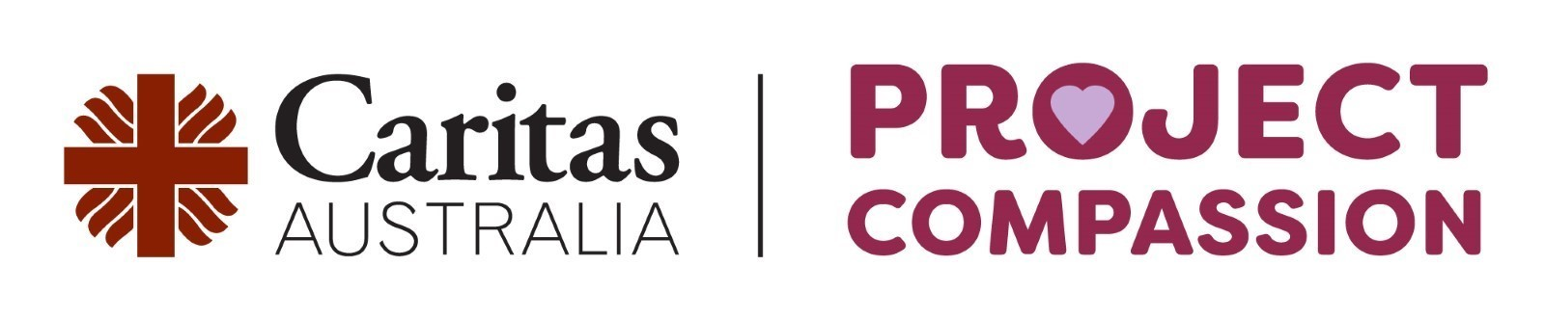
Third Sunday of Lent
7–8 March 2026

Monoranjon lives in a village in Bangladesh close to the sea, where floods and storms often damage his crops and his home. With support from Project Compassion, he learnt climate-resilient farming techniques and new ways to diversify his income, helping his family survive and build a safer, more sustainable future.
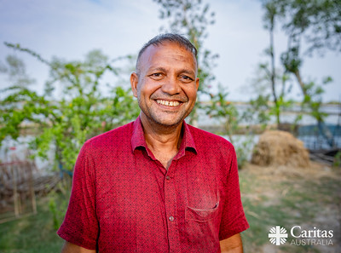
Please donate today.
You can support Project Compassion 2026 through the donation boxes, envelopes or by scanning the QR code.
Or online at: www.projectcompassion.org.au/donate
Or by calling: 1800 024 413
Thank you for standing with us, as we Unite Against Poverty this Lent.



THIRD SUNDAY of LENT – 8 March
MONORANJON from BANGLADESH
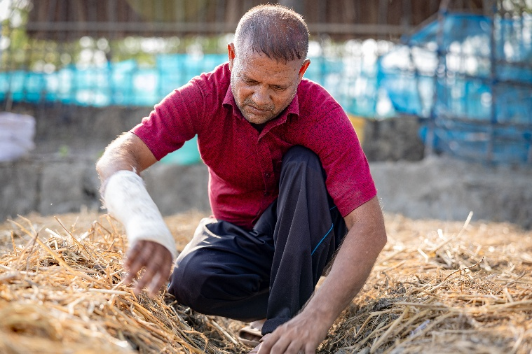
Monoranjon, 47, lives in a coastal village in southwest Bangladesh, one of the regions most affected by climate change. He and his family face extreme heat, cyclones, water scarcity, and rising salinity that is destroying crops and livelihoods. As a farmer and father of two, Monoranjon struggled to provide for his family and keep his daughter and son in school.
“In this dry season no seedlings come out from seeds. Due to heat of the sun and lack of water, plants are dying,” Monoranjon said.
Monoranjon working on his farm in southwest Bangladesh. Photo: Caritas Australia.
Thanks to support from Caritas Australia and its partner Caritas Bangladesh, Monoranjon joined the Community Managed Sustainable Livelihoods and Resilience Program. He learned climate-resilient farming techniques, including organic vegetable cultivation, livestock vaccination, crab fattening, and salt-tolerant crop production. His income has improved, allowing him to send his children to school and access better nutrition. Monoranjon now teaches others in his village, inspiring change and resilience across the community.
‘Doing this I maintain my livelihood, but we have to work very hard. Seeing me, many people started. This is how they grow vegetables,’ Monoranjon said.
Monoranjon also works with his community to plant mangrove seedlings on the mudflat coastlines across the delta they live on, to prevent further erosion and flooding of their lands.
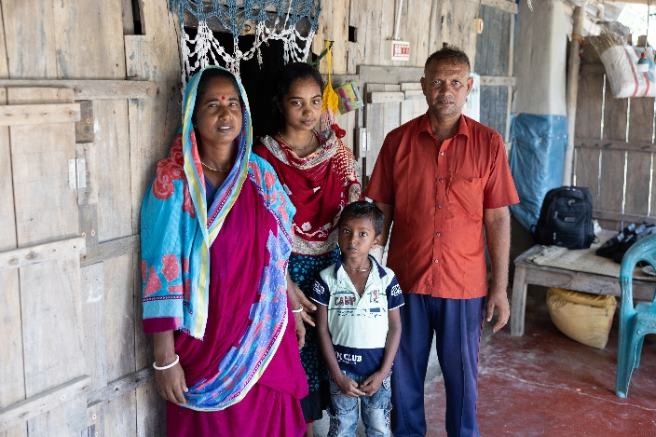
Despite these improvements, the region remains at grave risk. With the looming threat of increased strength and frequency of cyclones, rapid sea level rise, dangerously high temperatures and drought, more people like Monoranjon desperately need an increase in support, so they can continue to provide a future of education for their children, and a way out of poverty.
Along with your generous support, this project is supported by the Australian Government through the Australian NGO Cooperation Program (ANCP).
Monoranjon with his wife Anita, daughter Sushmita and son Chandon outside their home in southwest Bangladesh. Photo: Caritas Australia.
REFLECTION for THIRD SUNDAY of LENT Exodus17:3-7 | Ps 95:1-2, 6-7. 8-9. R. v.8 | Romans 5:1-2, 5-8 | John 4:5-42
Every summer seems to get a little longer and a little hotter. We have all become conscious of issues surrounding water. Either there seems to be too much, as when we see summer floods or rising sea levels in the Pacific. Other times, there seems to be too little water as when the rivers in our country run low or members of God’s family around the world experience drought. Caritas Australia, through Project Compassion, has been responding to the dire needs of water justice in a range of vulnerable countries.
Today’s readings may well cause us to reflect on the current state of God’s creation. In the book of Exodus, we hear that people are complaining to Moses because they are dying of thirst. In the Gospel, Jesus meets a woman in a Samaritan town. She has come to draw water from the well in the hottest part of the day. In both cases, access to water is precarious. Yet God responds not only to a thirst for water but to a deeper thirst as well. Moses’ people are thirsty for direction, leadership and hope. The woman in John’s Gospel has a thirst for love and acceptance which, Jesus tells her, will come from within if she is able to accept him and his message of life. As the story unfolds, we learn of her loneliness and see her reconnecting with her community.
In reflecting on this story in Listening Together, Cardinal Radcliffe reminds us that Jesus’ first words are abrupt. ‘Give me a drink.’ He considers the times in John’s Gospel when Jesus expresses thirst, including when he is on the cross. Radcliffe concludes that Jesus is thirsty on our behalf. He longs for our freedom.
Thirst is a great spiritual metaphor, one which Pope Leo XIV has used. But let’s not forget the millions of people for whom physical water is a real challenge. This week, Project Compassion shares with us the story of Monoranjon, a farmer in Bangladesh whose family has been deeply impacted by environmental damage, specifically salination of soil and water. This beautiful story reminds us of the importance of meeting people, as Jesus did, at their place of greatest need.
Our thirst for freedom and justice enables us to Unite Against Poverty.

Register your parish for online fundraising at
https://projectcompassion.org.au/parish
and then download your unique QR code to replace this box.
