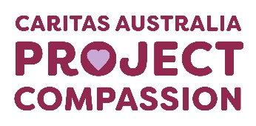
Project Compassion 2026

Parish Bulletin Notices

Throughout Lent, we kindly encourage parishes to promote Caritas Australia’s Project Compassion by sharing weekly bulletin notices with your parishioners and sharing content on your social media platforms to amplify the message of our Lenten appeal.
Need additional resources such as logos, high-resolution photos, or more details?
Please email us at - projectcompassion@caritas.org.au

Important Note:
The QR codes in the bulletin notices link to the Caritas Australia website for direct donations to Project Compassion.
If you’d like to track donations from your parish, you can create an online fundraising page. This will give you a unique QR code for your parish (to replace the ones provided) and allow you to monitor contributions from your community.
To learn more and register your parish page, visit:
https://www.projectcompassion.org.au/parish

*Please note: Photos provided are strictly for use in connection with Caritas Australia’s Project Compassion 2026 campaign.
Photo credits:
- Sisilia’s Story - Tanzania – Caritas Australia
- Monoranjon’s Story – Bangladesh - Caritas Australia
- Manaini’s Story – Fiji - Caritas Australia
- Ahmad’s Story – Gaza - Caritas Jerusalem

Video Links:
- 2nd Weekend of Lent (28 Feb -1 March) - Sisilia’s Story: https://vimeo.com/1128088709
- 3rd Weekend of Lent (7-8 March)- Monoranjon’s Story: https://vimeo.com/1128089124
- 4th Weekend of Lent (14-15 March) - Manaini’s Story: https://vimeo.com/1128089408
- 5th Weekend of Lent (21-22 March) - Ahmad’s Story: https://vimeo.com/1127713885

Second Week of Lent


Second Sunday of Lent
28 February – 1 March 2026

Sisilia is a 13-year-old girl living in remote Tanzania, who had to walk long distances to collect water every day. Thanks to Project Compassion, Sisilia’s school and village now have safe clean water close by and she can spend more time studying so she can fulfil her dream of one day becoming a pilot.
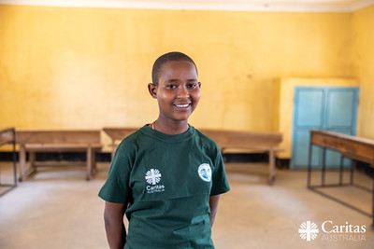
Please donate today.
You can support Project Compassion 2026 through the donation boxes, envelopes or by scanning the QR code.
Or online at: www.projectcompassion.org.au/donate
Or by calling: 1800 024 413
Thank you for standing with us, as we Unite Against Poverty this Lent.



SECOND SUNDAY of LENT – 1 March
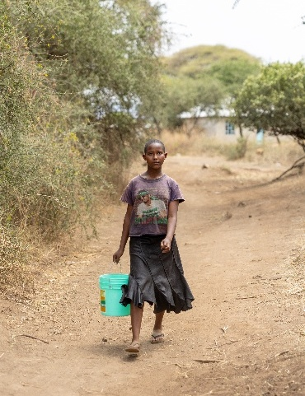
SISILIA from TANZANIA
Sisilia, aged 13, lives with her mother and siblings in a remote village in northern Tanzania. Life has been difficult since her father passed away when she was a baby.
“My mother does small farming and sometimes sells vegetables to get money. She supports the family on her own. We don’t have a regular income because my father passed away many years ago. Life is hard, but we try our best,” Sisilia said.
She had to walk up to 30 minutes, three times a day, to fetch water from a dirty canal. The water was unsafe, causing frequent illness, and the long walks left Sisilia exhausted, fearful of wild animals and struggling to focus on her studies.
Sisilia walked long distances to collect unclean water from a canal. Photo: Caritas Australia.
“I get very tired. Carrying heavy water containers every day after walking long distances is not easy. I was also getting piercing back pains. Sometimes I get home late and tired, and it’s hard to focus on my homework or revise for exams.” she said.
Lack of clean water is a major issue in Tanzania, where nearly 40% of people don’t have access to basic drinking water services and 75% don’t have access to basic sanitation services. (World Bank 2022).
With support from the A+ Successor Project, her school and village now have clean water taps. This means it takes Sisilia just two minutes to collect water from her house, reducing the risks she faced and giving her more time for learning. Access to safe water has also improved health, hygiene and nutrition for her school community. Teachers and students can drink clean water, maintain hygiene, and grow food in the school garden.
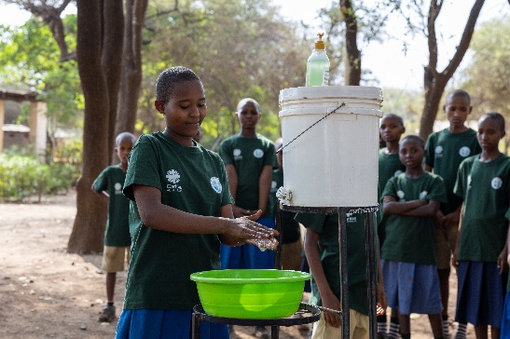
Sisilia has also joined a SWASH Club, where she learned about hygiene, sanitation, nutrition and child rights. She now confidently shares this knowledge with peers, parents and community members, even performing songs and demonstrations to promote good practices. This leadership has empowered her to advocate for children’s education and wellbeing in her community.
Despite many hardships, Sisilia remains determined to succeed. Her favourite subjects are Science, English and Maths, and she dreams of becoming a pilot.
Sisilia demonstrates how to wash her hands properly with soap. Photo: Caritas Australia.
With the support of Caritas Australia, local communities are finding ways to respond to challenges with resilience and courage. Your generosity makes it possible to stand with them on this journey.

REFLECTION for SECOND SUNDAY of LENT Genesis 12:1-4 | Ps 33:4-5, 18-19, 20, 22. R. v.22 | 2Timothy 1:8-10 | Matthew 17:1-9
We all need a vision. Long ago, the Book of Proverbs told us that ‘where there is no vision, the people perish.’ When we look at the world around us, with so many wars, so much violence, such widespread hardship and numerous groups of people putting up walls against each other, we might wonder where the real leaders are to be found. On the world stage, Pope Leo XIV often seems like a lone voice for peace, justice and sanity. He points a direction based on his deep encounter with God.
Perhaps we find vision in the less well-known stories of ordinary people, some of whom we may know. This week, Project Compassion shares with us the story of young Sisilia who lives in a remote part of northern Tanzania. Her father died when she was young, and her family has faced enormous difficulty. ‘Life is hard,’ she says as an understatement. Your help has enabled her village to gain access to a reliable supply of safe water. What has this got to do with education? The time that Sisilia spent walking three times a day for water was having a major impact on her schooling. She now has a vision for life, one she shares with her community.
In today’s readings, we hear about vision. In the book of Genesis, Abram leaves his country, his family and his father’s house. He may not know quite what will happen, but he puts his faith in a call that will lead to life and abundance. He does not have a map, but he does have a vision.
We hear in the Gospel that Jesus took his closest friends to the top of a high mountain. His face shone like the sun and became ‘as white as the light.’ A voice from heaven said, ‘this is my beloved son; listen to him.’ Peter said how wonderful it was to be there, and he wanted to build a tent so they could stay. But vision is always on the move and Jesus knew that he and his friends had a hard road ahead. The transfiguration may have only lasted a few minutes, but it was clear that Jesus’ friends never forgot it. Every year, we hear this story near the start of Lent because we, too, need to be inspired.
During Lent, we are also called to transfigure the world, to make a difference by uniting against poverty.

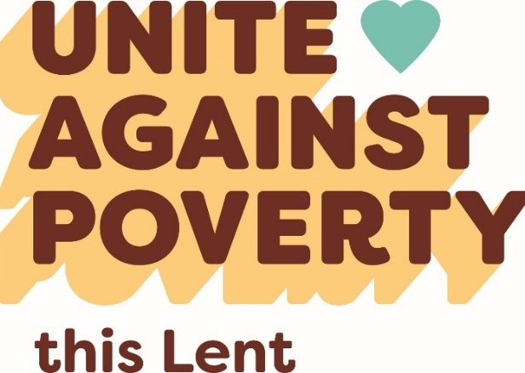
Register your parish for online fundraising at
https://projectcompassion.org.au/parish
and then download your unique QR code to replace this box.

