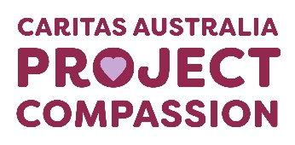
Project Compassion 2026

Parish Bulletin Notices

Throughout Lent, we kindly encourage parishes to promote Caritas Australia’s Project Compassion by sharing weekly bulletin notices with your parishioners and sharing content on your social media platforms to amplify the message of our Lenten appeal.
Need additional resources such as logos, high-resolution photos, or more details?
Please email us at - projectcompassion@caritas.org.au

Important Note:
The QR codes in the bulletin notices link to the Caritas Australia website for direct donations to Project Compassion.
If you’d like to track donations from your parish, you can create an online fundraising page. This will give you a unique QR code for your parish (to replace the ones provided) and allow you to monitor contributions from your community.
To learn more and register your parish page, visit:
https://www.projectcompassion.org.au/parish

*Please note: Photos provided are strictly for use in connection with Caritas Australia’s Project Compassion 2026 campaign.
Photo credits:
- Sisilia’s Story - Tanzania – Caritas Australia
- Monoranjon’s Story – Bangladesh - Caritas Australia
- Manaini’s Story – Fiji - Caritas Australia
- Ahmad’s Story – Gaza - Caritas Jerusalem

Video Links:
- 2nd Weekend of Lent (28 Feb -1 March) - Sisilia’s Story: https://vimeo.com/1128088709
- 3rd Weekend of Lent (7-8 March)- Monoranjon’s Story: https://vimeo.com/1128089124
- 4th Weekend of Lent (14-15 March) - Manaini’s Story: https://vimeo.com/1128089408
- 5th Weekend of Lent (21-22 March) - Ahmad’s Story: https://vimeo.com/1127713885

First Week of Lent

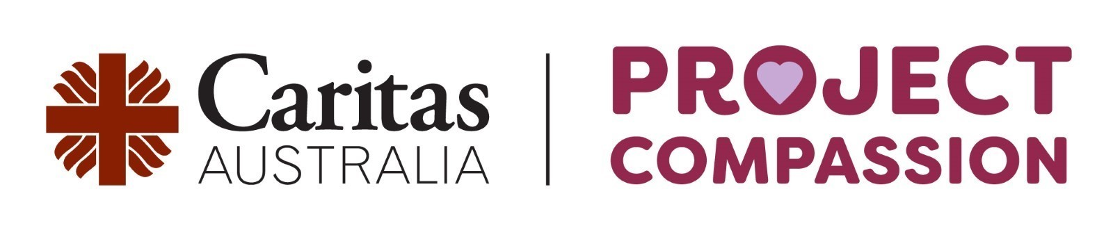
First Sunday of Lent
21–22 February 2026

Project Compassion 2026 shares four stories from around the world. We’ll meet Sisilia from Tanzania, Monoranjon from Bangladesh, Manaini from Fiji and Ahmad from Gaza.
Each of this year’s stories highlights unique challenges, yet they are united by the determination to rise above adversity and to build brighter, more hopeful futures for themselves, their families and their communities.
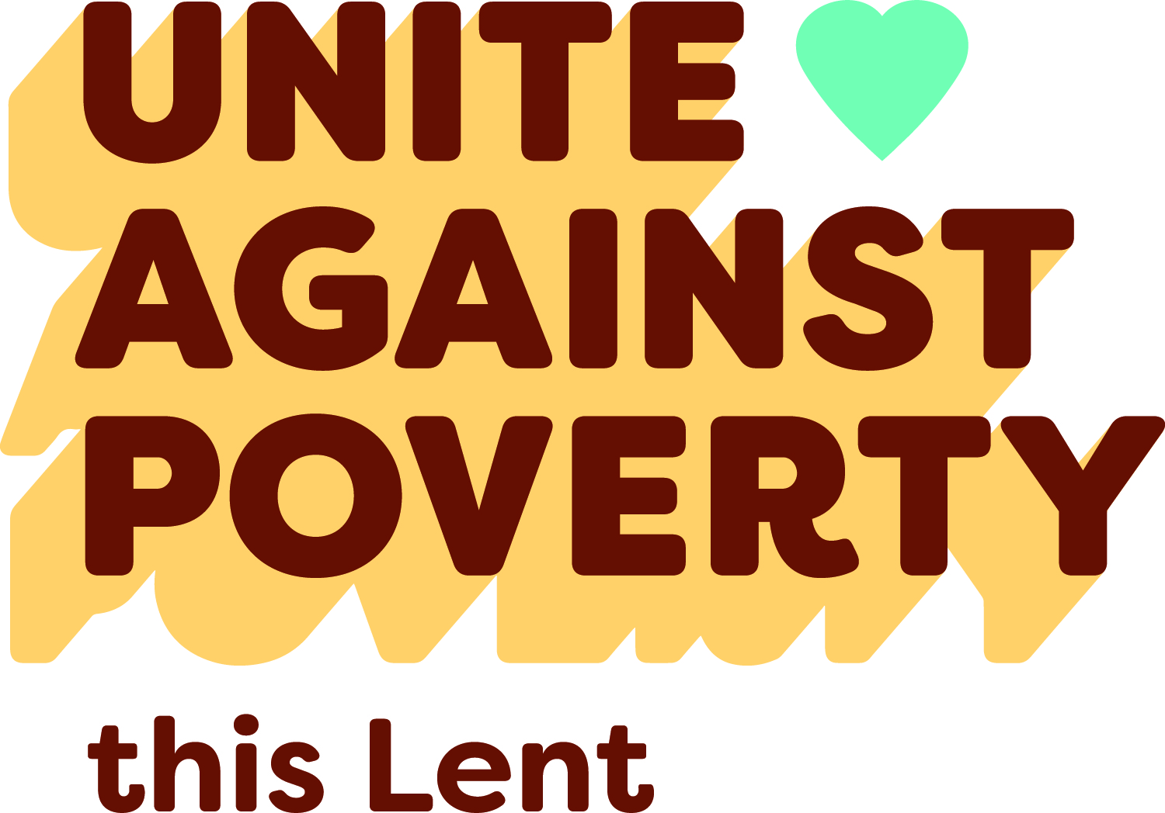
Please donate today.
You can support Project Compassion 2026 through the donation boxes, envelopes or by scanning the QR code.
Or online at: www.projectcompassion.org.au/donate
Or by calling: 1800 024 413
Thank you for standing with us, as we Unite Against Poverty this Lent.



FIRST SUNDAY of LENT – 22 February
This Lent, our parish community is called to Unite Against Poverty with Caritas Australia’s Project Compassion. Each year, Project Compassion invites us to encounter stories of courage and hope from people around the world who are striving for a brighter future.
In 2026, Project Compassion shares four stories of resilience and strength. We’ll meet Sisilia, a young student from Tanzania, whose education was being disrupted by long daily walks to collect water for her family. With the support of Caritas Australia and people like you, Sisilia now has access to clean water from taps installed in her school and village.
We’ll get to know Monoranjon from Bangladesh, where communities are heavily impacted by natural disasters and climate change. Caritas Australia, together with supporters across Australia, has helped Monoranjon to learn climate-resilient farming skills.
We’ll be introduced to Manaini from Fiji, who struggled with poverty and food insecurity. With support, she gained training in food processing and gardening, improving nutrition and creating income to support her children’s education.
And we’ll hear the story of Ahmad, a Caritas Jerusalem worker from Gaza who was displaced many times due to ongoing conflict. Despite this hardship, he continues to serve families in need through Caritas’ emergency response.
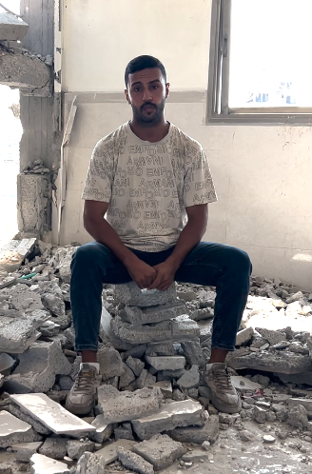
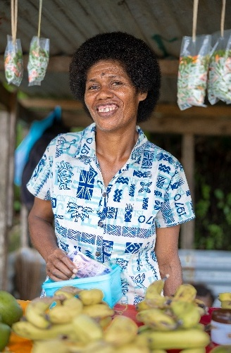
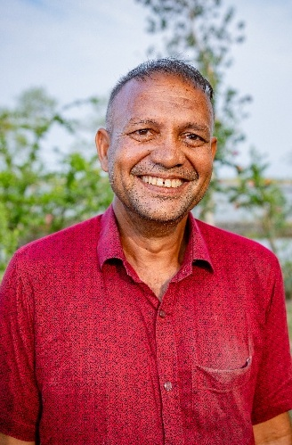
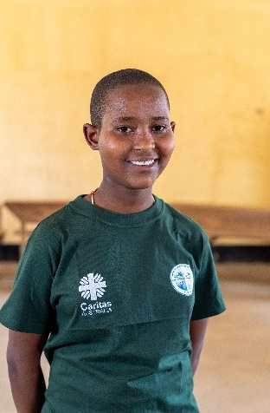
Sisilia (13) smiles as she stands in the middle of her classroom. Photo: Caritas Australia; Monoranjon lives in a region in southwest Bangladesh that is highly vulnerable to the effects of climate change. Photo: Caritas Australia; Manaini sells fresh fruits and vegetables that she and her community have grown and packaged on their farms, by the roadside in a small village in Fiji. Photo: Caritas Australia; Ahmad, a Caritas Jerusalem staff member in Gaza, sits in the ruins of a building. Photo: Caritas Jerusalem.

REFLECTION for FIRST SUNDAY of LENT Genesis 2:7-9; 3:1-7 | Ps 51:3-4, 5-6, 12-13, 17. R. v.3 | Romans 5:12-19 | Matthew 4:1-11
Nelson Mandela said that education was the most powerful weapon we can use to change the world. There are plenty of people who would agree with him. One of them is Oprah Winfrey who said that education was the way to move mountains, build bridges and, yes, to change the world.
Today’s readings certainly suggest the value of learning. The story from the Book of Genesis comes from pre-history. It has often been misunderstood to suggest that sin entered the world through one woman. This is not true. On the contrary, the readings tell us that the world is good. When humans try to overstretch their boundaries, trouble follows, and the experience of beauty and harmony is threatened. We need to choose our teachers. Are we going to listen to God or the serpent? In our modern world, the serpent takes many forms. There are countless threats to the harmony of the human race and the beauty of our natural environment.
Likewise, today’s story of the temptations in the wilderness from Matthew’s Gospel shows us that some lessons are difficult. Jesus teaches the devil. He tells the evil one that God is in charge. Jesus must decide which voices he will follow. He must learn that some ideas may not be as good as they sound. All the kingdoms of the world, Jesus learns, are no substitute for an honest and life-giving relationship with God.
Each week during Lent, Caritas Australia asks us to think about the world and learn more about our role in building God’s kingdom. Today we start with an introduction to Project Compassion, which allows us to appreciate how much the Catholic community, has been able to achieve across the decades for the most marginalised people of the world. We are all still learning. Pope Leo XIV has reminded us that the vulnerable are great teachers.
In Dilexi Te he writes:
Christians must not abandon almsgiving… It is always better at least to do something rather than nothing. Whatever form it may take, almsgiving will touch and soften our hardened hearts… for our part, we need to give alms as a way of reaching out and touching the suffering flesh of the poor.
The evil spirit will always focus on the negative and convince us that change is too difficult. The spirit of grace and truth will show us what is truly possible and help us sort our priorities.
Our generous support this Lenten season will enable Caritas Australia to provide life changing support to vulnerable communities in need. You can support Project Compassion 2026 through the donation boxes, envelopes, or by scanning your parish’s QR code.
Register your parish for online fundraising at
https://projectcompassion.org.au/parish
and then download your unique QR code to replace this box.
