
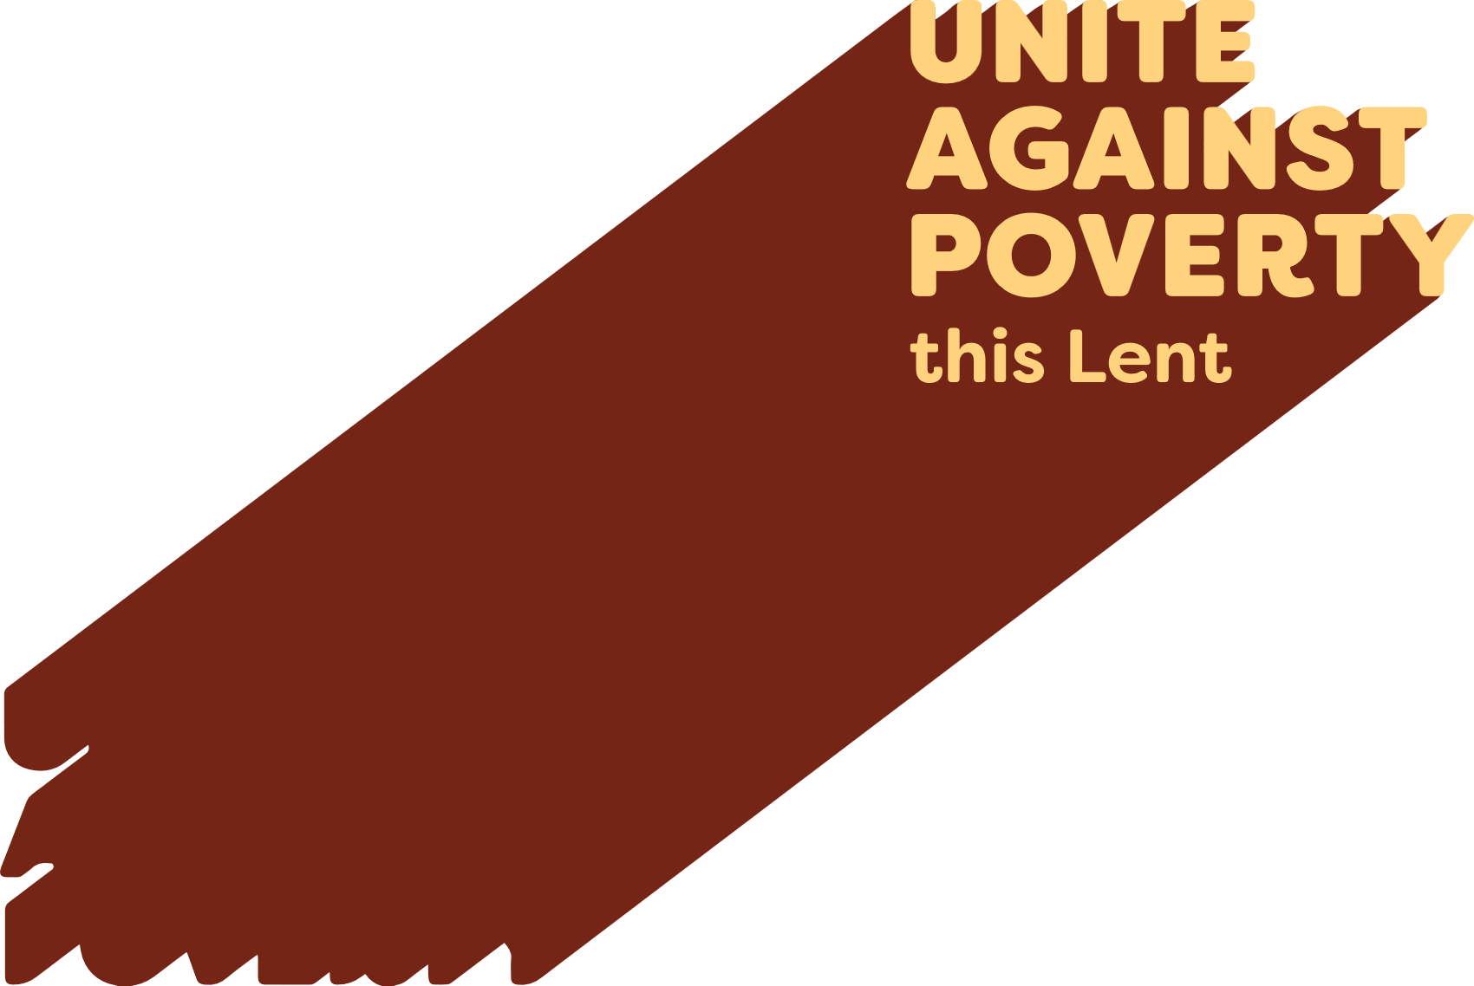

Lenten Weekly Reflection
Written by Michael McGirr
projectcompassion.org.au
Fourth Sunday of Lent
1Samuel 16:1, 6-7, 10-13 | Ps 23:1-3a, 3b-4, 5, 6. R. v.1 | Ephesians 5:8-14 | John 9:1-41
There are many occasions when we ask the question why and can’t find the answer for which we are looking. Why did we miss out on a job? Why did someone we love get cancer? Why can’t we find a place to live that we can afford? Why do some days seem so difficult?
It is good to sit with our confusion and even grief. It is good to share it with the Lord who loves us so tenderly. But sometimes we have to step aside from the question why did this happen? It may be better to start with where can I go from here? What small steps will enable me to face the future in a positive spirit?
Today’s readings touch upon these issues. In the Gospel, Jesus encounters a person who was born blind. The bystanders want to know why this happened. They think it must be because either he or his parents did something wrong. They are looking backwards. Jesus prefers to look forwards. He says, ‘he was born blind so that the works of God may be displayed in him.’ In other words, his blindness presents opportunities for growth, not a pretext for blame. The letter to the Ephesians similarly reminds us that we are on a journey from darkness to light. The whole of Lent could be described in those words. The letter says, ‘try to discover what the Lord wants of you.’ It asks us in terms of possibilities! The same thing happens when Samuel anoints David. It doesn’t matter that David is a young shepherd. He has a big future, as anyone familiar with the Bible well knows.
This week, Caritas Australia, through Project Compassion, draws us into the story of Manaini, a 44-year-old mother and subsistence farmer in remote northern Fiji. She has transformed her family’s life through food processing and organic farming, thanks to a Caritas-supported project. Once reliant on more store-bought food and prone to food waste, she now produces homemade flours, dried foods, and sells produce and baked goods from local crops. Her passion for learning has made her a key player in her community, working with others to embrace more sustainable, empowering ways of living. Thanks to the generosity of the Australian Catholic community, hundreds of thousands of people such as Manaini are finding an answer to the question, ‘where can we go from here.’
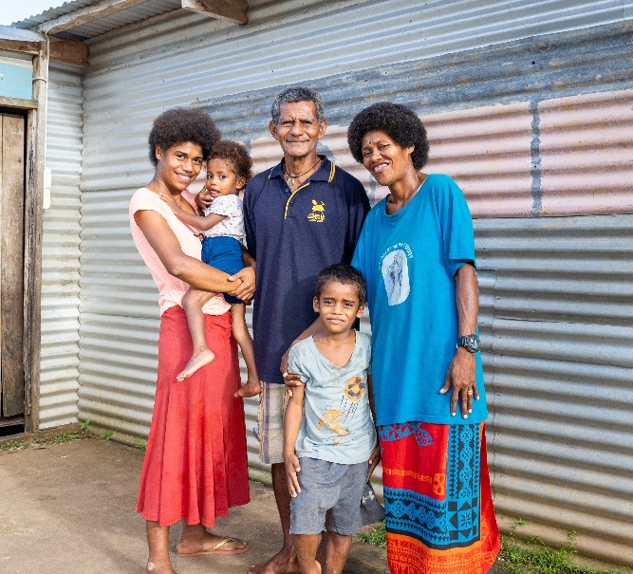
Prayer of Intercession

For all who lack the necessities of life, especially food security, that support for Project Compassion this Lent will enable Caritas to become a source of hope for them and for all those who hunger and thirst.

Photo: Manaini stands in front of her home with her husband (centre), daughter (left), granddaughter (left) and grandson (centre) in a small village in Fiji. Credit: Caritas Australia.

