
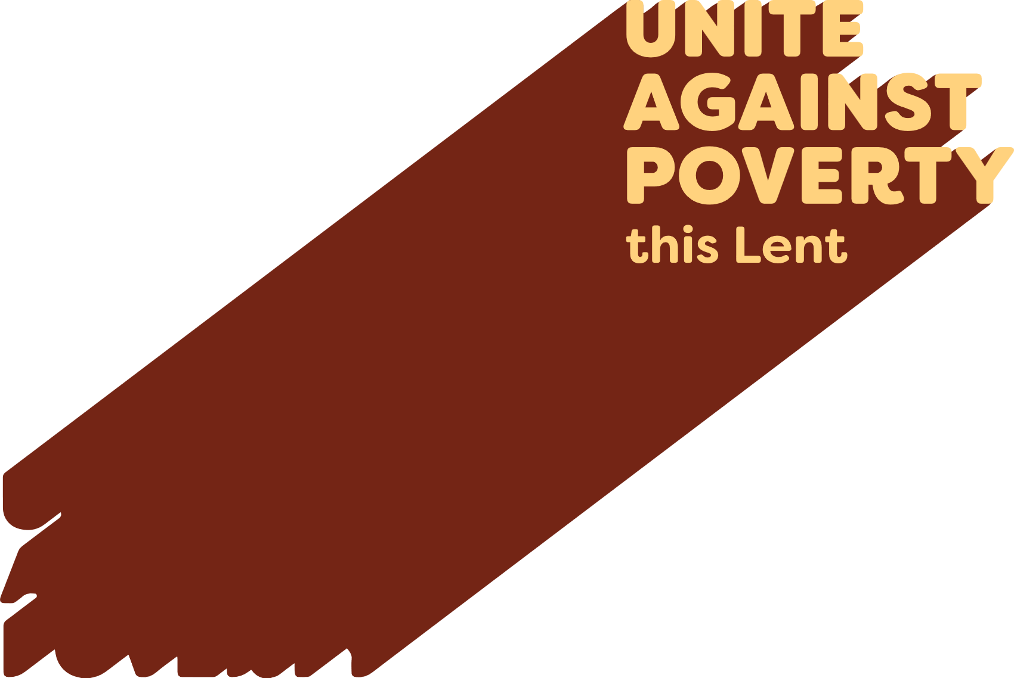

Lenten Weekly Reflection
Written by Michael McGirr
projectcompassion.org.au
Third Sunday of Lent
Exodus17:3-7 | Ps 95:1-2, 6-7. 8-9. R. v.8 | Romans 5:1-2, 5-8 | John 4:5-42
Every summer seems to get a little longer and a little hotter. We have all become conscious of issues surrounding water. Either there seems to be too much, as when we see summer floods or rising sea levels in the Pacific. Other times, there seems to be too little water as when the rivers in our country run low or members of God’s family around the world experience drought. Caritas Australia, through Project Compassion, has been responding to the dire needs of water justice in a range of vulnerable countries.
Today’s readings may well cause us to reflect on the current state of God’s creation. In the book of Exodus, we hear that people are complaining to Moses because they are dying of thirst. In the Gospel, Jesus meets a woman in a Samaritan town. She has come to draw water from the well in the hottest part of the day. In both cases, access to water is precarious. Yet God responds not only to a thirst for water but to a deeper thirst as well. Moses’ people are thirsty for direction, leadership and hope. The woman in John’s Gospel has a thirst for love and acceptance which, Jesus tells her, will come from within if she is able to accept him and his message of life. As the story unfolds, we learn of her loneliness and see her reconnecting with her community.
In reflecting on this story in Listening Together, Cardinal Radcliffe reminds us that Jesus’ first words are abrupt. ‘Give me a drink.’ He considers the times in John’s Gospel when Jesus expresses thirst, including when he is on the cross. Radcliffe concludes that Jesus is thirsty on our behalf. He longs for our freedom.
Thirst is a great spiritual metaphor, one which Pope Leo XIV has used. But let’s not forget the millions of people for whom physical water is a real challenge. This week, Project Compassion shares with us the story of Monoranjon, a farmer in Bangladesh whose family has been deeply impacted by environmental damage, specifically salination of soil and water. This beautiful story reminds us of the importance of meeting people, as Jesus did, at their place of greatest need.
Our thirst for freedom and justice enables us to Unite Against Poverty.
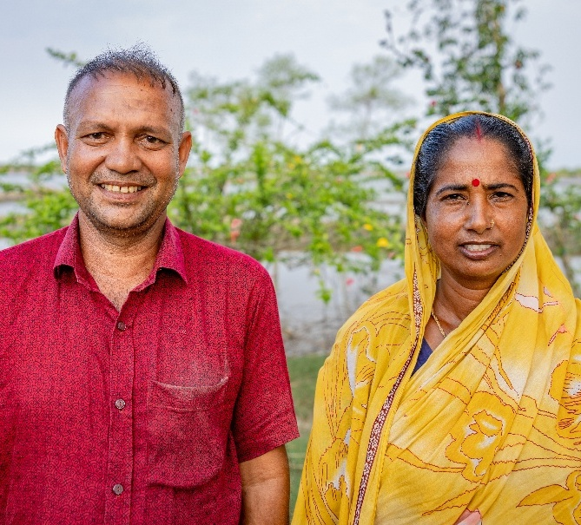

Prayer of Intercession
For vulnerable communities who thirst for justice and security, that our support for Project Compassion will be a sign to them of the love of God for all people.

Photo: Monoranjon and his wife, Anita, live in a village in southwest Bangladesh that is highly vulnerable to climate change. Credit: Caritas Australia.

