

**WEEKLY REFLECTIONS**

**ASH WEDNESDAY**

**Joel 2:12-18 | 2 Cor 5:20-6:2 | Matthew 6:1-6, 16-18**

*Now* is a wonderful word. It can also be challenging. Last year, during the lockdown when many people were working from home, there were jokes about the ‘four horsemen of procrastination.’ These were snacks, napping, social media and minor chores. Supposedly, they were time fillers that stopped us doing what we needed to do.

Lent begins with a great sense of *now*. It is a season of opportunity; it even has a flavour of urgency. Today, Ash Wednesday, we hear St Paul say that ‘now is the favourable time’. The reading from the prophet Joel says, ‘Now, now, it is the Lord who speaks, come back to me with all your heart.’ Jesus tells us, when we pray, to go to our private room so that our experience of God is one of intimacy and true connection, not just of routine. There is no sense in which Jesus is suggesting this can wait until tomorrow.

Lent calls us to respond to God and to others *now*. During Lent, Project Compassion will present us with inspiring stories from Caritas Australia about real people entering into partnership with us in real ways. The theme for Project Compassion this year comes from one of the great *now* moments in the whole of scripture. After the flood has receded in the Book of Genesis, God puts a rainbow in the sky as a sign that the earth will never again suffer in such a way. God makes a covenant with the human family and the whole of creation ‘for all future generations.’ It is an expression of hope, something we might relate to after the unsettling experiences of the last two years. For some people, this will be the first Easter we can come together since 2019. The ashes we wear today are an invitation to rebuild from wherever we happen to be on life’s journey. The hope we share starts *now*.

Today’s Psalm includes the line ‘Give me again the joy of your help.’ We know that God will reach into our lives this Lent. We are called to reach into the lives of others so that they might know the joy of true partnership.

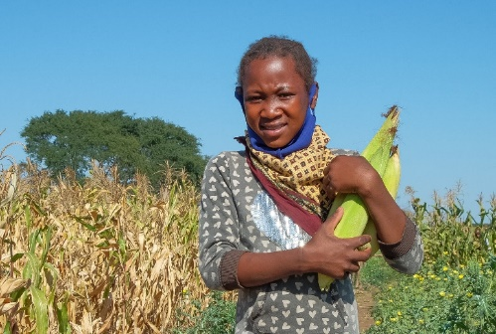

**Deut 26:4-10 | Rom 10:8-13 | Luke 4:1-13**

Lent is the season for getting back to basics. It is the time for having a clean-out, getting rid of attitudes and patterns of behavior that prevent us from being as free as God made us to be. We can all be hoarders of one kind or another. We can store up angers and resentments and fears that we no longer need. It is time to give them away.

In today’s Gospel, we learn that the Spirit led Jesus to a lonely place. Up to this point in Luke’s Gospel, we have seen Jesus as a member of his family and community. We have met Mary and Joseph and Elizabeth and Simeon and Anna and John the Baptist. Now Jesus must stand on his own and decide what really matters in life. Is he going to rely on material things? Is he going to want power at any price? Is he going to put himself rather than God at the heart of his decision making? These are the temptations of the devil.

This week through Project Compassion we have encountered the story of Anatercia, a truly remarkable 12-year-old living in southern Mozambique. Sickness, death and environmental challenges forced her to decide at a young age what really matters. She has been working for her family and community. This is where the work of Caritas Australia is so striking. With your help, Caritas is assisting Anatercia and thousands of young people like her to stand on their own two feet, to have food and water, and to pursue education. Her story shines a light on this year’s theme for Project Compassion from the book of Genesis: ‘for all future generations.’

Today, St Paul reminds us that ‘all belong to the same Lord, who is rich enough, however many ask for his help, for everyone who calls on the name of the Lord will be saved.’ The Lord calls on us as well! The Lord asks us to remove some of our own clutter and do what we can to embrace the whole human family. Our deepest longing is for God to be the centre of our lives and nothing else.

**WEEKLY REFLECTIONS**

**1ST SUNDAY OF LENT**

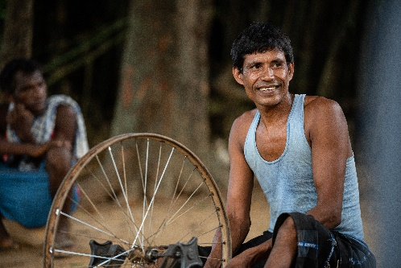

**Genesis 15:5-12, 17-18 | Phil 3:17-4:1 | Luke 9:28-36**

Apparently, there is an old Syrian saying ‘inside the people you know, there is a person you don’t know.’ One of God’s gifts is the grace to keep discovering beautiful things about the people close to us. If you talk to people who have been married for a long time, they will often mention the way their partner surprises them, even after twenty years of sharing the same kitchen sink. Likewise, our children and our friends. If we put them in a box with a label, we can become blind to some unexpected wonders God wants us to see.

Perhaps it was like this for Peter, James and John on the occasion of the transfiguration which we hear about in the Gospel today. By this stage, they have been on the road with Jesus for quite some time. They have seen the storm calmed, the demoniac brought to peace, the woman healed of her hemorrhage, the daughter of Jairus raised to life. They have heard outrageous things. You’d think they’d be getting the picture by now.

The experience on the mountain allows them to understand that they have hardly begun to understand the depth of the mystery of Jesus. A voice from the cloud says ‘this is my Son, the Chosen One. Listen to him.’

This week, as part of Project Compassion, we hear the story of Biru, a young man from the Ho ethnic minority in India. He lives with a disability. But there is so much more to him that needs to be seen. Our support of Caritas Australia has empowered him to become an entrepreneur, to meet his future with pride, confidence and hope. Project Compassion challenges us to see beyond the immediate situation of people such as Biru and discover the person we don’t yet know, to celebrate the possibilities of life ‘for all future generations.’

Both before and after their great experience on the mountain top, Luke’s Gospel reminds us that the disciples still face a challenging road. Life will teach them more and more about Jesus. Let us all be open the lessons of a real relationship with the God of justice and love.

**WEEKLY REFLECTIONS**

**2ND SUNDAY OF LENT**

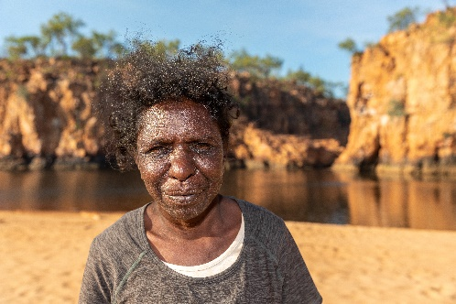

**Exodus 3:1-8, 13-15 | 1 Cor 10:1-6, 10-12 | Luke 13:1-9**

Sometimes you hear Indigenous people refer to Jesus as a ‘person of Country’. What might this mean? It is hard to imagine the Gospels without the connection of Jesus to the sea, the river, the desert, the fields and the mountain. His teaching often featured seeds and birds and sheep and corn. In today’s Gospel, we hear the parable of the fig tree. The impatient person wants to cut it down. A wiser person is prepared to work with nature by putting manure on the tree and looking after it. This is a story of growth. God is creative. God is patient with us. God gives us another chance.

We have so much to learn from the depth and resilience of Australian Indigenous culture and spirituality, both of which are intimately linked to Country. This week, Project Compassion features the story of Janice, a Wagilak woman from the Northern Territory. Janice, who lives in a remote community, is part of the Djilpin Arts Aboriginal Corporation, supported by Caritas Australia. Janice is among those overcoming many obstacles to keeping their culture strong. She does this through dance. She honours the generations who have come before her and taught their community how to respect the land and live in harmony with it. Our response to Project Compassion is providing practical support for the blossoming of Indigenous culture for all future generations.

In today’s reading, Moses is in the wilderness, a place of surprising possibilities. Like the Australian landscape, the wilderness in scripture is subtle; it is a place of encounter with God. Moses thinks he is having a regular day in the family business, looking after his father-in-law’s sheep. But a voice comes from a bush that is blazing without being burnt up. The voice tells Moses to take off his shoes because ‘the place on which you stand is holy ground.’ This is the beginning of the freedom story of his people, the start of their journey out of captivity.

May our journey to the freedom God wants for us also begin with the realisation that we too are standing on Holy Ground. God calls us all to be people of Country.

**WEEKLY REFLECTIONS**

**3RD SUNDAY OF LENT**

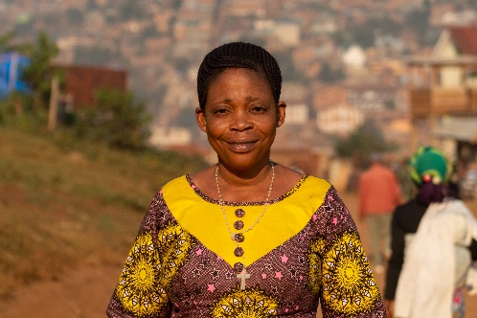

**Joshua 5:9-12 | 1 Cor 5:17-21 | Luke 15:1-3, 11-32**

One of the most beautiful expressions in the Bible comes from the prophet Ezekiel. ‘Thus says the Lord, I will take their hearts of stone and give them hearts of flesh.’ It is a call to be tender and compassionate.

You would need a heart of stone not to be affected by the stories we encounter today. Most of us have heard the story of the two sons in today’s Gospel over and over. The brilliance of the way Jesus tells stories is that it still gets under our skin. Here are two young men who think they can live on their own terms. One has a sense of entitlement and demands his share of his father’s estate which he then squanders. He is finally prepared to eat humble pie and find his way home. The other son has a different sense of entitlement. He believes that his hard work and reliability should provide him with a greater share of his father’s love. At different times in our life, we can relate more to one or other of these people. Jesus implies that they are both blind to the way God’s love works and that they both need to grow. They have both been dead and need to come to life.

The story we encounter this week through Caritas Australia’s Project Compassion is also deeply moving. Rosalie, aged 37, lives in one of the most damaged countries in the world, the Democratic Republic of Congo (DRC). From the age of fifteen, she was forced to become a child soldier, exposed to violence and heartbreak. She actually says that she was forced into combat with a baby on her back. Now she has seven children and dreams of a better future for them. Thanks to your support of Project Compassion, she has been able to start a small business, save so her children might go to school and become an inspiration to others. Recovery from the trauma of war affects people around the world.

Our second reading today reminds us that we are ‘ambassadors for Christ.’ St Paul says, ‘for anyone who is in Christ, there is a new creation.’ Let us all be part of building that new creation, setting the world to rights as best we can. God wants to reconcile the world to himself. Our part in this is to reach out in compassion and love to heal the wounds of the whole human family. The theme of Project Compassion this year asks us to think and act ‘for all future generations.’ Our hearts need to be warm and strong.

**WEEKLY REFLECTIONS**

**4TH SUNDAY OF LENT**

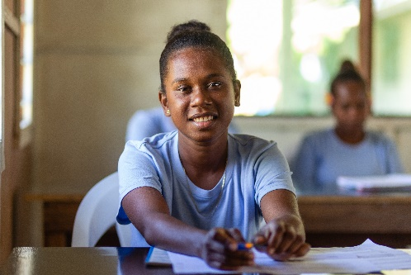

**Isaiah 43:16-21 | Phil 3:8-14 | John 8:1-11**

Pope Francis has spoken a great deal about our need for more women to occupy positions of leadership, both in the Church and in the world at large. For example, in his wonderful letter about the way we belong to each other, *Fratelli Tutti*, he says ‘the organisation of societies worldwide is still far from reflecting clearly that women possess the same dignity and identical rights as men. We say one thing with words, but our decisions and reality tell another story.’ He is concerned about ‘those women who endure situations of exclusion, mistreatment and violence’.

Pope Francis is very much reflecting the attitude of Jesus whose closeness to women distinguished him as a leader and teacher in his time. You might think of significant encounters in the New Testament: the woman at the well, Martha and Mary, the widow of Nain. You might also think of the woman we meet in today’s Gospel, described by the scribes and Pharisees as ‘caught in the very act of committing adultery.’ Listen to the sneer in those words.

These men, who are supposed to be educated and respected, have been peeping through the window. Their behavior is salacious, domineering and demeaning. In their self-righteousness, they threaten violence. There is no sign of the woman’s partner who is surely just as much part of the story. Jesus neatly turns the tables. He starts by sitting on the ground, occupying a position lower than that of the woman. He is the only one not taking an eyeful of her.

Caritas Australia, whom we support through Project Compassion, has long acted in constructive ways to uphold the dignity of women and honour their strength, resilience and leadership. A good example is Shaniella, a young woman from a remote village in the Solomon Islands. She is the feature of this week’s story and embodies the theme of this year’s Project Compassion: For all future generations. Take a few minutes to share her story and consider the odds she is overcoming to create a safer and healthier environment for herself and her community. She is the kind of person who should surely grab our attention.

Today’s second reading reminds us that none of us is perfect. But like St Paul, we are still running, still trying to achieve ‘the perfection that comes through faith in Christ.’ This does not mean judging others as the scribes and Pharisees did. It means challenging ourselves, in the words of the prophet Isaiah, to put water in the wilderness as we consider what we might do ‘for all future generations.’

**WEEKLY REFLECTIONS**

**5TH SUNDAY OF LENT**



**WEEKLY REFLECTIONS**

**PALM SUNDAY**

**Luke 19:28-40 | Phil 2:6-11 | Luke 22:14-23:56**

Today we read the passion narrative from the Gospel of St Luke. It is not by any means for the faint hearted. Even if it is familiar to us, we should try to remember how extraordinary it is. After so many centuries of cruelty, crucifixion still ranks as one of the most appalling things people have ever thought to do to their fellow humans. Yet this was how God chose to show the depth of his love. God was prepared to go to any lengths for us. The letter to the Philippians says that Jesus did not cling to his equality with God but emptied himself to assume the condition of a slave. Why? The only possible explanation is love. Anyone who has loved another knows that it will inevitably bring a share of suffering. Jesus walks alongside all who suffer. He shares their cross as they share his.

The fact that crucifixion was so common in the Roman world should also make us pause for a moment. Jesus lived and died in a world in which people were routinely degraded. He met plenty of them in his travels, people cast by the wayside, and helped many. For those without power, life was fragile, even cheap. Has much changed? Throughout Lent, Caritas Australia has invited us to share the work of Project Compassion. The stories we have encountered remind us that the world is still an uneven field. Project Compassion invites us to respond in love to free people in captivity to very challenging circumstances. It invites us in a small way to carry the cross, to live in hope of the Resurrection.

Perhaps this week, as well as joining in the services of Holy Week, we can take some time to sit quietly with the passion narrative from Luke’s Gospel on our own. Think about all the characters we meet: Peter, Judas, Pilate, Herod, the women of Jerusalem, Simon of Cyrene, the soldiers, the two criminals, the women from Galilee, the centurion, Joseph of Arimathea. Try to see the events from each of their perspectives. Then quietly see them from your own perspective, from your world in 2022. Pray in humble gratitude.