Project Compassion 2024
Parish and Community Bulletin Notices

We encourage parishes to include information about Project Compassion in their bulletin and social media to increase awareness of the Lenten appeal. If you would like any other information, logos or photos, please email us: education@caritas.org.au
There are two versions for each week, one being a shorter summary, for when you are tight on space. Please note that the photos can only be used in relation to Caritas Australia’s Project Compassion campaign.
Project Compassion Sunday
10 & 11 February
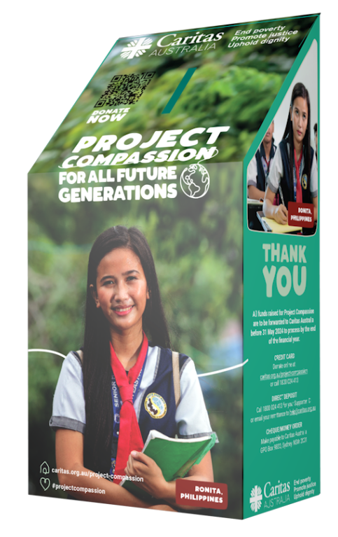
Please take home a Project Compassion box or set of donation envelopes to support Caritas Australia this Lenten season and help support vulnerable people around the world, now and for all future generations.
With your support, Caritas Australia has been able to support communities around the world to tackle poverty, food security, education, water and sanitation and disaster risk reduction.
Project Compassion 2024 reminds us that the good that we do today will extend and impact the lives of generations to come. Together, we can help vulnerable communities face their challenges today and build a better tomorrow for all future generations.
You can donate through Project Compassion donation boxes and envelopes available from your parish, by visiting caritas.org.au/project-compassion or by calling 1800 024 413.

Summary Version
Project Compassion Sunday
10 & 11 February
Please take home a Project Compassion box or a set of donation envelopes to support Caritas Australia this Lenten season and help support vulnerable people around the world, now and for all future generations. With your support, Caritas Australia has been able to support vulnerable communities around the world to tackle poverty, food security, education, water and sanitation and disaster risk reduction to build a better future for all.
Together, we can help vulnerable communities face their challenges today and build a better tomorrow for all future generations.
You can donate through Project Compassion donation boxes and envelopes available from your parish, by visiting caritas.org.au/project-compassion or by calling 1800 024 413.

First Sunday of Lent
17 & 18 February

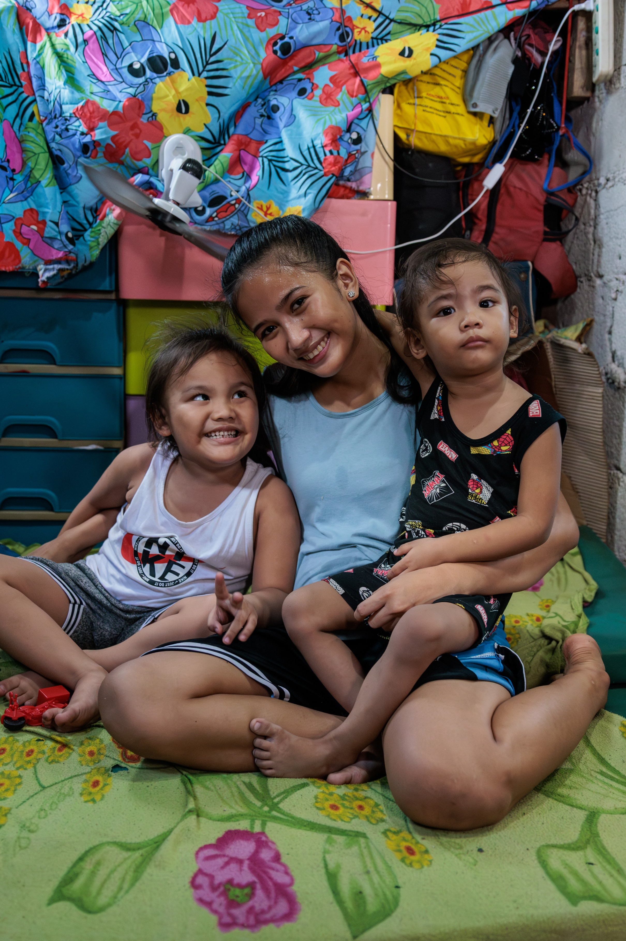
This year, Project Compassion brings you the stories of three resilient women from three different corners of the world. They are facing vastly different challenges, but are all united by one dream: to create a better tomorrow for all future generations. ​
Meet Ronita from the Philippines. Ronita is a mother of two young boys living in a slum in Quezon City. She went back to school to finish her education so that she could earn income to support her children.
Meet Leaia from Samoa. Not having access to a reliable source of clean water was very difficult for Leaia and her family. But, with the support of Caritas Australia, a water tank was installed at their home, improving their health and living conditions.
Meet Memory from Malawi. Memory, the eldest daughter from a rural Malawian family, trained to become a carpenter and is now a trailblazer for future generations of women in her village.
Throughout Project Compassion, you will get to know the stories of Ronita, Leaia and Memory. Journey with them as they forge a path to a brighter future for all generations.
Please donate to Project Compassion.
You can donate through Project Compassion donation boxes and envelopes available from your parish, by visiting caritas.org.au/project-compassion or by calling 1800 024 413.
Photo: Richard Wainwright/Caritas Australia

Summary Version
First Sunday of Lent
17 & 18 February
This year, Project Compassion brings you the stories of three resilient women: Ronita from the Philippines, Leaia from Samoa and Memory from Malawi. While from three different corners of the world and facing vastly different challenges, they are all united by one dream: to create a better world for all future generations.
Please donate to Project Compassion.
You can donate through Project Compassion donation boxes and envelopes available from your parish, by visiting caritas.org.au/project-compassion or by calling 1800 024 413.

Second Sunday of Lent
24 & 25 February

Ronita is 22. She lives with her husband and two children in a barangay (local district) in Quezon City, which is situated in Metro Manila in the Philippines.
Ronita left school when she became pregnant as a teenager. This could have had a life-long impact on her ability to find work and provide for her family but, thankfully, she heard about the Alternative Learning System (ALS) program run by the Faithful Companions of Jesus (FCJ), Caritas Australia’s local partners in the Philippines.
Through the FCJ, Ronita was able to re-enrol in her studies and continue learning in a safe and flexible environment – even with the arrival of her second child.
After completing her ALS classes, Ronita went on to earn her Grade 12 Senior High School Diploma. With her new diploma, Ronita has now secured a job at a call centre and is looking to a brighter future for her whole family.
“I have now graduated senior school and I am so proud of myself,” she said. “I feel hopeful for the future… Now it’s not impossible for me to achieve my dream… Thank you.”
Please donate to Project Compassion.
Together, we can help vulnerable communities face their challenges today and build a better tomorrow for all future generations.
You can donate through Project Compassion donation boxes and envelopes available from your parish, by visiting caritas.org.au/project-compassion or by calling 1800 024 413.
Photo: Richard Wainwright/Caritas Australia
Summary Version
Second Sunday of Lent
24 & 25 February
After the birth of her children, 22-year-old Ronita was at risk of having to leave school permanently. But, with the support of Caritas Australia’s partners in the Philippines, she resumed her studies and secured a job at a call centre to support her family.
Please donate to Project Compassion.
Together, we can help vulnerable communities face their challenges today and build a better tomorrow for all future generations.
You can donate through Project Compassion donation boxes and envelopes available from your parish, by visiting caritas.org.au/project-compassion or by calling 1800 024 413.

Third Sunday of Lent
2 & 3 March
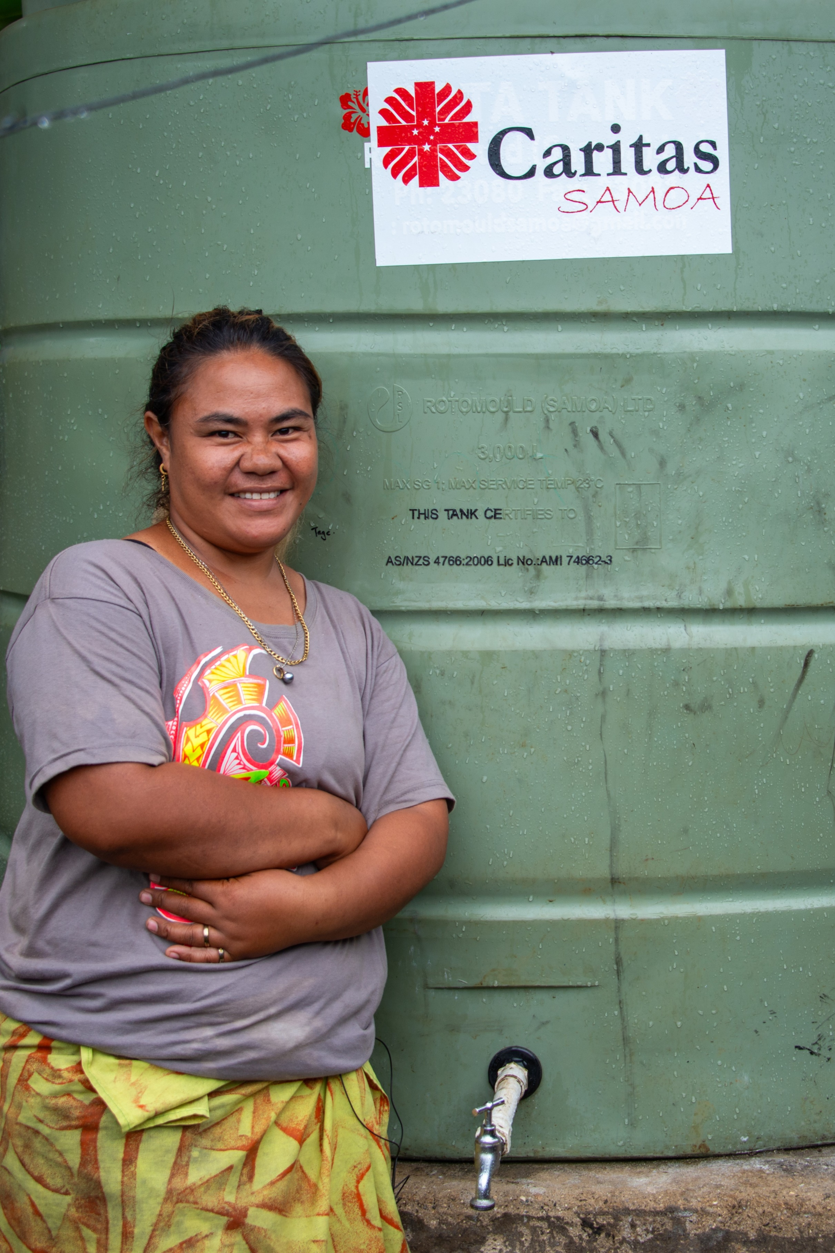
Samoa may be a country surrounded by water, but access to clean drinking water is scarce in some areas, with many families facing extreme hardship as a result.
Leaia lives with her five children, husband, brother and sister-in-law on the island of Upolu in Samoa. Not having access to a reliable source of clean water caused Leaia a lot of worry.
Their home is not connected to a piped water system, so they had to rely solely on rainwater collected in old fridges. When their water ran out, Leaia had to walk with her young children to collect water in buckets and containers from a neighbour down the street.
With the support of Caritas Australia's local partner, Caritas Samoa, a water tank was installed at Leaia's home. She and her family now have a steady supply of clean drinking water at home. Next year, they will also have a toilet built, with the support of Caritas Samoa, which will further improve their health and living conditions.
“We are very thankful and grateful for the water tank. It has helped us so much and made our daily life easier,” Leaia said.
Please donate to Project Compassion.
Together, we can help vulnerable communities face their challenges today and build a better tomorrow for all future generations.
You can donate through Project Compassion donation boxes and envelopes available from your parish, by visiting caritas.org.au/project-compassion or by calling 1800 024 413.
Photo: Laura Womersley/Caritas Australia

Summary Version
Third Sunday of Lent
2 & 3 March
Not having access to a reliable source of clean water was very difficult for Leaia and her family. But with the support of Caritas Australia, a water tank was installed at their home, improving their health and living conditions.
Please donate to Project Compassion.
Together, we can help vulnerable communities face their challenges today and build a better tomorrow for all future generations.
You can donate through Project Compassion donation boxes and envelopes available from your parish, by visiting caritas.org.au/project-compassion or by calling 1800 024 413.

Fourth Sunday of Lent
9 & 10 March

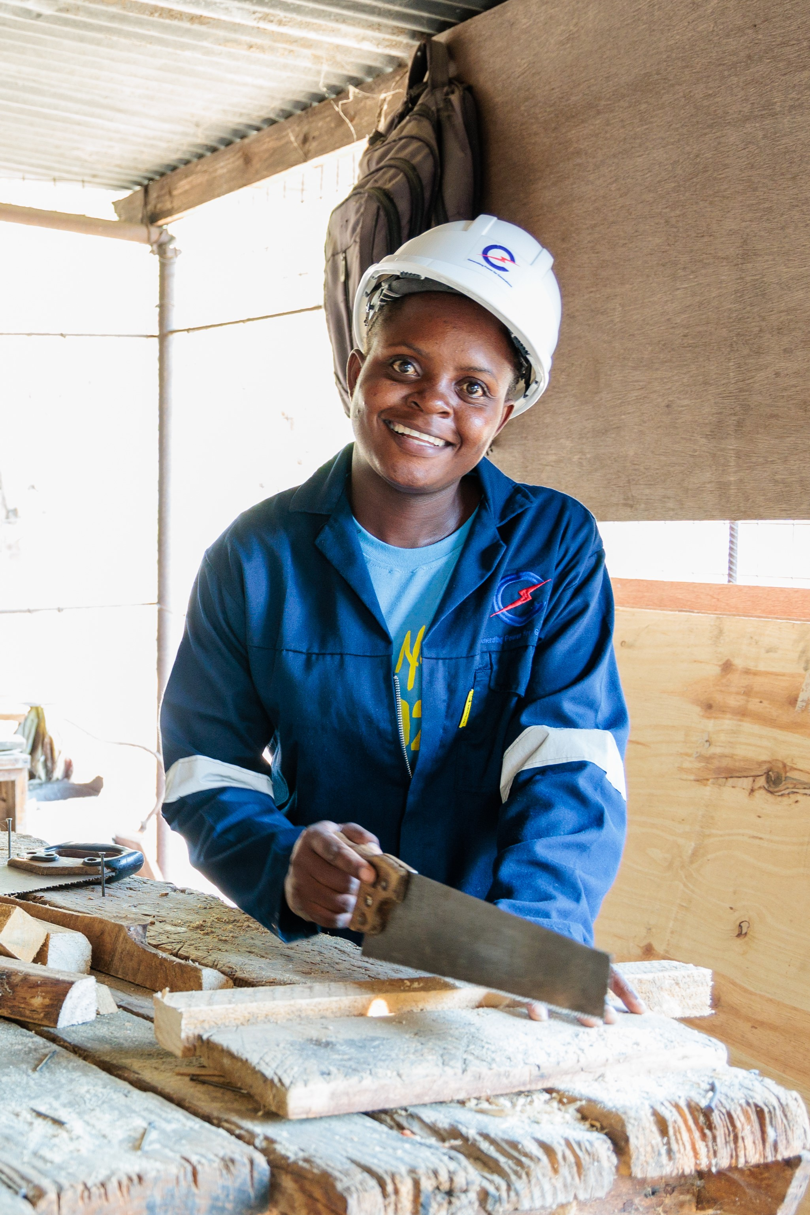
Memory is 26 years old and lives in rural Malawi. As the eldest child in a low-income farming family, Memory had to take on many household chores and farming activities to support her parents. They struggled to pay for Memory’s school fees and school supplies, and Memory often had to walk to school barefooted.
With the support of Caritas Australia and its partner the Catholic Development Commission in Malawi (CADECOM), Memory was able to enrol at a technical college where she learnt technical skills in carpentry. She undertook a three-year carpentry course, with CADECOM supporting part of her tuition and boarding fees.
Memory became the first female carpenter from her village. Today, she works as a carpenter at one of Malawi’s largest hydroelectric power stations. With the income from her job, she can provide financial support to her family and inspire other young women in her community so that they may have the opportunity to succeed in a male-dominated industry.
Please donate to Project Compassion.
Together, we can help vulnerable communities face their challenges today and build a better tomorrow, for all future generations.
You can donate through Project Compassion donation boxes and envelopes available from your parish, by visiting caritas.org.au/project-compassion or by calling 1800 024 413.
Photo: Tim Lam/Caritas Australia

Summary Version
Fourth Sunday of Lent
9 & 10 March
As the eldest child in a low-income farming family in rural Malawi, Memory faced many barriers to her education. But, with the support of Caritas Australia, she enrolled in a technical school and became the first female carpenter in her village.
Please donate to Project Compassion.
Together, we can help vulnerable communities face their challenges today and build a better tomorrow for all future generations.
You can donate through Project Compassion donation boxes and envelopes available from your parish, by visiting caritas.org.au/project-compassion or by calling 1800 024 413.

Fifth Sunday of Lent
16 & 17 March

Partnership in action
The work of Caritas Australia is only possible with the dedication, passion and tenacity of our local partners who implement the programs. They are the heroes on the ground, working tirelessly behind-the-scenes every day to create a better future for their communities.
Caritas Australia partners with the Faithful Companions of Jesus (FCJ) to support communities living in urban slums in the Philippines. FCJ runs a number of programs that include house renovating, food processing, basic literacy skills, urban gardening, upcycling and income generating activities. They also have a clinic visited weekly by a doctor and community nurse.
Caritas Australia partners with Caritas Samoa to assist communities to have increased access to clean water, sanitation and hygiene to ensure human health and well-being by providing water tanks and sanitation facilities.
Caritas Australia partners with the Catholic Development Commission in Malawi through the A+ program. Since 2016, the A+ program has helped 7,397 families across Malawi improve their food security, access to basic water and sanitation, boost women’s income generation and strengthen child protection.
Please donate to Project Compassion.
Together, we can help vulnerable communities face their challenges today and build a better tomorrow for all future generations.
You can donate through Project Compassion donation boxes and envelopes available from your parish, by visiting caritas.org.au/project-compassion or by calling 1800 024 413.
Photo: Richard Wainwright / Caritas Australia

Summary Version
Fifth Sunday of Lent
16 & 17 March
The work of Caritas Australia is only possible with generous supporters and the dedication, passion and tenacity of our local partners who implement the programs. They are the heroes on the ground working tirelessly behind-the-scenes every day to create a better future for their communities.
Please donate to Project Compassion 2023.
Together, we can help vulnerable communities face their challenges today and build a better tomorrow, for all future generations.
You can donate through Project Compassion donation boxes and envelopes available from your parish, by visiting caritas.org.au/project-compassion or by calling 1800 024 413.

Sixth Sunday of Lent (Palm Sunday)
23 & 24 February
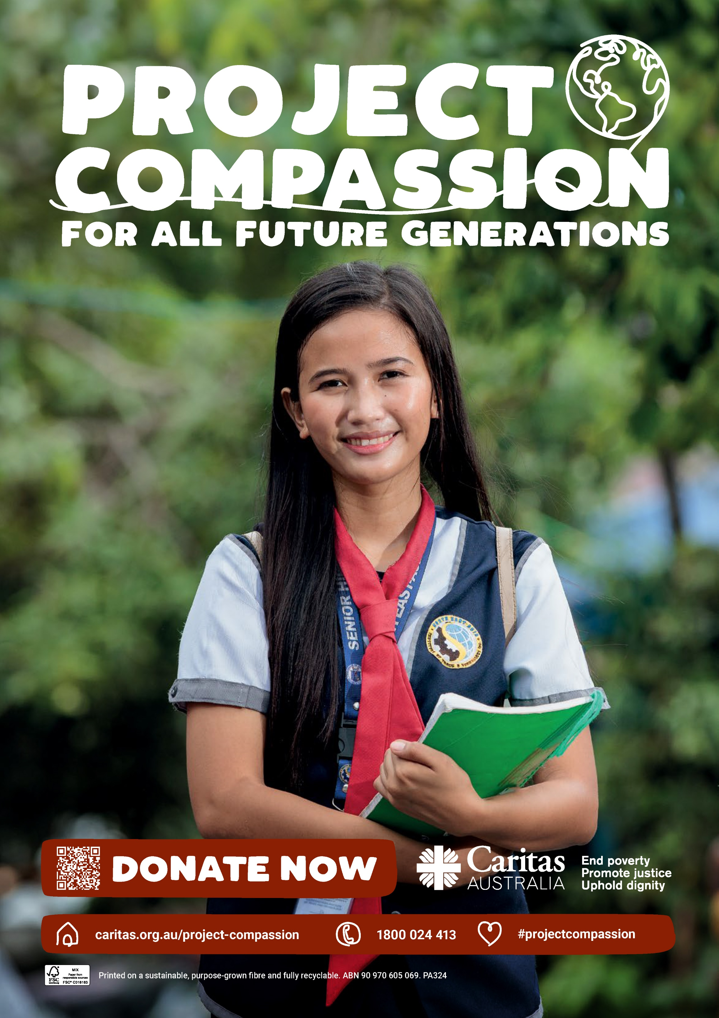
This year, we shared with you the story of three inspiring women from across the globe, who overcame challenges to complete their education, access water and find secure employment. With the support of compassionate people like you, they are now forging a path to a better future for their families and their communities.
Ronita from the Philippines has now graduated high school and secured a job at a call centre. This job was only possible because of a certificate she gained from completing her studies.
Leaia and her family now have a water tank at their home in Samoa. She and her family now have a steady supply of clean drinking water. Next year, they will also have a toilet built, with the support of Caritas Samoa, which will further improve their health and living conditions.
Memory completed her vocational training course in carpentry and joinery. After completing a work contract at one of the largest electrical companies in Malawi, Memory now plans to return to her village and provide carpentry services to people in her community.
It’s through the generosity of people like you that we can continue to support people like Ronita, Leaia and Memory.
There is still time to donate! Together, we can help vulnerable communities face their challenges today and build a better tomorrow, for all future generations.
You can donate through Project Compassion donation boxes and envelopes available from your parish, by visiting caritas.org.au/project-compassion or by calling 1800 024 413.

Summary Version
Sixth Sunday of Lent (Palm Sunday)
23 & 24 February

As Project Compassion 2024 comes to an end, we want to thank you for your incredibly generous support throughout Lent.
This year, we shared with you the story of three inspiring women from across the globe, who overcame challenges to complete their education, access water and find secure employment. With the support of compassionate people like you, they are now forging a path to a better future for their families and their communities.
There is still time to donate! Together, we can help vulnerable communities face their challenges today and build a better tomorrow, for all future generations.
Please donate to Project Compassion
You can donate through Project Compassion donation boxes and envelopes available from your parish, by visiting caritas.org.au/project-compassion or by calling 1800 024 413.
Easter Sunday
31 March

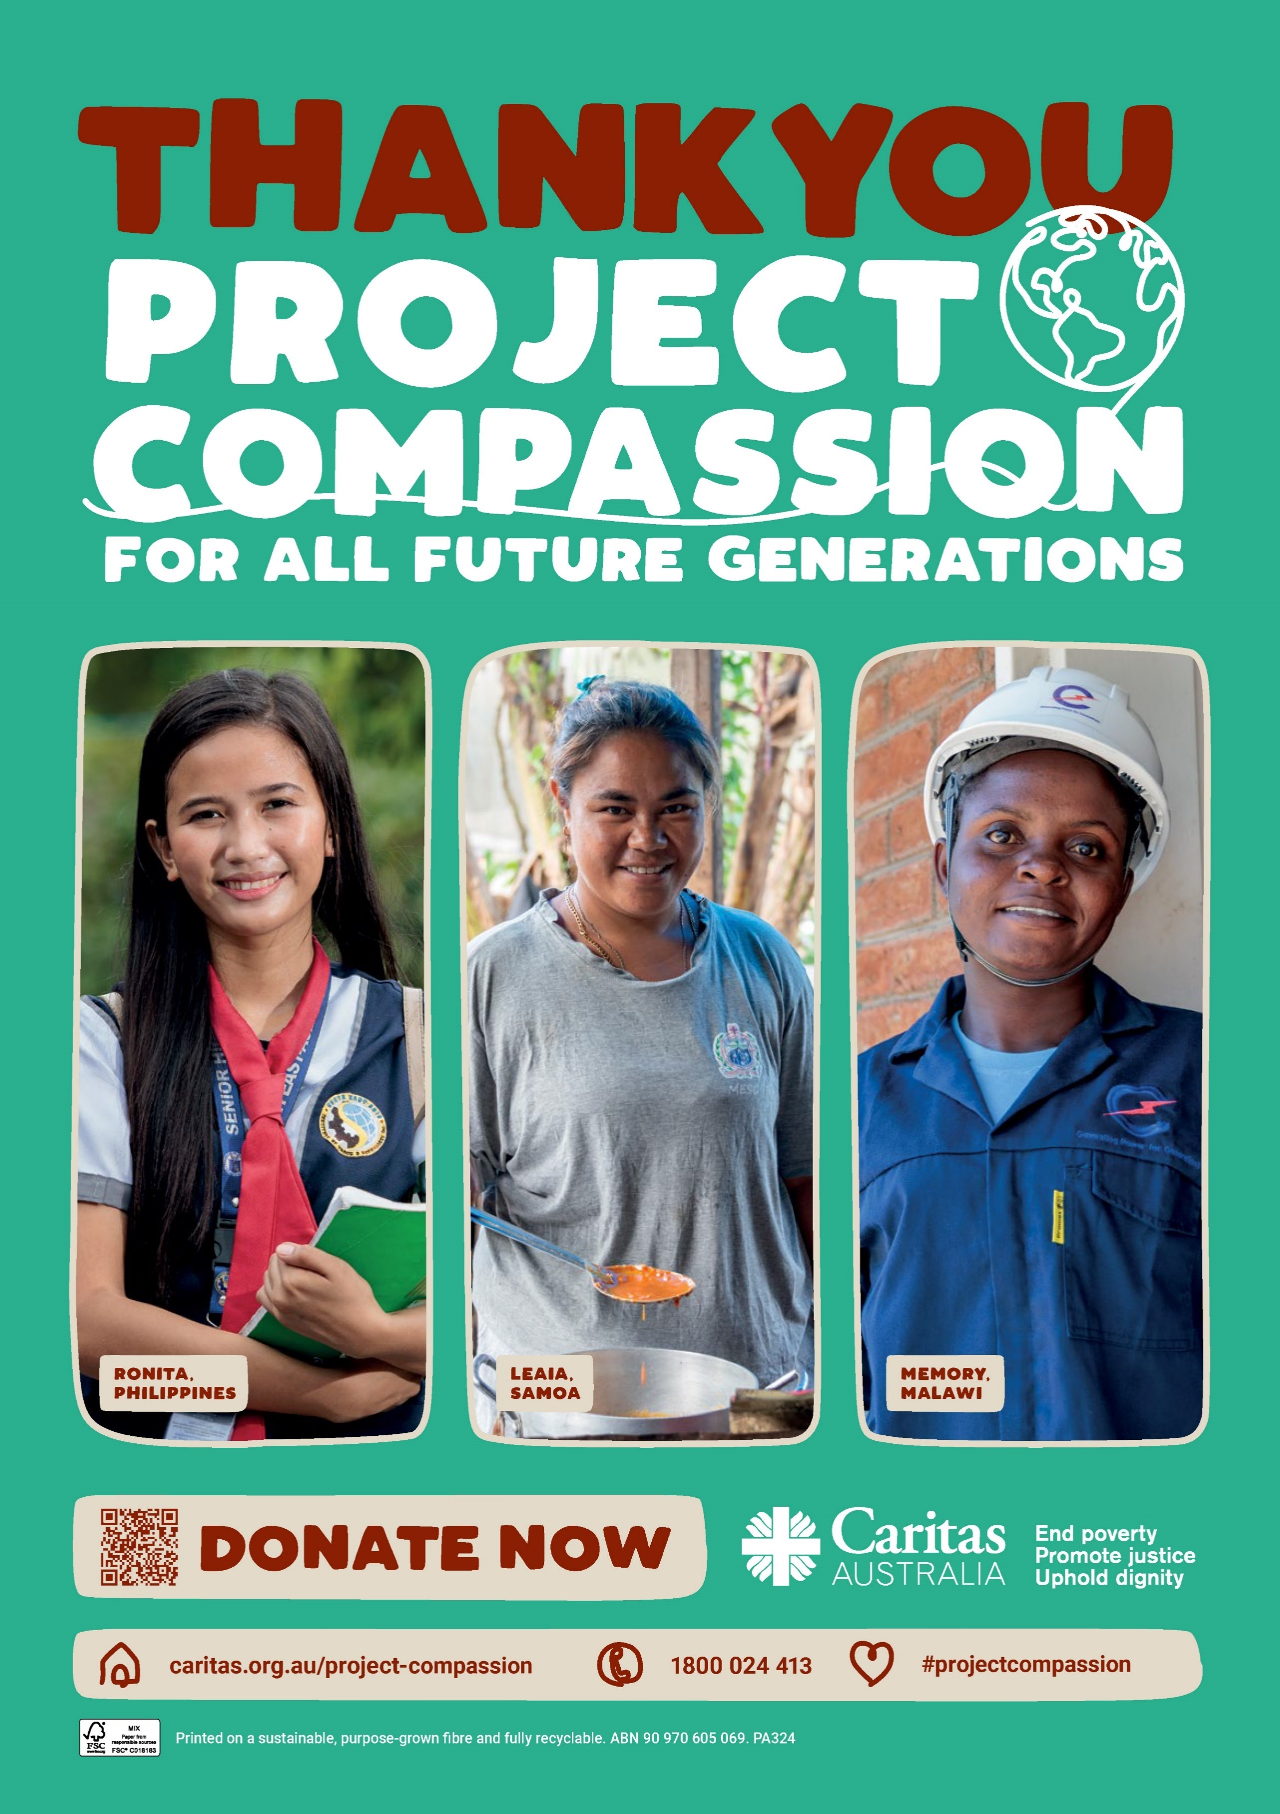
Happy Easter from all at Caritas Australia!
Thank you for your continued support through Project Compassion. Together, we can help vulnerable communities face their challenges today and build a better tomorrow, for all future generations.
Thank you for supporting Caritas Australia’s Project Compassion 2024 Lenten appeal.
You can donate through Project Compassion donation boxes and envelopes available from your parish, by visiting caritas.org.au/project-compassion or by calling 1800 024 413.

Thank you – Weeks after easter
Thank You!
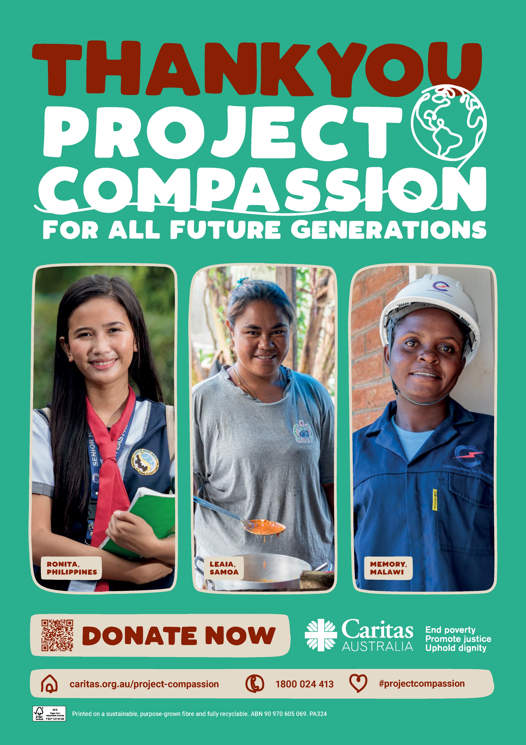
Caritas Australia would like to THANK YOU for supporting Project Compassion 2024. If you still have your Project Compassion box or set of envelopes at home, please bring them back next week or visit caritas.org.au/project-compassion and donate online.
Your generosity will empower the world’s most vulnerable communities to grow stronger and lift themselves out of poverty.
Together, we can help vulnerable communities face their challenges today and build a better tomorrow, for all future generations.
You can donate through Project Compassion donation boxes and envelopes available from your parish, by visiting caritas.org.au/project-compassion or by calling 1800 024 413.

