PROJECT COMPASSION 2022
School Newsletter Notices
We encourage schools to include information about Project Compassion in their weekly newsletter, daily bulletins and social media as a way of informing parents and the wider community about our Lenten appeal. If you would like any other information, logos or photos, please email us: education@caritas.org.au
We have provided two images for each story for you to choose from depending on the layout of your publication. These photos can only be used in relation to Caritas Australia’s Project Compassion campaign.
Ash Wednesday – 2 March 2022  (Week beginning Monday 28th February)  This week the season of Lent begins with Ash Wednesday, which also marks the beginning of the annual Caritas Australia Project Compassion Appeal. Donations to Project Compassion allows Caritas Australia, the Catholic Agency for International Aid and Development, to work with local communities around the world to end poverty, promote justice and uphold dignity.  The theme of Project Compassion 2022 is ‘For All Future Generations’ and reminds us that the good that we do today will extend and impact the lives of generations to come. It invites us to make the world a better place by working together now and finding long-term solutions to global issues. We encourage you to put your compassion into action this Lent through your prayer, fasting and almsgiving by supporting Project Compassion. Each family will receive a Project Compassion box and/or a set of envelopes for their donations or you can donate online via the Caritas Australia website at: lent.caritas.org.au | 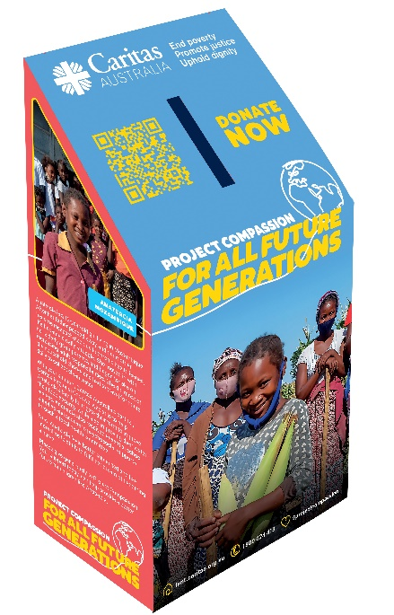  Credit: Caritas Australia
First Week of Lent  (Week beginning Monday 7th March)  We begin our annual Lenten Project Compassion journey by learning about Anatercia, a 12-year-old girl living in a small village in southern Mozambique. She began to take on more and more adult responsibilities as her mother has chronic health issues. She did most of the household chores and had to travel up to five hours every day to collect clean water. Water scarcity also meant that harvests were poor and there was never enough to eat.  With your support, Caritas Australia’s local partner, Caritas Regional Chokwe, was able to help Anatercia’s family to irrigate their farm to improve their food security. They also improved water access for households in the village, delivered sustainable farming training, and provided Anatercia with essential school supplies.  Anatercia’s health, education and quality of life have improved, along with the outlook of her whole community for all future generations.  Watch a short film about Anatercia’s story here.  Please support Project Compassion: lent.caritas.org.au | 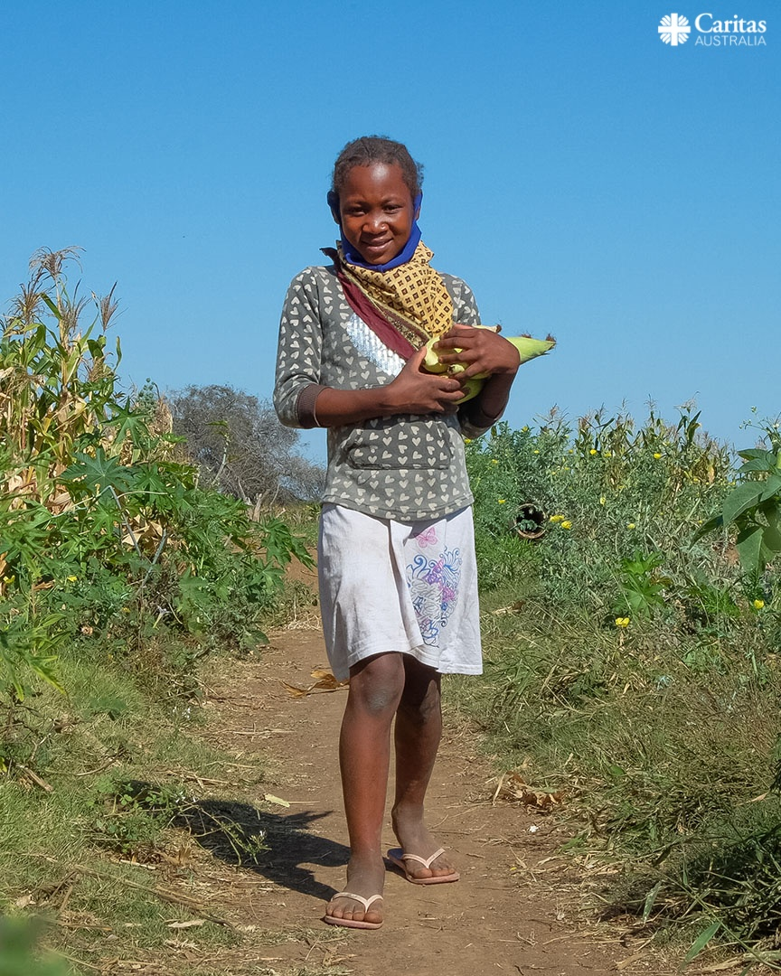  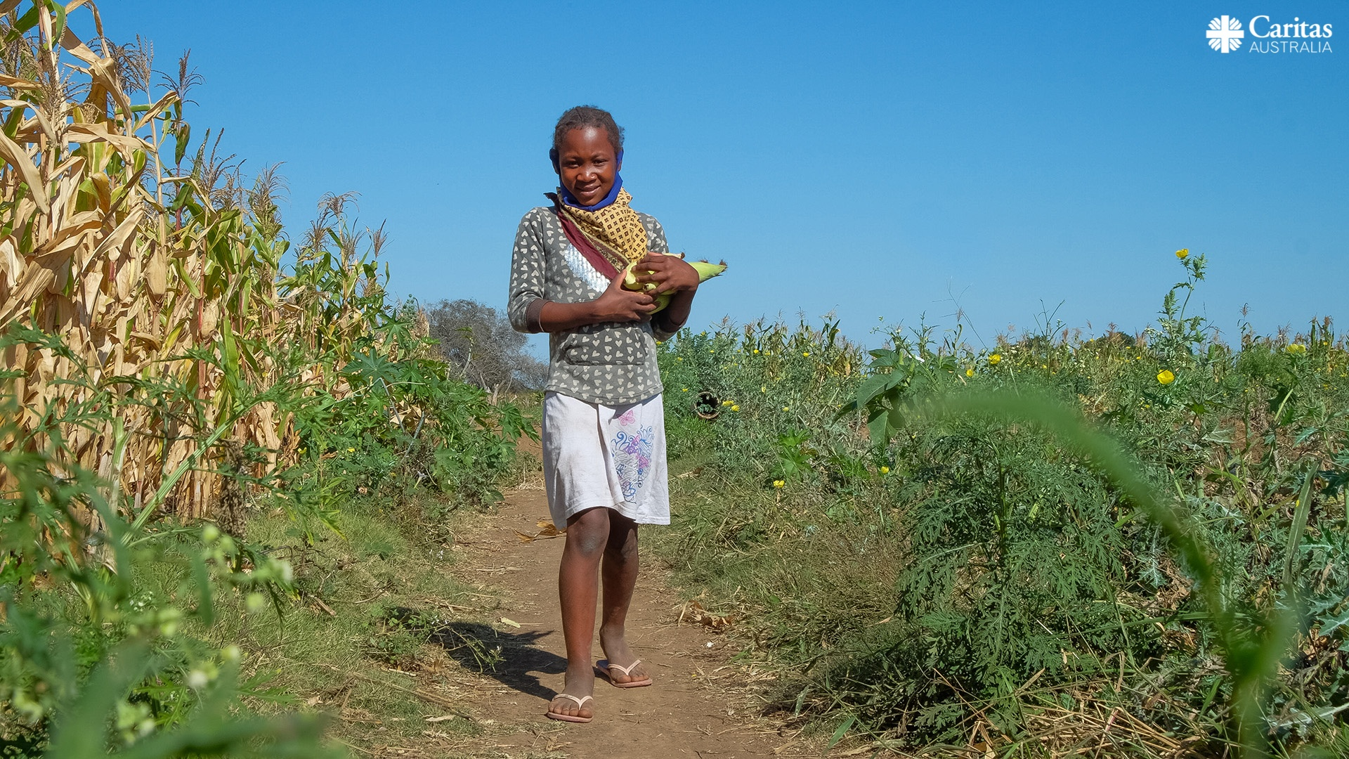  Photo: Emidio Josine/Caritas Australia
Second Week of Lent  (Week beginning Monday 14th March)  This week through Project Compassion we learn about Biru who lives in a rural village in India’s east. He lost mobility in one of his legs, after contracting polio as a child. Biru worked as a shepherd, looking after other people’s cattle, to support his wife and four daughters. Keeping up with the cattle was a challenge.  Biru taught himself how to repair bicycles by watching other people, but he never dreamed of using those skills to start his own business. With your generous support, Biru was able to access an entrepreneurship and livelihoods training program, run by Caritas Australia’s partner, Caritas India. He gained the support and skills he needed to start his own bicycle repair business. Now, Biru earns enough money to support his family.  Watch a short film about Biru’s story here.  Please support Project Compassion: lent.caritas.org.au | 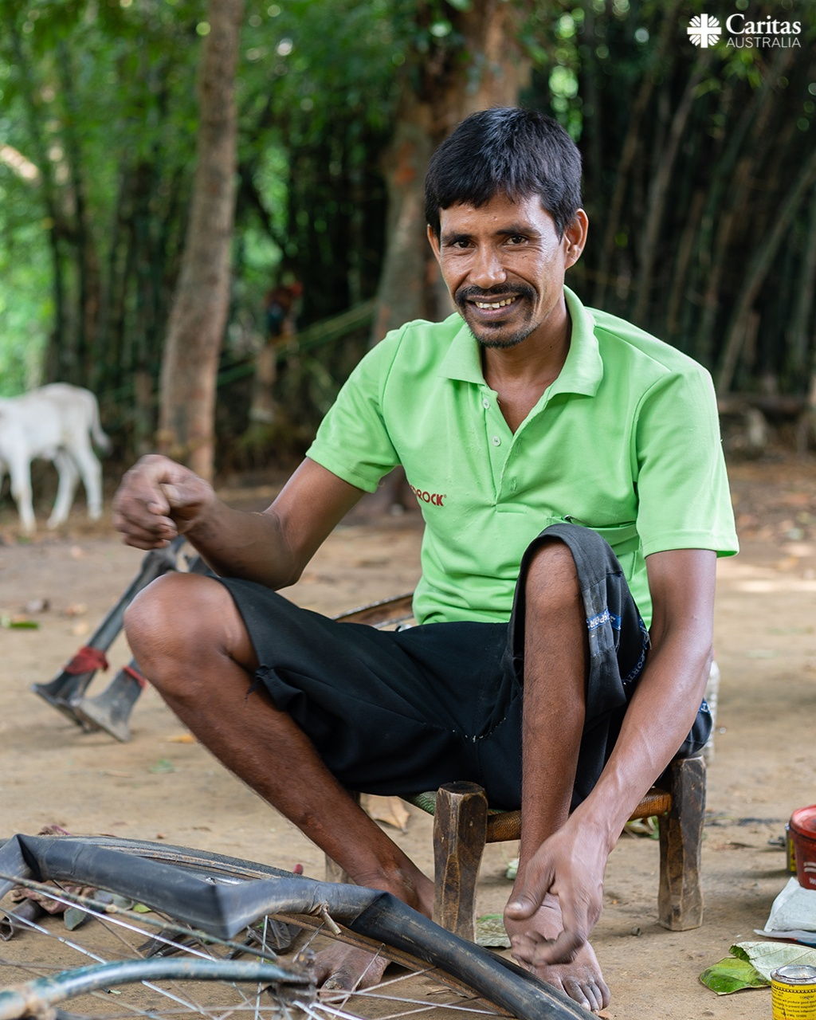  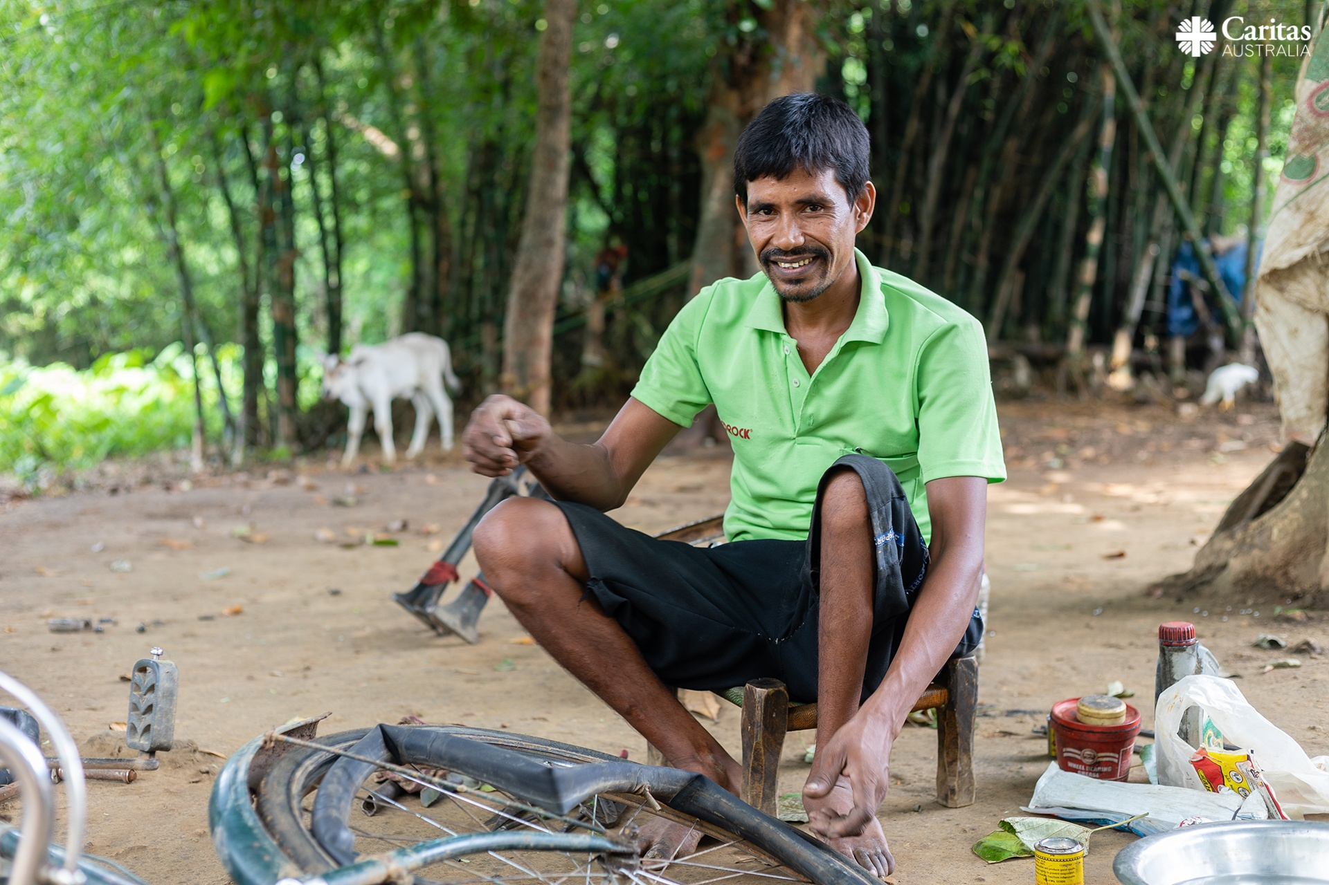  Photo: Sameer Bara/Caritas Australia
Third Week of Lent  (Week beginning Monday 21st March)  We are now in the third week of Lent with the Project Compassion story of Janice, a Wagilak woman and traditional dancer who tells her family’s stories through movements handed down over generations.  Like many remote Aboriginal and Torres Strait Islander communities, Janice’s faces a range of challenges – low employment and education, financial hardship, poorer health and lower life expectancy.  With your help, Caritas Australia supports Djilpin Arts Aboriginal Corporation, which operates a centre for traditional and contemporary Aboriginal arts and culture, providing employment and generating income for local communities.  Janice believes that Djilpin Arts’ work is essential to create opportunities for young people to stay on-country, to share intergenerational knowledge between elders and the younger generation - to promote healing, and to keep culture alive.  Watch a short film about Janice’s story here.  Please support Project Compassion: lent.caritas.org.au | 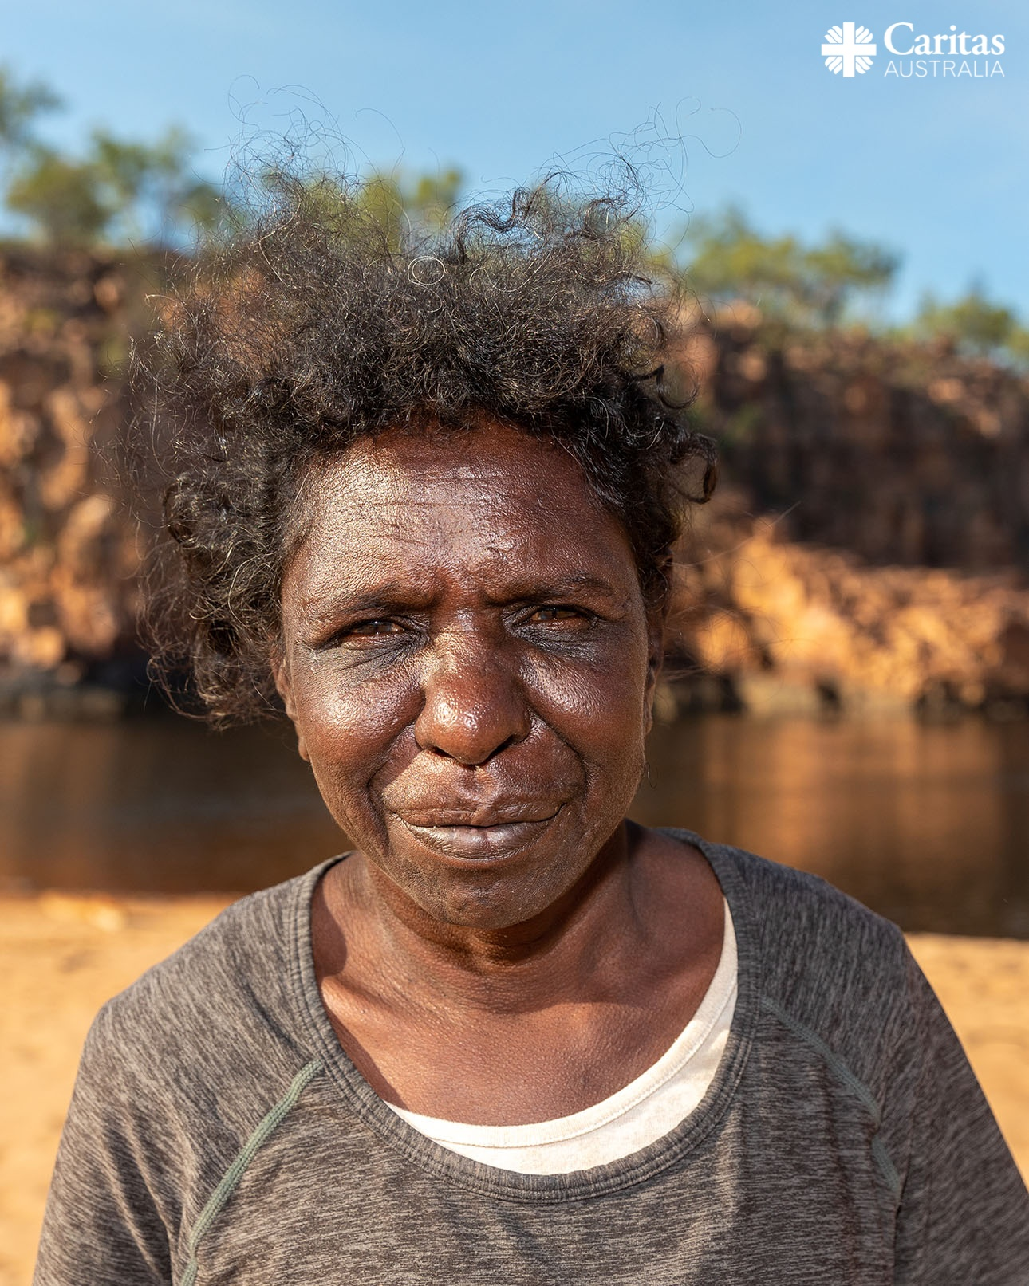  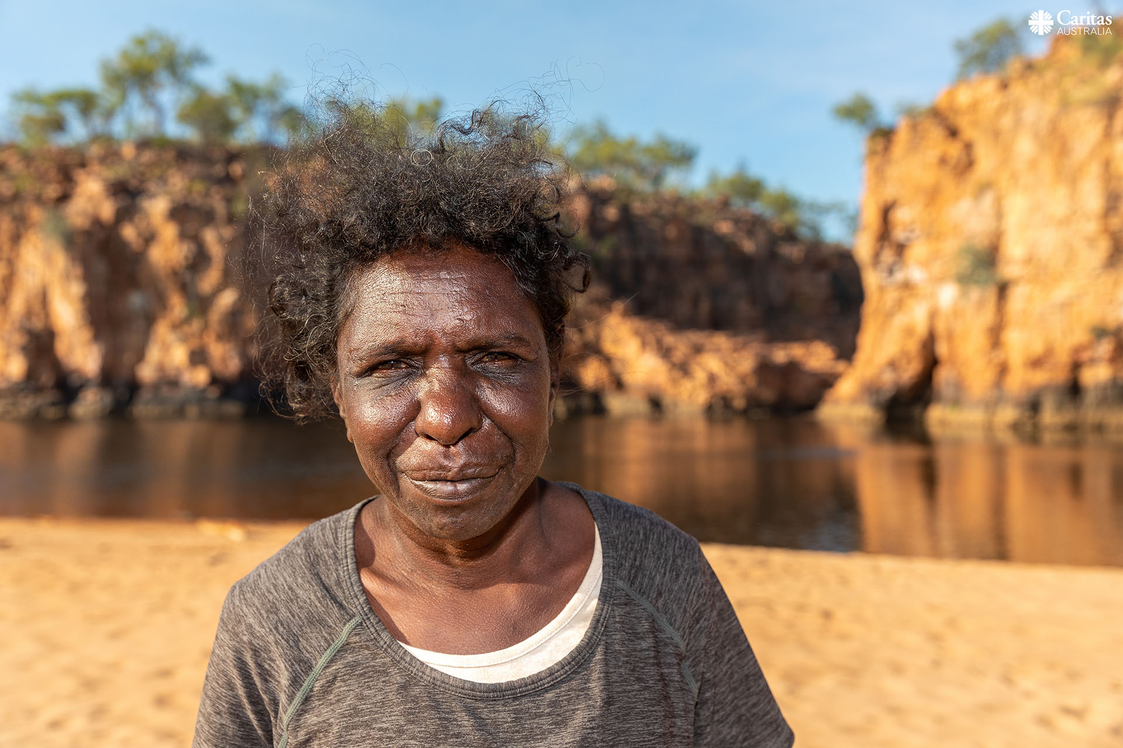  Photo: Richard Wainwright/Caritas Australia
Fourth Week of Lent  (Week beginning Monday 28th March)  This week through Project Compassion we learn about Rosalie, who lives with her husband and seven children in the Democratic Republic of Congo. Forced to join the army when she was just 15-years-old, Rosalie experienced significant trauma and hardship during her years in the military. After she was demobilised from the army, Rosalie, like other ex-combatants, was left to fend for herself in the community.  With your generous support and through Caritas Australia's partners, the Catholic Agency for Overseas Development (CAFOD) and Caritas Bukavu, Rosalie was able to connect with other members of her community and participate in business skills training to help her to reintegrate into society.  She joined a savings group which helped her with a loan to start her own small business selling second-hand shoes and natural remedies.  “I can eat, dress, maintain my health and help others. My children study and manage to eat twice a day. I have learnt to work hand-in-hand with other members of the community. Really, there is more joy in sharing with others.” - Rosalie  Watch a short film about Rosalie’s story here.  Please support Project Compassion: lent.caritas.org.au | 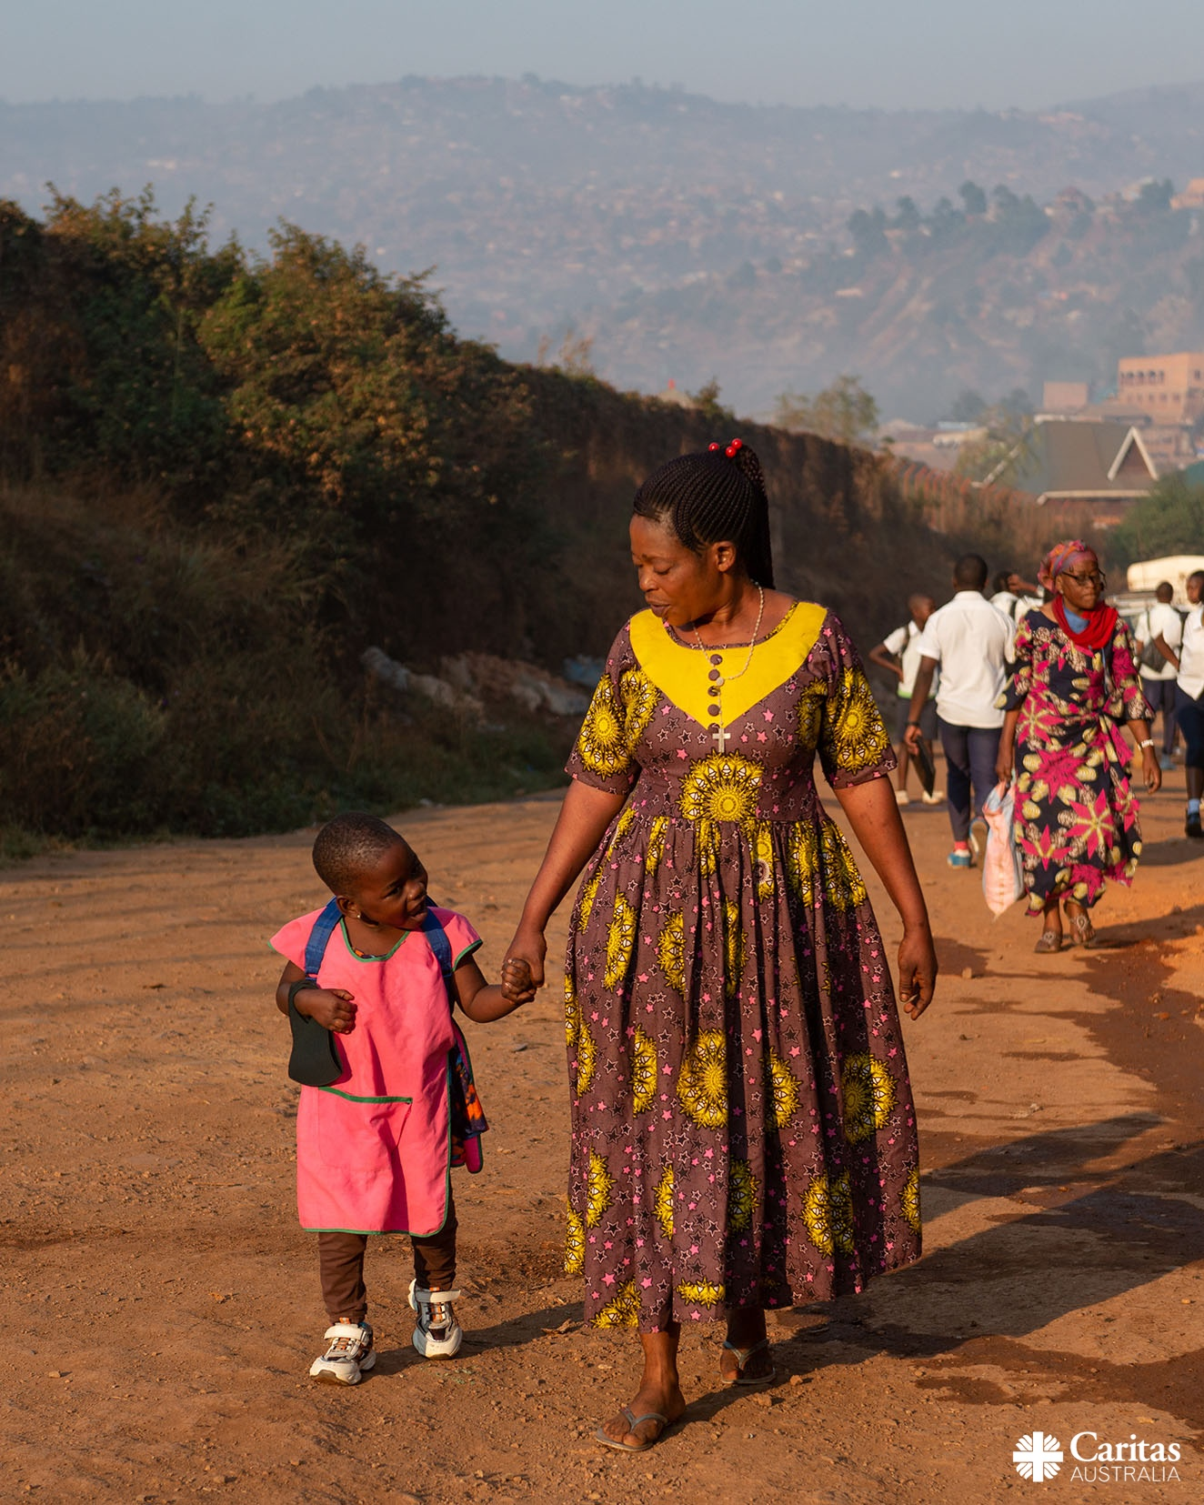  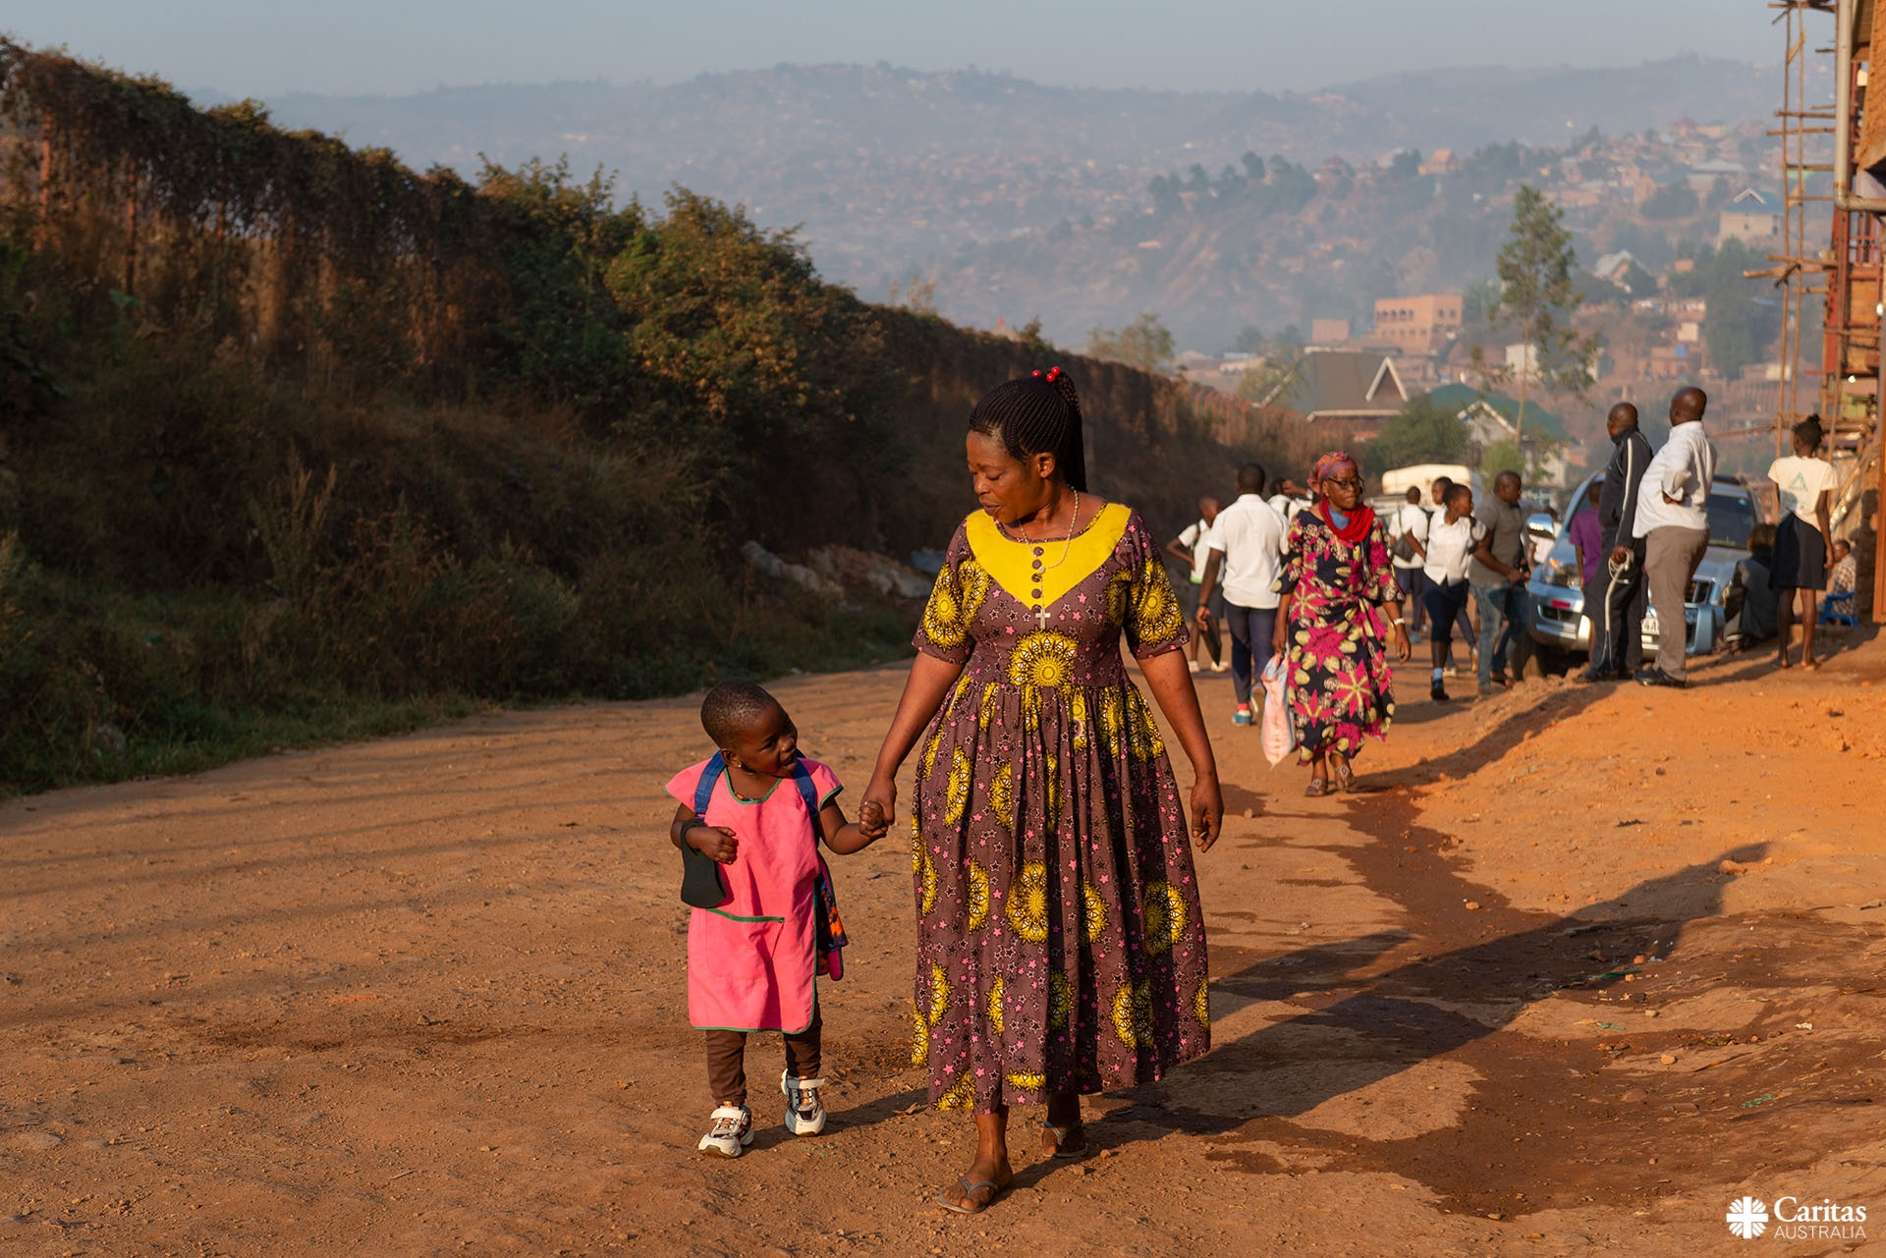  Photo: Arlette Bashizi /Caritas Australia
Fifth Week of Lent  (Week beginning Monday 4th April)  This week through Project Compassion we learn about Shaniella who is attending a vocational school in the Solomon Islands supported by Caritas Australia Solomon Islands (CASI).  Not long after Shaniella started, the school was hit by a landslide, flooding, and a cyclone, all in quick succession.  With your kind support, CASI helped install water tanks, restoring clean water access to nearby schools, health centres and the wider community. Training was held in agricultural skills to help boost the school community’s food security, as well as in environmental risk management and emergency responses.  Now, Shaniella can complete her skills training, with enough water and food to eat, and improved sanitation. She is improving her ability to earn an income, learning skills which will expand her job opportunities. Students are also better prepared to respond when disaster strikes.  Watch a short film about Shaniella’s story here.  Please support Project Compassion: lent.caritas.org.au | 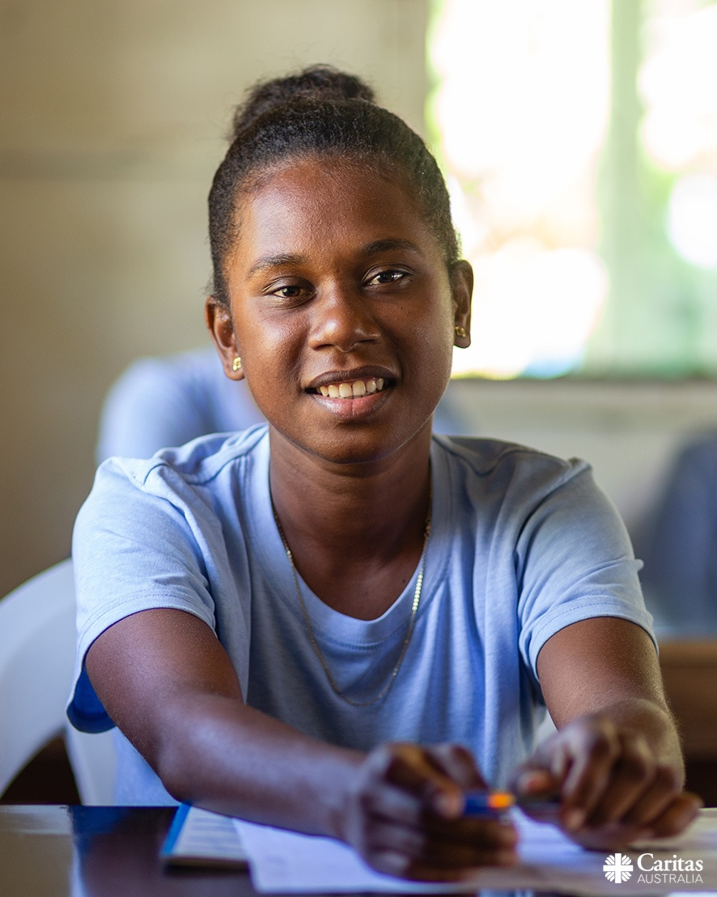  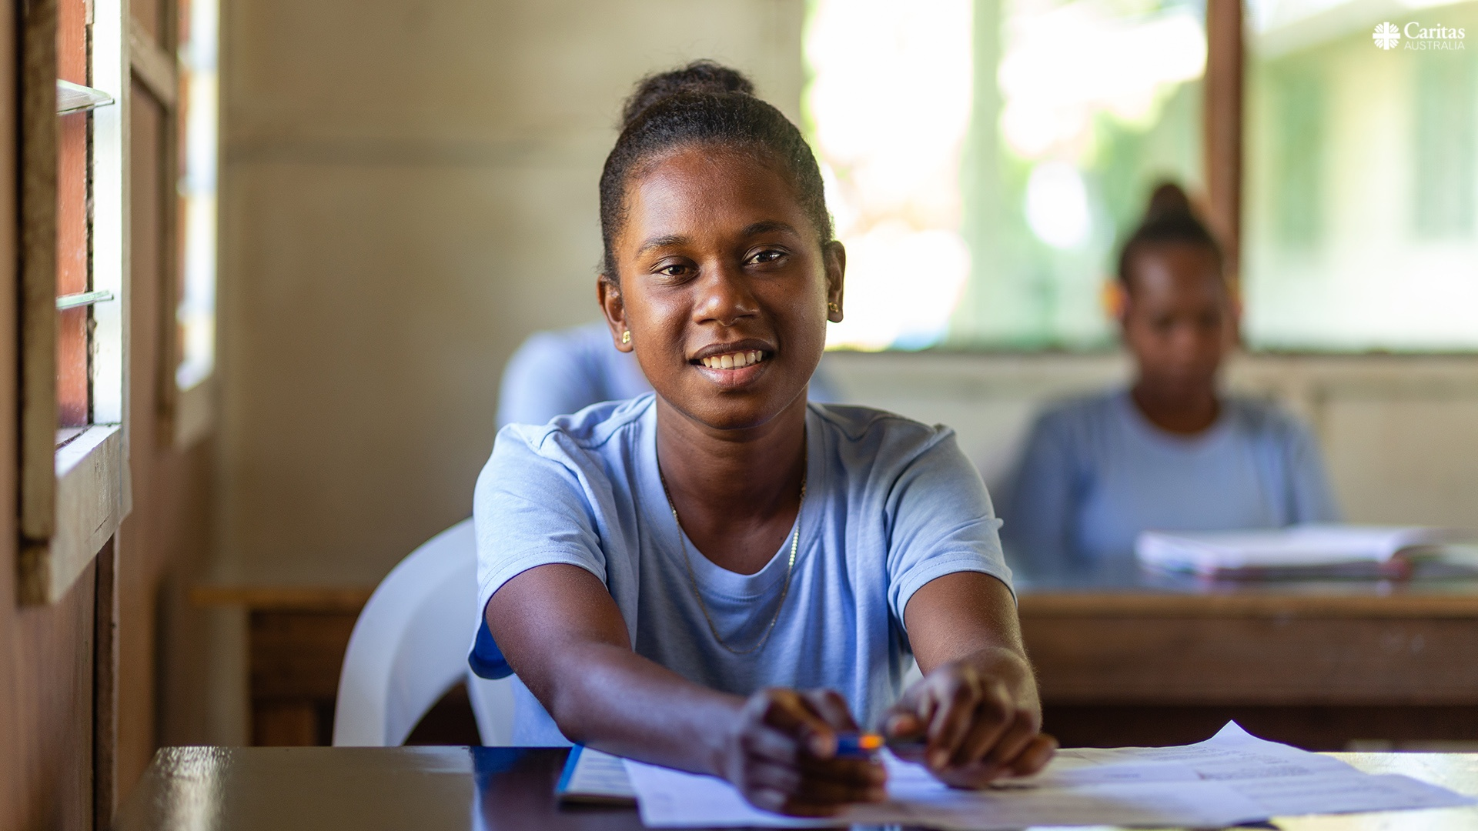  Photo: Neil Nuia/Caritas Australia
HOLY WEEK  (Week beginning Monday 11th April)  As we enter Holy Week, we continue to reflect on the lives of people vulnerable to extreme poverty and injustice and how we can respond through supporting Caritas Australia’s Project Compassion appeal.  Your generosity is the pebble that allows Caritas Australia to create the ripples that will improve the livelihoods of vulnerable communities, supporting them to flourish and create opportunities for future generations to live to their full potential and thrive.  Thank you!  Please return all Project Compassion boxes and envelopes to the school office by Friday 27th May or donate online via the Caritas website at lent.caritas.org.au | 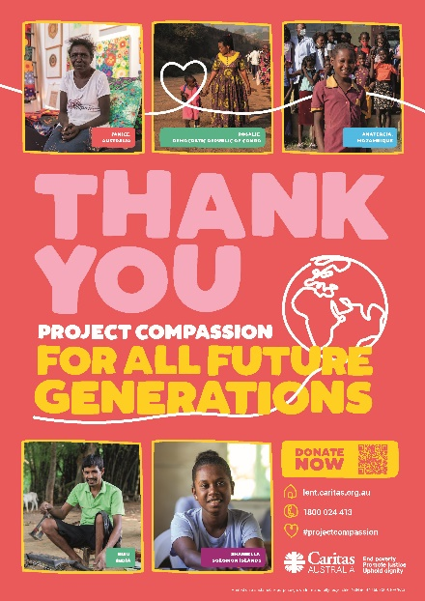  Credit: Caritas Australia

