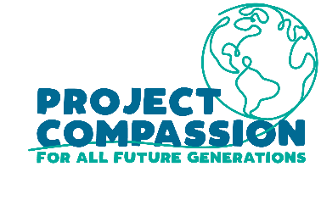
Project Compassion 2023
Parish and Community Bulletin Notices

We encourage parishes to include information about Project Compassion in their bulletin and social media to increase awareness of the Lenten appeal. If you would like any other information, logos or photos, please email us: education@caritas.org.au
There are two versions for each week, one being a shorter summary if you are tight on space. Please note the photos can only be used in relation to Caritas Australia’s Project Compassion campaign.
Project Compassion Sunday
18 & 19 February

Please take home a Project Compassion box or set of donation envelopes to support Caritas Australia this Lenten season and help support vulnerable people around the world, now and For All Future Generations.

With your support, Caritas Australia has been able to support communities around the world to tackle poverty, food security, education, water and sanitation and disaster risk reduction. Project Compassion 2023 reminds us that the good that we do today will extend and impact the lives of generations to come.

As St Pope John Paul II said, “The future starts today, not tomorrow.”

Together, we can help vulnerable communities face their challenges today and build a better tomorrow For All Future Generations.

You can donate through Project Compassion donation boxes and envelopes available from your parish, by visiting caritas.org.au/project-compassion, or by calling 1800 024 413.

Summary Version
Project Compassion Sunday
18 & 19 February

Please take home a Project Compassion box or a set of donation envelopes to support Caritas Australia this Lenten season and help support vulnerable people around the world, now and For All Future Generations. With your support, Caritas Australia has been able to support vulnerable communities around the world to tackle poverty, food security, education, water and sanitation and disaster risk reduction to build a better future for all.
Together, we can help vulnerable communities face their challenges today and build a better tomorrow For All Future Generations.

You can donate through Project Compassion donation boxes and envelopes available from your parish, by visiting caritas.org.au/project-compassion, or by calling 1800 024 413.

First Sunday of Lent
25 & 26 February

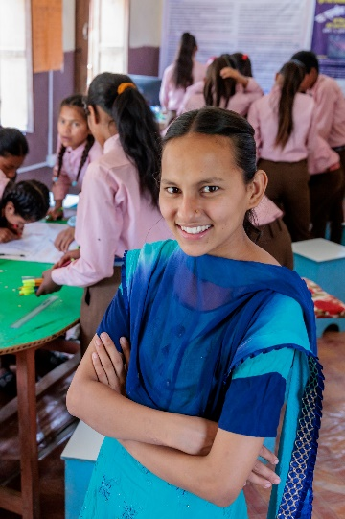
Laxmi, 16, lives in in Jajarkot, a remote district in Nepal where almost half of the population live below the poverty line. Tragedy struck when Laxmi was 10 years old and her father passed away. Her father worked hard to pay for his children's education and after losing him Laxmi was at risk of falling further into extreme poverty.
With the support of our partner Caritas Nepal, Laxmi joined a child's club at her school where she was encouraged to resume her education. Through the child’s club, Laxmi developed the skills and confidence to become a leader, advocating for clean water taps at her school.
Laxmi is now excelling in her studies and working towards her dream of becoming a civil engineer. She continues to be involved in the child's club, serving as an advisor and mentoring the next generation of young leaders at her old school.
Please donate to Project Compassion 2023.

Together, we can help vulnerable communities face their challenges today and build a better tomorrow For All Future Generations.

You can donate through Project Compassion donation boxes and envelopes available from your parish, by visiting caritas.org.au/project-compassion, or by calling 1800 024 413.

Photo: Richard Wainwright/Caritas Australia

Summary Version
First Sunday of Lent
25 & 26 February
After losing her father when she was just 10-years-old, Laxmi was at risk of falling further into extreme poverty. But with the support of our partner Caritas Nepal, Laxmi joined a child's club, became a leader in her school and is now a mentor to other children in her village.
Please donate to Project Compassion 2023.
Together, we can help vulnerable communities face their challenges today and build a better tomorrow For All Future Generations.
You can donate through Project Compassion donation boxes/envelopes available from your parish, by visiting caritas.org.au/project-compassion, or by calling 1800 024 413.

Second Sunday of Lent
4 & 5 March
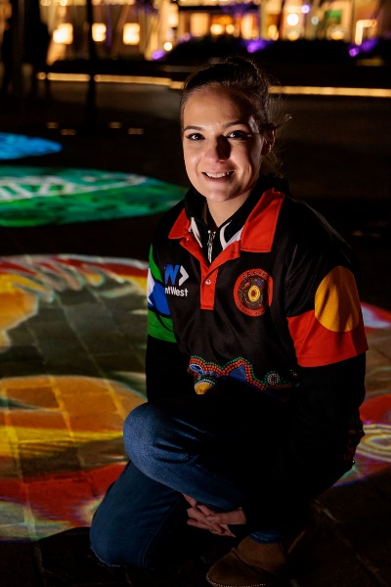
Tereesa is a Gamilaroi woman from Western Sydney who struggled with homelessness while raising her four children. Once Tereesa became pregnant with her first child at the age of 16, she left school.. A single mother struggling with homelessness, Tereesa’s only concern was finding stability for her children.
Seeking a better future for her family, Tereesa joined Baabayn Aboriginal Corporation’s Young Mums and Bubs Group, supported by Caritas Australia. Baabayn helped Tereesa access housing and psychological support. Today, Tereesa is studying a certificate in Community Services so that she can strengthen her skills and give back to her community.
Tereesa now works at Baabayn, providing support to young mothers and mentoring the next generation of young people.

Please donate to Project Compassion 2023.
Together, we can help vulnerable communities face their challenges today and build a better tomorrow For All Future Generations.

You can donate through Project Compassion donation boxes/envelopes available from your parish, by visiting caritas.org.au/project-compassion, or by calling 1800 024 413.

Photo: Richard Wainwright/Caritas Australia

Summary Version
Second Sunday of Lent
4 & 5 March
Tereesa is a Gamilaroi woman from Western Sydney who struggled with homelessness while raising her four children. Through the Baabayn Young Mums and Bubs Group, Tereesa was able to reconnect with her culture and create a better future for her children.
Please donate to Project Compassion 2023
Together, we can help vulnerable communities face their challenges today and build a better tomorrow For All Future Generations.

You can donate through Project Compassion donation boxes/envelopes available from your parish, by visiting caritas.org.au/project-compassion, or by calling 1800 024 413.

Third Sunday of Lent
11 & 12 March
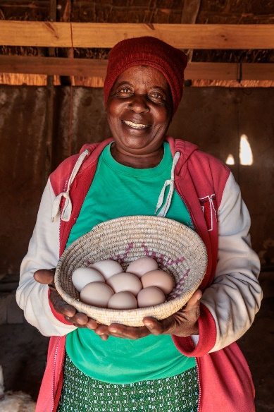
Priscilla lives in the Hwange district in Zimbabwe with her husband, Charles, and their two grandsons. Climate change continues to bring unprecedented challenges for people living in the most vulnerable and remote communities in Zimbabwe.
With the support of Caritas Hwange, Priscilla learnt conservation farming skills to grow drought-resistant crops to support her family during the current food crisis. Priscilla was able to produce a bumper harvest in her first year of practising conservation farming. Priscilla used the funds from her harvest to start poultry farming, which enabled her to sell eggs to pay for her grandchildren’s school fees, books and stationery. The poultry farming provides a safety net for Priscilla and her family during times of hardship, like the current drought.
While the situation in Zimbabwe and across eastern Africa remains dire, the work of Caritas Hwange means that Priscilla can learn the skills she needs to build resilience and support her family during this current food crisis.
Please donate to Project Compassion 2023.

Together, we can help vulnerable communities face their challenges today and build a better tomorrow For All Future Generations.

You can donate through Project Compassion donation boxes/envelopes available from your parish, by visiting caritas.org.au/project-compassion, or by calling 1800 024 413.

Photo: Richard Wainwright/Caritas Australia

Summary Version
Third Sunday of Lent
11 & 12 March
Zimbabwe is experiencing an intense drought, exacerbated by climate change. With the support of Caritas Hwange, Priscilla learnt conservation farming skills to grow drought-resistant crops and started poultry farming to support her family during the current food crisis.
Please donate to Project Compassion 2023.

Together, we can help vulnerable communities face their challenges today and build a better tomorrow For All Future Generations.

You can donate through Project Compassion donation boxes/envelopes available from your parish, by visiting caritas.org.au/project-compassion, or by calling 1800 024 413.

Fourth Sunday of Lent
18 & 19 March

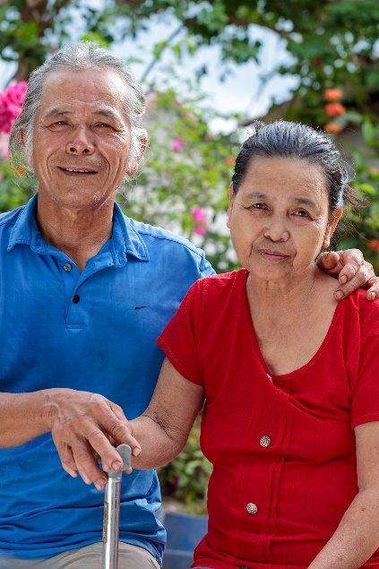
Thu lives in Vietnam. When Thu was 12 years old, he stepped on an unexploded land mine and lost his leg. ​
Living with a disability in rural Vietnam presented many challenges for Thu, who worked mainly as a rice farmer. Thu also took on the role of caring for his wife, Linh, after she suffered a stroke.​
Determined to turn their lives around, Thu and Linh joined the Empowerment of People with Disabilities program, run by Caritas Australia’s local partner in Vietnam, the Centre for Sustainable Rural Development (SRD).
For Thu, the greatest impact the program has had is enabling the change in Linh’s physical and mental wellbeing. With the support of a physiotherapist, Linh can now walk short distances with the aid of a walking stick.

Please donate to Project Compassion 2023.
Together, we can help vulnerable communities face their challenges today and build a better tomorrow For All Future Generations.
You can donate through Project Compassion donation boxes and envelopes available from your parish, by visiting caritas.org.au/project-compassion, or by calling 1800 024 413.
Photo: Phan Tan Lam/Caritas Australia

Summary Version
Fourth Sunday of Lent
18 & 19 March
Thu lost his leg after stepping on a land mine in Vietnam. With the support of the Centre for Sustainable Rural Development, Thu can now earn extra income and care for his wife as she recovers from a stroke.
Please donate to Project Compassion 2023.
Together, we can help vulnerable communities face their challenges today and build a better tomorrow For All Future Generations.

You can donate through Project Compassion donation boxes/envelopes available from your parish, by visiting caritas.org.au/project-compassion, or by calling 1800 024 413.

Fifth Sunday of Lent
25 & 26 March
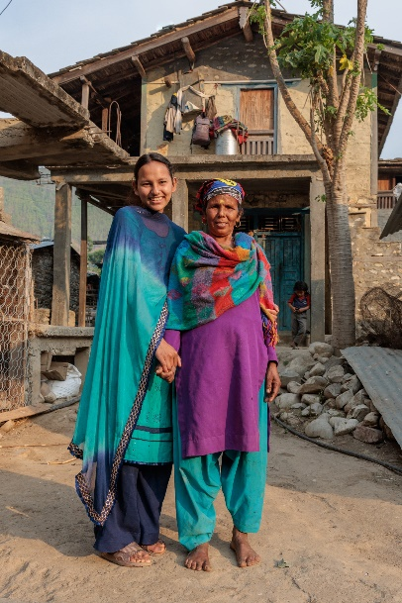
Project Compassion brings together Australian schools, parishes and supporters to raise funds for people in vulnerable communities across the world. This year, we introduced you to the story of four inspiring people whose lives have been transformed with your generous support: Laxmi, Tereesa, Priscilla and Thu.
Today, they are creating a better world for their families, their communities and for all future generations.
Project Compassion is a demonstration of the faith, empathy and generosity of our supporters. It is the lifeblood of Caritas Australia – without it, we could not do the vital work we do. Thank you for helping transform lives today and for all future generations.

Please donate to Project Compassion 2023.
Together, we can help vulnerable communities face their challenges today and build a better tomorrow For All Future Generations.
You can donate through Project Compassion donation boxes and envelopes available from your parish, by visiting caritas.org.au/project-compassion, or by calling 1800 024 413.

Photo: Richard Wainwright/Caritas Australia

Summary Version
Fifth Sunday of Lent
25 & 26 March
Project Compassion brings together Australian schools, parishes and supporters to raise funds for people in vulnerable communities across the world. This year, we introduced you to the story of four inspiring people whose lives have been transformed with your generous support: Laxmi, Tereesa, Priscilla and Thu. Today, they are creating a better world for their families, their communities and for all future generations.
Please donate to Project Compassion 2023.
Together, we can help vulnerable communities face their challenges today and build a better tomorrow For All Future Generations.
You can donate through Project Compassion donation boxes and envelopes available from your parish, by visiting caritas.org.au/project-compassion, or by calling 1800 024 413.

Sixth Sunday of Lent (Palm Sunday)
1 & 2 April
Every day, more than 200 million children miss out on school, around 690 million people go hungry and 2.2 billion people cannot access clean drinking water. In recent years, COVID-19 has also devastated vulnerable communities already living in poverty, with the health and economic impacts to reverberate for years to come.
It’s through the generous support of people like you that we are able to continue to help lift vulnerable communities out of poverty – support that is needed now more than ever.
Thank you for your continued support for Project Compassion – past, present and future. Together, we can help vulnerable communities face their challenges today and build a better tomorrow For All Future Generations.
Please donate to Project Compassion 2023 to help continue empowering vulnerable communities around the world to lift themselves and their communities out of poverty.
Together, we can help vulnerable communities face their challenges today and build a better tomorrow For All Future Generations.

You can donate through Project Compassion donation boxes/envelopes available from your parish, by visiting or by calling 1800 024 413.

Summary Version
Sixth Sunday of Lent (Palm Sunday)
1 & 2 April
Every day, more than 200 million children miss out on school, around 690 million people go hungry and 2.2 billion people cannot access clean drinking water.
With your generosity, Caritas Australia has been able to help millions of vulnerable people around the world, through the Project Compassion appeal.
Please donate to Project Compassion 2023 to help continue empowering vulnerable communities around the world to lift themselves and their communities out of poverty.
Together, we can help vulnerable communities face their challenges today and build a better tomorrow For All Future Generations.

You can donate through Project Compassion donation boxes/envelopes available from your parish, or visit caritas.org.au/project-compassion or phone 1800 024 413.

Easter Sunday
9 April
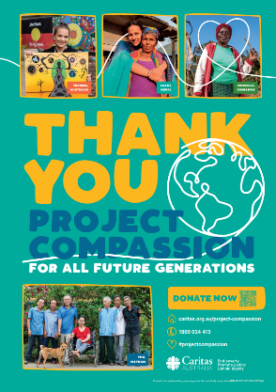
Happy Easter from all at Caritas Australia!
Thank you for your continued support for Project Compassion – past, present and future. Together, we can help vulnerable communities face their challenges today and build a better tomorrow For All Future Generations.
Thank you for supporting Caritas Australia’s Project Compassion 2023 Lenten appeal.
Together, we can help vulnerable communities face their challenges today and build a better tomorrow For All Future Generations.
You can donate through Project Compassion donation boxes and envelopes available from your parish, by visiting caritas.org.au/project-compassion or by calling 1800 024 413.

Thank you – Weeks after easter
Thank You!

Caritas Australia would like to THANK YOU for supporting Project Compassion 2023. If you still have your Project Compassion box or set of envelopes at home, please bring them back next week or visit caritas.org.au/project-compassion and donate online.
Your generosity will empower the world’s most vulnerable communities to grow stronger and lift themselves out of poverty.
Together, we can help vulnerable communities face their challenges today and build a better tomorrow For All Future Generations.
You can donate through Project Compassion donation boxes/envelopes available from your parish, by visiting caritas.org.au/project-compassion, or by calling 1800 024 413.

