PROJECT COMPASSION 2023
School Newsletter Notices
We encourage schools to include information about Project Compassion in their weekly newsletter, daily bulletins and social media as a way of informing parents and the wider community about our Lenten appeal. If you would like any other information, logos or photos, please email us: education@caritas.org.au
For each story, we have provided two images for you to choose from, depending on the layout of your publication. These photos can only be used in relation to Caritas Australia’s Project Compassion campaign.

Ash Wednesday – 22 February 2023  (Week beginning Monday 20th February)  This week, the season of Lent begins with Ash Wednesday, which also marks the beginning of the annual Caritas Australia Project Compassion Appeal. Donations to Project Compassion allow Caritas Australia, the Catholic Agency for International Aid and Development, to work with local communities around the world to end poverty, promote justice and uphold dignity.  The theme of Project Compassion 2023 is ‘For All Future Generations’ and reminds us that the good we do today extends to impact the lives of generations to come. It invites us to make the world a better place by working together now and finding long-term solutions to global issues. We encourage you to put your compassion into action this Lent through prayer, fasting and almsgiving in support of Project Compassion. Each family will receive a Project Compassion box and/or a set of envelopes for their donations or you can donate online via the Caritas Australia website at: www.caritas.org.au/project-compassion | 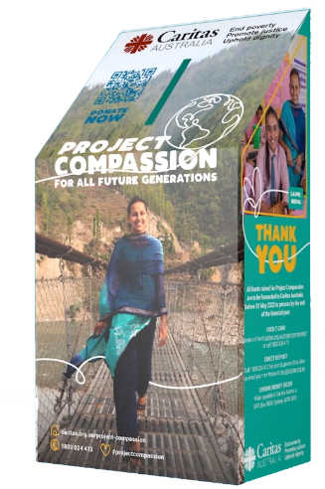  Credit: Caritas Australia
First Week of Lent  (Week beginning Monday 27th February)  We begin our annual Lenten Project Compassion journey by learning about Laxmi, a 16-year-old girl living in Jajarkot, a remote district in Nepal where almost half of the population live below the poverty line. Tragedy struck when Laxmi was 10 years old and her father passed away. Her father worked hard to pay for his children's education and, after losing him, Laxmi was at risk of falling further into extreme poverty.  With the support of our partner Caritas Nepal, Laxmi joined a child's club at her school where she was encouraged to resume her education. Through the child’s club, Laxmi developed the skills and confidence to become a leader, advocating for clean water taps at her school.  Laxmi is now excelling in her studies and working towards her dream of becoming a civil engineer. She continues to be involved in the child's club, serving as an advisor and mentoring the next generation of young leaders at her old school.  Watch a short film about Laxmi’s story here.  Please support Project Compassion: www.caritas.org.au/project-compassion. | 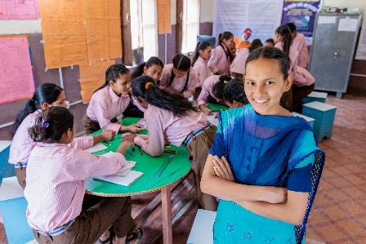  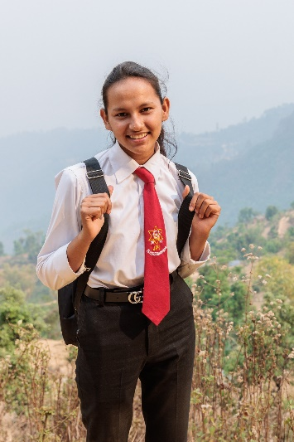  Photo: Richard Wainwright/Caritas Australia
Second Week of Lent  (Week beginning Monday 6th March)  This week through Project Compassion we learn about Tereesa, a Gamilaroi woman from Western Sydney who struggled with homelessness while raising her four children. At just 16 years old, she had to leave school after falling pregnant with her first child. A single mother struggling with homelessness, Tereesa’s only concern was finding stability for her children.  Seeking a better future for her family, Tereesa joined Baabayn Aboriginal Corporation’s Young Mums and Bubs Group, supported by Caritas Australia. Baabayn helped Tereesa access housing and psychological support. Through Baabayn, Tereesa was also able to hear stories from Indigenous Elders and reconnect with her culture.  Today, Tereesa is studying a certificate in Community Services so that she can strengthen her skills and give back to her community. Tereesa now works at Baabayn, providing support to young mothers and mentoring the next generation of young people.  Watch a short film about Tereesa’s story here.  Please support Project Compassion: www.caritas.org.au/project-compassion | 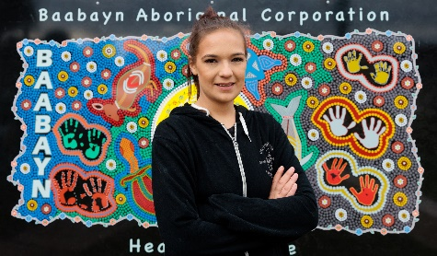  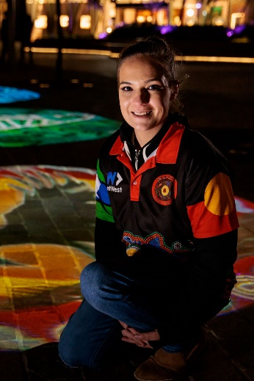  Photo: Richard Wainwright/Caritas Australia
Third Week of Lent  (Week beginning Monday 13th March)  We are now in the third week of Lent with the Project Compassion story of Priscilla, who lives in the Hwange district in Zimbabwe with her husband, Charles, and two of their grandchildren. Climate change continues to bring unprecedented challenges for people living in the most vulnerable and remote communities in Zimbabwe.  During times of intense drought and food shortages, Priscilla had to commute to the town centre and wait in long queues to collect food.  With the support of Caritas Hwange, Priscilla learnt conservation farming skills to grow drought-resistant crops and started poultry farming to support her family during the current food crisis. Priscilla was able to produce a bumper harvest in her first year of practising in conservation farming. Priscilla also used the funds from her harvest to start poultry farming, which enabled her to sell eggs to pay for her grandchildren’s school fees, books and stationery. The poultry farming provides a safety net for Priscilla and her family during times of hardship, like the current drought.  While the situation in Zimbabwe and across eastern Africa remains dire, the work of Caritas Hwange means that Priscilla can learn the techniques, tools and resources she needs to build resilience and support her family during this current food crisis.  Watch a short film about Priscilla’s story here.  Please support Project Compassion: www.caritas.org.au/project-compassion | 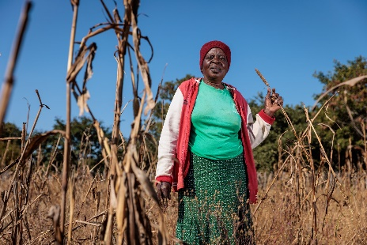  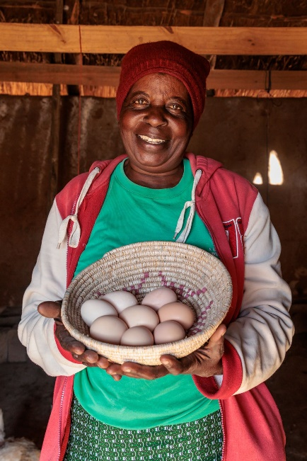  Photo: Richard Wainwright/Caritas Australia
Fourth Week of Lent  (Week beginning Monday 20th March)  This week through Project Compassion we learn about Thu, who lives in Vietnam. When Thu was 12 years old, he stepped on an unexploded land mine and lost his leg. ​  Living with a disability in rural Vietnam presented many challenges for Thu, who worked mainly as a rice farmer. Thu also took on the role of caring for his wife, Linh, after she suffered a stroke.​  Determined to turn their lives around, Thu and Linh joined the Empowerment of People with Disabilities program, run by Caritas Australia’s local partner in Vietnam, the Centre for Sustainable Rural Development (SRD).  For Thu, the greatest impact the program has had is enabling the change in Linh’s physical and mental wellbeing. With the support of a physiotherapist, Linh can now walk short distances with the aid of a walking stick.  Watch a short film about Thu’s story here.  Please support Project Compassion: www.caritas.org.au/project-compassion | 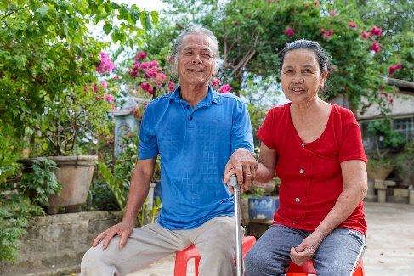  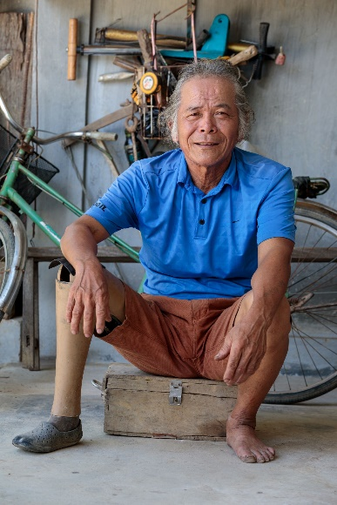  Photo: Phan Tan Lam/Caritas Australia
Fifth Week of Lent  (Week beginning Monday 27th March)  Project Compassion brings together Australian schools, parishes and supporters to raise funds for people in vulnerable communities across the world. This year, we introduced you to the story of four inspiring people whose lives have been transformed with your generous support: Laxmi, Tereesa, Priscilla and Thu.  Today, they are creating a better world for their families, their communities and for all future generations.  Project Compassion is a demonstration of the faith, empathy and generosity of our supporters. It is the lifeblood of Caritas Australia – without it, we could not do the vital work we do. Thank you for helping transform lives today and for all future generations.  Please support Project Compassion: www.caritas.org.au/project-compassion | 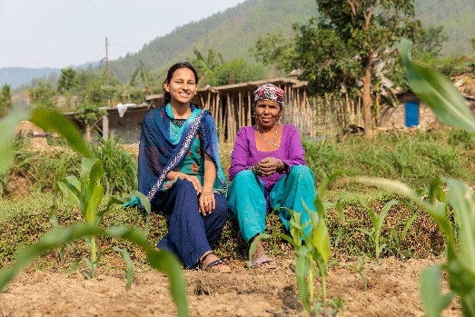  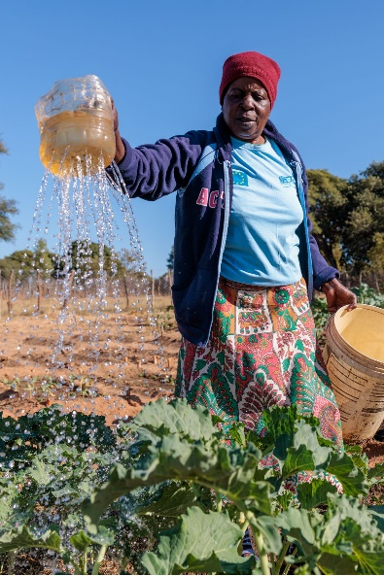  Photo: Richard Wainwright/Caritas Australia
HOLY WEEK  (Week beginning Monday 3rd April)  As we enter Holy Week, we continue to reflect on the lives of people vulnerable to extreme poverty and injustice and how we can respond through supporting Caritas Australia’s Project Compassion appeal.  Your generosity is the pebble that allows Caritas Australia to create the ripples that will improve the livelihoods of vulnerable communities, supporting them to flourish and create opportunities for future generations to live to their full potential.  Thank you!  Please return all Project Compassion boxes and envelopes to the school office by Friday 26th May or donate online via the Caritas Australia website at www.caritas.org.au/project-compassion | 