Project Compassion 2022 Parish and Community Bulletin Notices
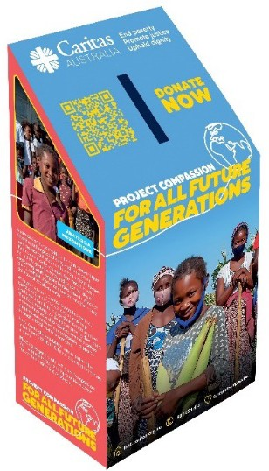Project Compassion Sunday, 26 & 27 February

Project Compassion Sunday 26 & 27 February
Please take home a Project Compassion box and a set of donation envelopes to support Caritas Australia this Lenten season and help support vulnerable people around the world, now and For All Future Generations.

With your support, Caritas Australia has been able to support vulnerable communities around the world to tackle poverty, food security, education, water and sanitation and disaster risk reduction. Project Compassion 2022 reminds us that the good that we do today will extend and impact the lives of generations to come to build better future for all.

As St Pope John Paul II said,
“The future starts today, not tomorrow.”

Together, we can help vulnerable communities face their challenges today and build a better tomorrow For All Future Generations. You can donate through Project Compassion donation boxes and envelopes available from your Parish, by visiting lent.caritas.org.au, or by calling 1800 024 413.

Summary Version
Project Compassion Sunday 26 & 27 February
Please take home a Project Compassion box and a set of donation envelopes to support Caritas Australia this Lenten season and help support vulnerable people around the world, now and For All Future Generations. With your support, Caritas Australia has been able to support vulnerable communities around the world to tackle poverty, food security, education, water and sanitation and disaster risk reduction to build a better future for all.

Together, we can help vulnerable communities face their challenges today and build a better tomorrow For All Future Generations.
You can donate through Project Compassion donation boxes and envelopes available from your Parish, by visiting lent.caritas.org.au, or by calling 1800 024 413.

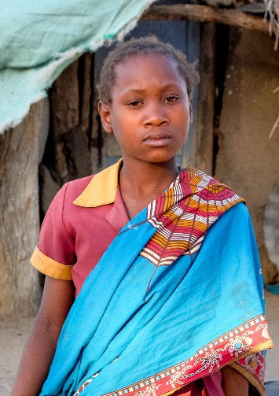
First Sunday of Lent 5 & 6 March
Anatercia 12, was struggling to cope with adult responsibilities after her father died. Then she participated in Caritas Australia- supported training and gained access to psychosocial supports.
Now, Anatercia can easily access clean drinking water, community members are able to grow healthy crops all year round, and there is enough nutritious food to eat. Anatercia feels better supported by her community, has more time to study and do her homework, and hopes to fulfil her dream of becoming a nurse.

Please donate to Project Compassion 2022 to help young people succeed in the future and bring stability to vulnerable youth like Anatercia.

Together, we can help vulnerable communities face their challenges today and build a better tomorrow For All Future Generations.
You can donate through Project Compassion donation boxes and envelopes available from your Parish, by visiting lent.caritas.org.au, or by calling 1800 024 413.

Summary Version

First Sunday of Lent 5 & 6 March
Anatercia 12, was struggling to cope with adult responsibilities after her father died. Then she participated in Caritas Australia-supported training and gained access to psychosocial supports. Now, her quality of life has improved and she can focus on school.
Please donate to Project Compassion 2022 to help young people succeed in the future and bring stability to vulnerable youth like Anatercia.

Together, we can help vulnerable communities face their challenges today and build a better tomorrow For All Future Generations.
You can donate through Project Compassion donation boxes and envelopes available from your Parish, by visiting lent.caritas.org.au, or by calling 1800 024 413.

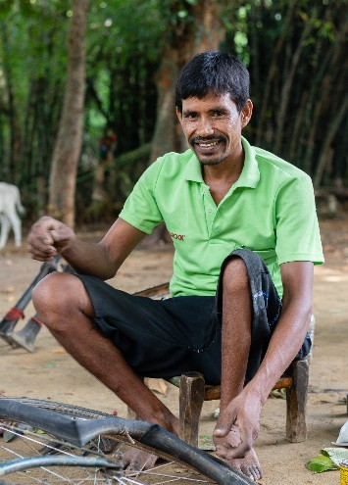
Second Sunday of Lent 12 & 13 March
Biru 30, lives in a rural village in Jharkand State in India’s east. He lost mobility in one of his legs, after contracting polio as a child, which makes it difficult for him to walk. With your generous support, Biru was able to access an entrepreneurship and livelihoods development program, run by Caritas Australia’s partner, Caritas India. He gained the skills, support and encouragement he needed to establish his own bicycle repair business.

Now, Biru is able to provide a good life for his family – and an essential service to his community. He has discovered a sense of pride, confidence and hope which has inspired others living with a disability and paved the way For All Future Generations.
Please donate to Project Compassion 2022 and help people living with disabilities in India gain access to education and clean water, empowering them with skills to build a better future for all.

Together, we can help vulnerable communities face their challenges today and build a better tomorrow For All Future Generations. You can donate through Project Compassion donation boxes and envelopes available from your Parish, by visiting lent.caritas.org.au, or by calling 1800 024 413.

Summary Version

Second Sunday of Lent 12 & 13 March
As a person with a disability living in remote India, Biru faced the prospect of a life of poverty and discrimination. With your support, he participated in entrepreneurship training and gained the skills to become financially independent.
Please donate to Project Compassion 2022 and help people living with disabilities in India gain access to education and clean water, empowering them with skills to build a better future.
Together, we can help vulnerable communities face their challenges today and build a better tomorrow For All Future Generations.
You can donate through Project Compassion donation boxes and envelopes available from your Parish, by visiting lent.caritas.org.au, or by calling 1800 024 413.

Third Sunday of Lent 19 & 20 March
Janice 44, is a proud Wagilak woman, a traditional dancer, living in a remote community in the Northern Territory. As elders grow older and pass away, she knows she must share her knowledge with the younger generation. However, the community faces multiple challenges, including a lack of jobs, limited educational opportunities, and socio-economic which can lead to young people becoming disconnected from culture.

With your help, Caritas Australia supports Djilpin Arts Aboriginal Corporation, which operates a centre for traditional and contemporary Aboriginal arts and culture, providing employment and generating income for local communities.

Please donate to Project Compassion 2022 and help provide employment and training for First Australians, allowing them to remain on country and keep their culture alive.

Together, we can help vulnerable communities face their challenges today and build a better tomorrow For All Future Generations.
You can donate through Project Compassion donation boxes and envelopes available from your Parish, by visiting lent.caritas.org.au,
or by calling 1800 024 413.

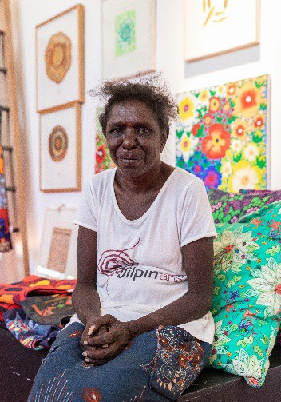Summary Version

Third Sunday of Lent 19 & 20 March
Janice 44, is a proud Wagilak woman, a traditional dancer, who tells stories through movements handed down over generations. With your support, Janice and the Djilpin Arts Aboriginal Corporation support the community to generate income and employment, while keeping culture alive.
Please donate to Project Compassion 2022 and help provide employment and training for First Australians, allowing them to remain on country and keep their culture alive.

Together, we can help vulnerable communities face their challenges today and build a better tomorrow For All Future Generations.
You can donate through Project Compassion donation boxes and envelopes available from your Parish, by visiting lent.caritas.org.au, or by calling 1800 024 413.

Fourth Sunday of Lent 26 & 27 March
Rosalie 44, is an ex-combatant who lives with her husband and seven children in the Democratic Republic of Congo. Forced to join the army when she was just 15-years-old, Rosalie experienced significant trauma and hardship during her years in the military. After she was demobilised from the army, Rosalie, like other ex-combatants, was left to fend for herself in the community.
With your generous support and through our local partners, Rosalie was able to connect with other members of her community and participate in business skills training to help her to reintegrate into society.

Please donate to Project Compassion 2022 and help women like Rosalie to succeed in the future, providing hope For All Future Generations.
Together, we can help vulnerable communities face their challenges today and build a better tomorrow For All Future Generations. You can donate through Project Compassion donation boxes and envelopes available from your Parish, by
visiting lent.caritas.org.au, or by calling 1800 024 413.

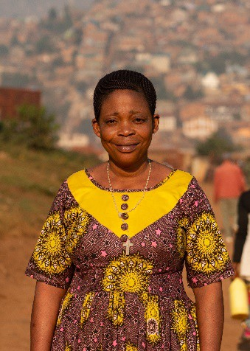Summary Version

Fourth Sunday of Lent 26 & 27 March
From her life as a child soldier in the Democratic Republic of Congo, Rosalie is a now a business owner, a community leader and a role model for other ex-combatants seeking to
readjust to civilian life.
Please donate to Project Compassion 2022 and help women like Rosalie to succeed in the future, providing hope For All Future Generations.
Together, we can help vulnerable communities face their challenges today and build a better tomorrow For All Future Generations.
You can donate through Project Compassion donation boxes and envelopes available from your Parish, by visiting lent.caritas.org.au, or by calling 1800 024 413.

Fifth Sunday of Lent 2 & 3 April
Shaniella 23, grew up in a remote village in the Solomon Islands in a province which has limited educational and job opportunities
– and one of the country’s highest poverty rates. After leaving school, she decided to move closer to the capital city, Honiara, to study hospitality and tourism. However, her vocational training school was hit by a landslide and cyclone in quick succession, destroying its water supply system and the vegetable garden that it relies on for food.
With your generous support, Caritas Australia has helped the school to install water tanks, re-establish its garden and provided training in disaster risk reduction. Shaniella can now complete her job skills training and the school has enough food and water for its students.
Please donate to Project Compassion 2022 so this transformational program can continue to empower and strengthen vulnerable communities For All Future Generations.

Together, we can help vulnerable communities face their challenges today and build a better tomorrow For All Future Generations. You can donate through Project Compassion donation boxes and envelopes available from your Parish, by
visiting lent.caritas.org.au, or by calling 1800 024 413.

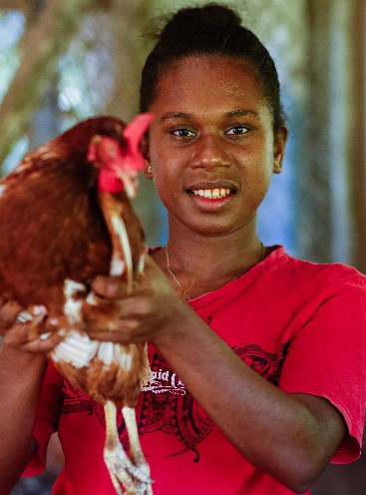Summary Version

Fifth Sunday of Lent 2 & 3 April
Shaniella 23, from the Solomon Islands was determined to forge a path out of poverty, moving away to vocational school. With your support, Shaniella was able to overcome further challenges of natural disasters, and gain the skills she needs to create a brighter future for herself.
Please donate to Project Compassion 2022 so this transformational program can continue to empower and strengthen vulnerable communities For All Future Generations.
Together, we can help vulnerable communities face their challenges today and build a better tomorrow For All Future Generations.
You can donate through Project Compassion donation boxes and envelopes available from your Parish, by visiting lent.caritas.org.au, or by calling 1800 024 413.

Sixth Sunday of Lent 9 & 10 April
Every day, more than 200 million children miss out on school, around 690 million people go hungry and 2.2 billion people cannot access clean drinking water. In recent years, COVID-19 has also devastated vulnerable communities already living in poverty, with the health and economic impacts to reverberate for years to come.
It’s through the generous support of people like you, even amidst the COVID-19 pandemic, that we are able to continue to help lift vulnerable communities out of poverty – support that is needed now more than ever. Thousands of schools and Parishes in Australia have supported Project Compassion over the past year alone.
Thank you for your continued support for Project Compassion – past, present and future. Together, we can help vulnerable communities face their challenges today and build a better tomorrow For All Future Generations.
Please donate to Project Compassion 2022 to help continue empowering vulnerable communities around the world lift themselves and their communities out of poverty.
Together, we can help vulnerable communities face their challenges today and build a better tomorrow For All Future Generations. You can donate through Project Compassion donation boxes and envelopes available from your Parish, by visiting lent.caritas.org.au, or by calling 1800 024 413.

Summary Version

Sixth Sunday of Lent 9 & 10 April
Every day, more than 200 million children miss out on school, around 690 million people go hungry and 2.2 billion people cannot access clean drinking water.
With your generosity, Caritas Australia has been able to help millions of vulnerable people around the world, through Project Compassion appeal.
Please donate to Project Compassion 2022 to help continue empowering vulnerable communities around the world lift themselves and their communities out of poverty.
Together, we can help vulnerable communities face their challenges today and build a better tomorrow For All Future Generations. You can donate through Project Compassion donation boxes and envelopes available from your Parish, or visit lent.caritas.org.au or phone
1800 024 413.

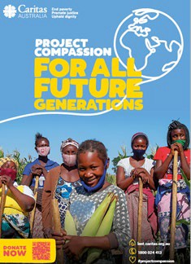
Easter Sunday 17 April

Happy Easter from all at Caritas Australia!
Thank you for your continued support for Project Compassion – past, present and future. Together, we can help vulnerable communities face their challenges today and build a better tomorrow For All Future Generations.

Thank you for supporting Caritas Australia’s Project Compassion 2022 Lenten appeal.

Together, we can help vulnerable communities face their challenges today and build a better tomorrow For All Future Generations. You can donate through Project Compassion donation boxes and envelopes available from your Parish, by visiting lent.caritas.org.au, or by calling 1800 024 413.

THANK YOU

Thank You!
Caritas Australia would like to THANK YOU for supporting Project Compassion 2022. If you still have your Project Compassion box or set of envelopes at home, please bring them back next week or visit lent.caritas.org.au and donate online.

Your generosity will empower the world’s most vulnerable communities to grow stronger and lift themselves out of poverty.

Together, we can help vulnerable communities face their challenges today and build a better tomorrow For All Future Generations.
You can donate through Project Compassion donation boxes and envelopes available from your Parish, by visiting lent.caritas.org.au,
or by calling 1800 024 413.

