WEEKLY REFLECTIONS
ASH WEDNESDAY
Joel 2:12-18 I Ps 50:3-6. 12-14. 17. R. v.3 I 2 Corinthians 5:20-6:2 I Matthew 6:1-6, 16-18

Written by Michael McGirr
It was not many years ago that every school and parish had an incinerator. At our school, one of the jobs of the class monitor was to take out the trash and set fire to it. It is uncomfortable to think now about how much soot we put into the atmosphere. Not to mention the fumes of burning plastic and other things. The word recycling was still a few years away; frankly, it’s a pity it didn’t enter our vocabulary a bit sooner. One time, two members of our class decided to start throwing ash at each other. They made an unholy mess and ended up looking like wrecks. The teacher made them write out fifty times the line from today’s Psalm: ‘O wash me more and more from my guilt.’ With benefit of hindsight, I can see that the Psalm has bigger things on its mind than ten-year-olds getting dirty in the incinerator.
The focus of the Psalm is far more on God’s mercy and kindness than our silly behaviour. It asks for strength, a ‘steadfast spirit.’ It also asks for the gift of intimacy with God. ‘Do not cast me away from your presence. ’Later, I discovered that at school the teachers used ashes from the incinerator to place on our foreheads on Ash Wednesday. I don’t think this was the correct procedure and was, I think, a matter of convenience. Yet it does seem to make a point. When we receive the ashes, we are asked to remember that we are dust and will return to dust.
The journey of Lent takes in hope from a place of humility to one of light. The things we throw away, the people we disregard, are the very place we can encounter God. Project Compassion, organised by Caritas Australia, is a great way of embracing the journey of Lent. It asks us to remember that there are people in the world who are often treated like rubbish. Metaphorically, they live among the ashes. Our decisions can make a huge impact on helping them journey with hope into light.
The rituals of Ash Wednesday have a special meaning for all of us. They call us to recognise the humanity we share with others and to return with our hearts to the God of justice. Like Mary, we are called to be a blessing for all generations to come.
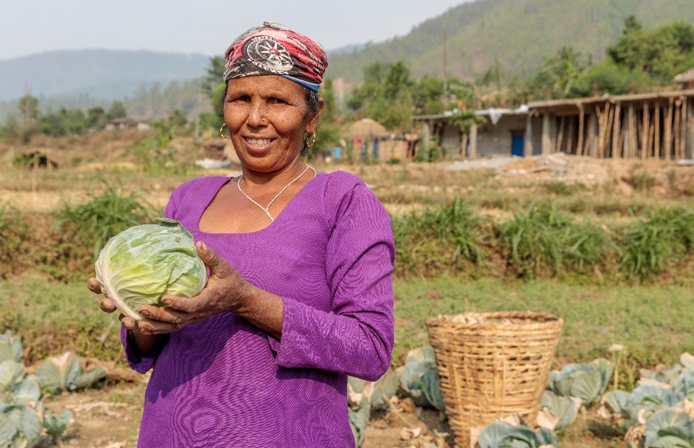

Laxmi's mother Mankala (52) harvests cabbages from her fields close to her home in Jajarkot district, western Nepal. Photo: Richard Wainwright/Caritas Australia

WEEKLY REFLECTIONS
FIRST SUNDAY OF LENT

Genesis 2:7-9; 3:1-7 I Romans 5:12-19 I Matthew 4:1-11

Written by Michael McGirr
Nelson Mandela said that education was the most powerful weapon we can use to change the world. There are plenty of people who would agree with him, one of them is Oprah Winfrey. She said that education was the way to move mountains, build bridges and to change the world. Today’s readings certainly suggest the value of learning.
The story from the Book of Genesis comes from pre-history. It has often been misunderstood to suggest that sin entered the world through one woman, yet this is not true. On the contrary, the readings tell us that the world is good. When humans try to overstretch their boundaries, trouble follows and the experience of beauty and harmony is threatened. We need to choose our teachers. Are we going to listen to God or the serpent?
In our modern world, the serpent takes many forms. There are many threats to the harmony of the human race and the beauty of our natural environment. Likewise, today’s story of the temptations in the wilderness from Matthew’s Gospel shows us that some lessons are difficult. Jesus actually teaches the devil, telling the evil one that God is in charge. Jesus has to decide which voices he will follow, and has to learn that some ideas may not be as good as they sound. All the kingdoms of the world, Jesus learns, are no substitute for an honest and life-giving relationship with God.
Each week during Lent, Caritas Australia asks us to think about a special story. The story focuses on someone who has benefitted from your generosity through Project Compassion. This week, we hear about 16-year-old Laxmi who lives in a remote part of Nepal. Your help has enabled her to overcome family hardship to pursue her education. She was tempted to give up on school, but Project Compassion enabled her to follow a more positive direction and to realise what she could achieve for her community by becoming an engineer. The evil spirit will always get us to focus on what we don’t have. The spirit of light will show us what is truly possible.
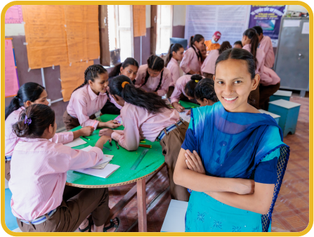
Laxmi (16) facilitating a wall magazine poster making session with Child Club members at her old school in Jajarkot district, western Nepal. Photo: Richard Wainwright/Caritas Australia
WEEKLY REFLECTIONS
SECOND SUNDAY OF LENT
Genesis 12:1-4a I 2 Timothy 1:8b-10 I Matthew 17:1-9

Written by Michael McGirr
Think for a moment about some of the things you have on your walls at home. They don’t have to be fancy or expensive. They might be photos of your family or perhaps of deceased grandparents. They might be prints of famous paintings or posters with sayings that mean a lot to you. It is very common that Christians have special things: crucifixes or images of saints. All of these things inspire us in one way or another. If ever you have had to pack up to move house and looked at your bare walls as you leave, they will seem empty and colourless.
Art is one of the things that transfigures our world and makes it more beautiful. Other things do this as well: laughter, tears, cooking, music, hugs and sharing stories. They all transfigure our houses and allow us to see them as homes. They unlock the true potential of an otherwise ordinary space.
This week Project Compassion, organised by Caritas Australia, presents us with the story of Tereesa, a 27-year-old indigenous woman from Western Sydney, the area with the largest urban indigenous population in the country. Tereesa became pregnant at the age of 16.
With your help, Project Compassion has been able to support the Mums and Bubs program run by Baabayn Aboriginal Corporation. This allowed Tereesa to find accommodation, gain skills and continue her education. She was also able to connect with her culture. Her glorious artwork was featured on the Wulugul Walk during Sydney’s Vivid Light festival last year. Her use of light and colour transfigured the environment where it was displayed. In so many places, Project Compassion helps people to achieve their vision.
Of course, the transfiguration of Jesus is unique. We hear in today’s Gospel that Jesus took his closest friends to the top of a high mountain. His face shone like the sun and his face became ‘as white as the light.’ A voice from heaven said ‘this is my beloved son; listen to him.’ Peter said how wonderful it was to be there. The transfiguration may have only lasted a few minutes but it was clear that Jesus’ friends never forgot it. Like a work of art on a wall, the memory made the world seem very different. During Lent, we are also called to transfigure the world, to make a difference.

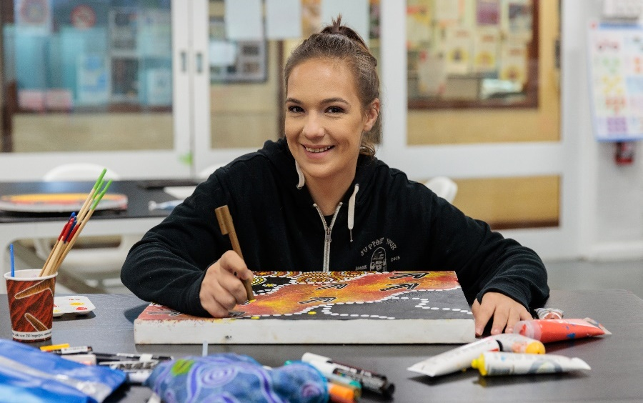

Tereesa works on one of her paintings at Baabayn Aboriginal Corporation in Western Sydney. Photo: Richard Wainwright/Caritas Australia

WEEKLY REFLECTIONS
THIRD SUNDAY OF LENT

Exodus 17:3-7 I Romans 5:1-2, 5-8 I John 4:5-42

Written by Michael McGirr
Every summer seems to get a little longer and a little hotter. We have all become conscious of issues surrounding water. Either there seems to be too much, as during last year’s summer floods or when the sea levels rise in the Pacific. Other times, there seems to be too little water as when the rivers in our country run low or members of God’s family around the world experience drought.
Caritas Australia, through Project Compassion, has been responding to the dire needs of places such as Ethiopia and Somalia where a cruel drought, compounded by a shortage of grain from Ukraine, has led to dire consequences. Today’s readings may well cause us to reflect on the current state of God’s creation.
In the book of Exodus, we hear that people are complaining to Moses because they are dying of thirst. In the Gospel, Jesus meets a woman in a Samaritan town. She has come to draw water from the well in the hottest part of the day. In both cases, access to water is precarious. Yet God responds not only to a thirst for water but to a deeper thirst as well. Moses’ people are thirsty for direction, leadership and hope. The woman in John’s Gospel has a thirst for love and acceptance which, Jesus tells her, will come from within if she is able to accept him and his message of life. As the story unfolds, we learn of her loneliness and see her reconnecting with her community.
This week, Caritas Australia shares with us an account of its response to a water shortage in Zimbabwe. Thanks to our support for Project Compassion, Caritas is involved in providing access to water in many places. It seems such a basic thing. One we mostly take for granted. But once a community has access to water, it grows in every possible way. People have more time for healthcare and education. People find energy to build their future. This week’s scripture readings have a strong sense of a hope-filled future. May we too, in our time, be sources of hope for all future generations.

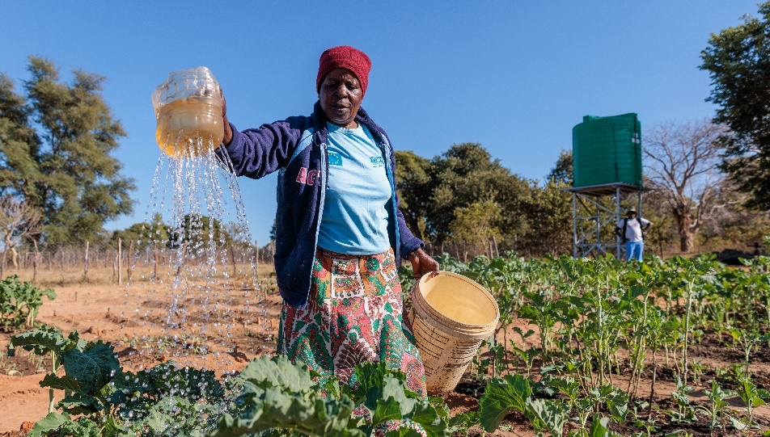

Priscilla waters her vegetables at a community nutrition garden near her home in Hwange district, north-western Zimbabwe.
Photo: Richard Wainwright/Caritas Australia

WEEKLY REFLECTIONS
FOURTH SUNDAY OF LENT
1 Samuel 16:1B, 6-7, 10-13A I Ephesians 5:8-14 I John 9:1-41

Written by Michael McGirr
There are many occasions when we ask the question why, and can’t find the answer for which we are looking. Why did we miss out on a job? Why did someone we love get cancer? Why can’t we find a place to live that we can afford? Why do some days seem so difficult?
It is good to sit with our confusion and even grief. It is good to share it with the Lord who loves us so tenderly. But sometimes we have to step aside from the question why did this happen? It may be better to start with, where can I go from here? What small steps will enable me to face the future in a positive spirit?
Today’s readings touch upon these issues. In the Gospel, Jesus encounters a person who was born blind. The bystanders want to know why this happened. They think it must be because either he or his parents did something wrong. They are looking backwards. Jesus prefers to look forward. He says ‘he was born blind so that the works of God may be displayed in him.’ In other words, his blindness presents opportunities for growth, not a pretext for blame. The letter to the Ephesians similarly reminds us that we are on a journey from darkness to light. The whole of Lent could be described in those words. The letter says ‘try to discover what the Lord wants of you.’ It asks us in terms of possibilities! The same thing happens when Samuel anoints David. It doesn’t matter that David is a young shepherd. He has a big future, as anyone familiar with the Bible well knows.
This week Project Compassion shares with us the story of Thu, who lives in Vietnam. At the age of 12, Thu’s life was thrown into chaos when he trod on a land mine from the Vietnam War. Surely, he must have asked why he was among the unlucky ones. He might have asked the same thing again when his wife suffered a stroke. But Thu joined the Empowerment of People with Disabilities program, supported by Caritas Australia through our local partners, the Centre for Sustainable Rural Development. As with so many others, your generosity enabled Thu and his family to build a brighter future. Thank you for helping in this wonderful work of transformation.
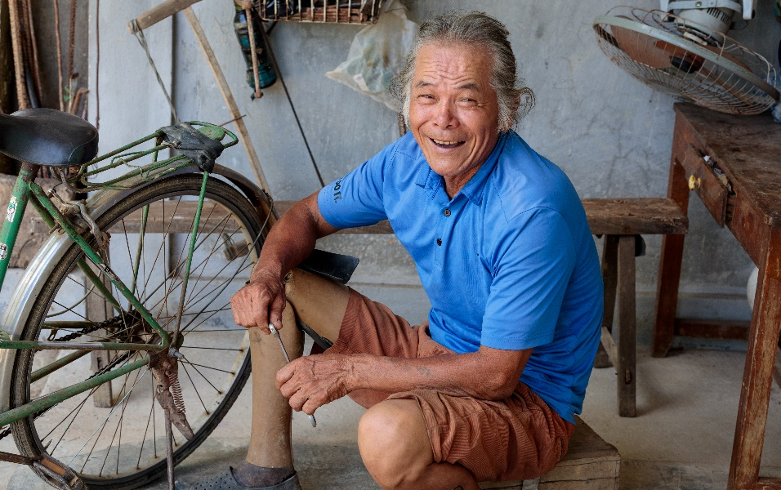
Thu fixes a bicycle at his home in Quang Tri province, Vietnam.
Photo: Phan Tan Lam/Caritas Australia
WEEKLY REFLECTIONS
FIFTH SUNDAY OF LENT

Ezekiel 37:12-14 I Romans 8:8-11 I John 11:1-45

Written by Michael McGirr
It must be difficult for somebody who has never experienced love to understand the Gospels. They are so full of different emotions, many of them tender. Just think of the beautiful reconciliation between Jesus and Peter after the resurrection. Jesus allows Peter to say that he loves him on no less than three occasions.
Thankfully, most of us can write down a long list of people we have loved and also of those who have loved us. Many names would appear on both lists! We keep a special place in our hearts and prayers for the people we know who have died. Even after a long time, their memory will still bring a tear to our eyes. That sorrow comes from a place of deep gratitude. God changes the world one heart at a time.
When we encounter today’s Gospel, the story of the raising of Lazarus, we are in a world of emotion. Martha and Mary are grieving for their brother. Jesus loves these two women. Thomas, the twin, is full of bravado and bluster, just as he was later when he wanted proof of the resurrection. Both Martha and Mary are disappointed, even angry, that Jesus has not come sooner. Jesus weeps at the grave of his friend. The mourners who have come to comfort the family must also have been sensitive to the situation. When Jesus says ‘I am the resurrection and the life’ he is not explaining an idea. He is responding to the deepest longings of our hearts, as he always does.
Today’s Psalm reminds us ‘My soul is longing for the Lord more than the watcher for daybreak.’ Over the last few weeks we have shared some of the stories presented to us by Caritas Australia to make us more aware of the inspirational work we can support through Project Compassion. There have been stories from Zimbabwe, Vietnam, Nepal and First Australians. Through your generosity, Caritas Australia is able to support partners in 18 different countries. These are all people who, not unlike Lazarus, are longing to be unbound and set free. The Gospel calls us to believe in the Life to which Jesus invites us; that Life is built on justice and compassion.
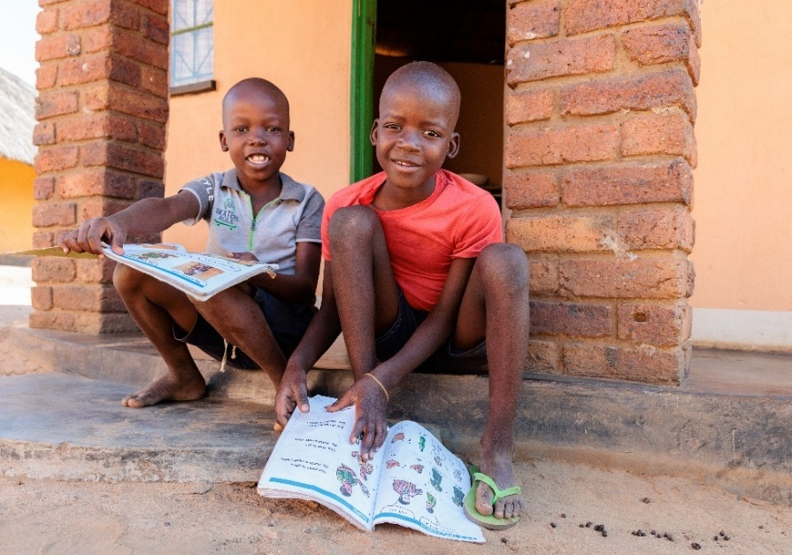

Priscilla’s grandchildren, Obry (8) and Jayden (7), read their school books at their home in Hwange district, north-western Zimbabwe. Photo: Richard Wainwright/Caritas Australia

WEEKLY REFLECTIONS
PALM SUNDAY
Is 50:4-7 I Phil 2:6-11 I Mt 26:14 – 27:66

Written by Michael McGirr
It is only once in every three years that we publicly share together Matthew’s full account of the arrest, trial and death of Jesus. Today is that day. Matthew’s passion is rich in every sense of the word. It is the longest account of what Jesus endured and it also has the most diverse cast of characters. Only Matthew devotes time not only to the tragic fate of Judas, who was filled with remorse, but even to the thirty pieces of silver that were used to buy a cemetery for foreigners called the Field of Blood. Only Matthew tells us about the dream of Pilate’s wife which leads her to send a message to her husband that he should have nothing to do with Jesus. Matthew’s Gospel features a number of dreams. Joseph is told in a dream to take Mary as his wife, to flee with his family to Egypt and later to return from Egypt. Dreams are one of the many links between Matthew’s Gospel and the Hebrew scriptures.
This is by no means to say that Matthew’s Gospel is merely an interesting piece of literature. It is only to suggest that, in Holy Week, Matthew’s Passion is a wonderful encounter to enter slowly as we spend time with the Lord, allowing the mystery of the cross to deepen within us. One commitment we might make is to take a section each day this week and stay with it for ten minutes.
Monday Mt 26: 14-35, Tuesday Mt 26: 36-56, Wed Mt 26: 57-75, Thursday Mt 27: 1-26, Friday Mt 27: 27-56, Saturday: Mt 27: 57-66.
The trial and death of Jesus reminds us of the tragedy of injustice that continues to this day in so many places around the world. Throughout Lent, Caritas Australia, through Project Compassion, has attempted to draw our attention to many important issues in our world. We have been invited to take up the cross and follow Jesus in our own time. We can pray, with Jesus, ‘Let it be as you, not I, would have it.’

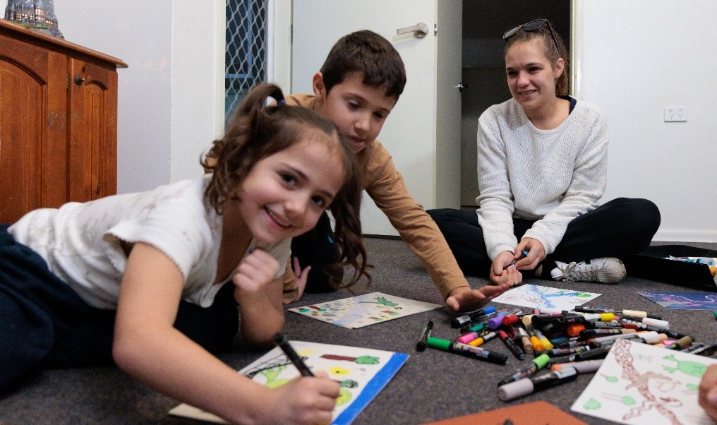

Tereesa teaches her children art and craft skills at their home in Western Sydney.
Photo: Richard Wainwright/Caritas Australia

